SOP For ModSim

Dhruv Savaj

Dhruv.savaj@ssminfotech.com

SOP For ModSim

* How to Configure ModSim
* First Start ModSim Application

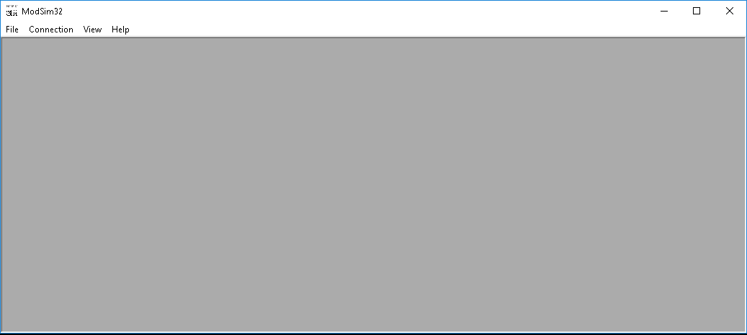

* Then Go to File Menu and Click on New or Press (ctrl + N).

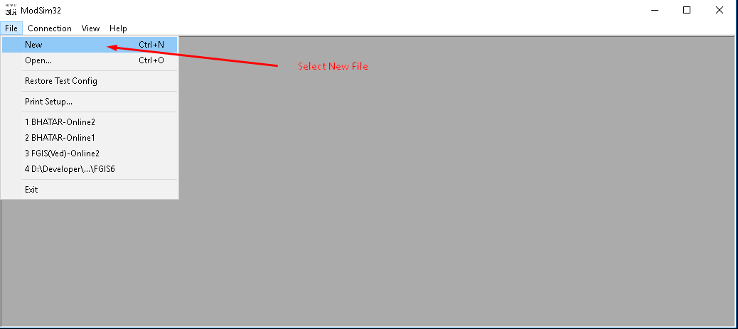

* After click on new File open a file in ModSim application

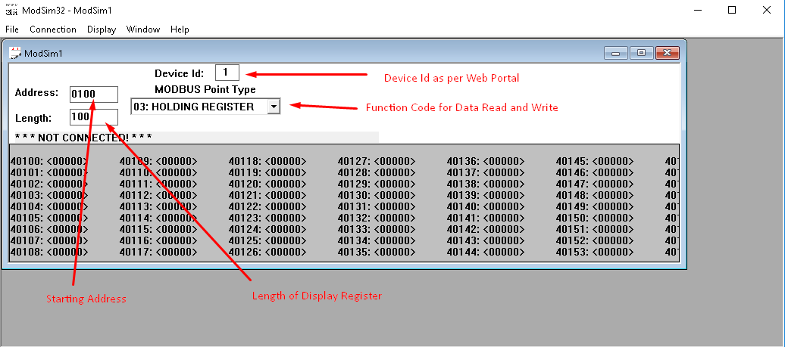

* To Connect with Com Port Go to Connection menu and click on connect, then after select Port to connect with ModSim

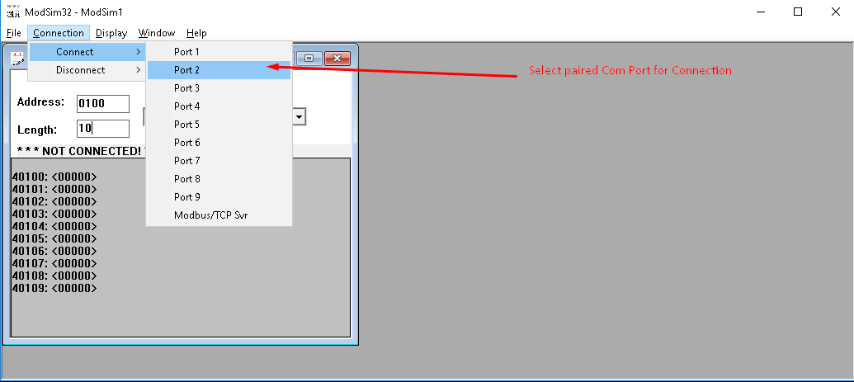

* After click on your com port, then after open a dialog box fill required details and press Ok button.

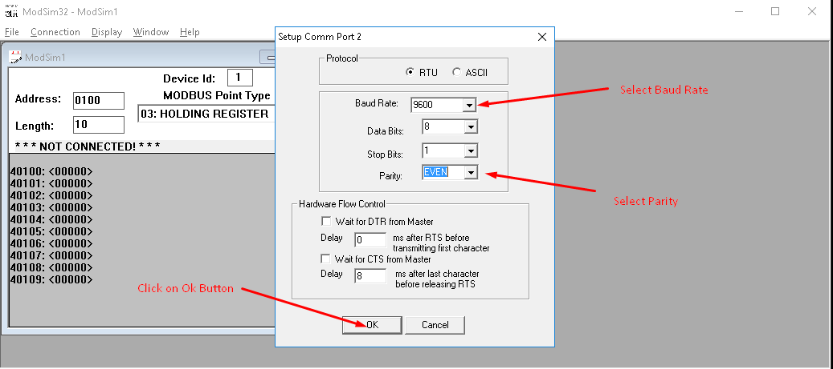

* If com port is valid and details is correct then it connected to your selected port.

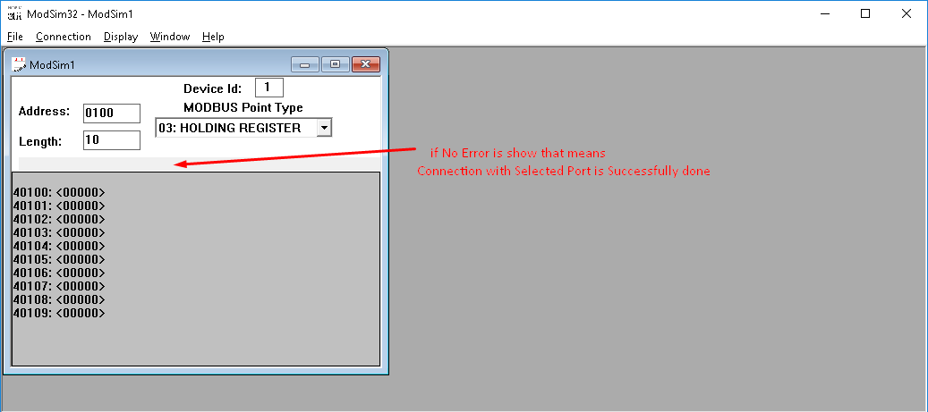

* To assign value to register double click on register value. And then after open a dialog box set value to textbox. And click on update button. If you want to auto update value then click on auto simulation then and set interval or lower, higher limit and click on ok button.

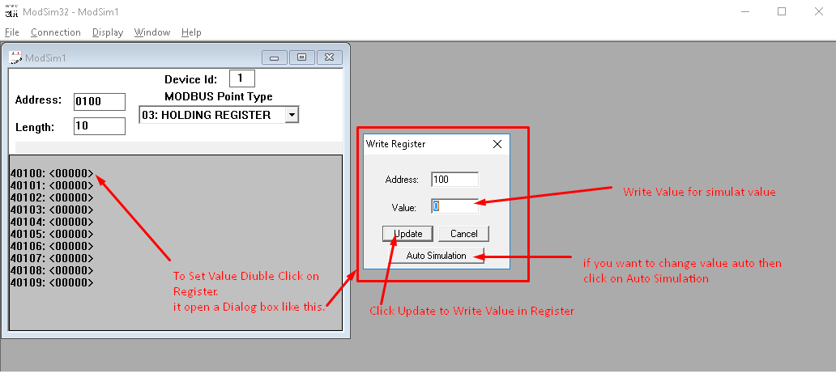

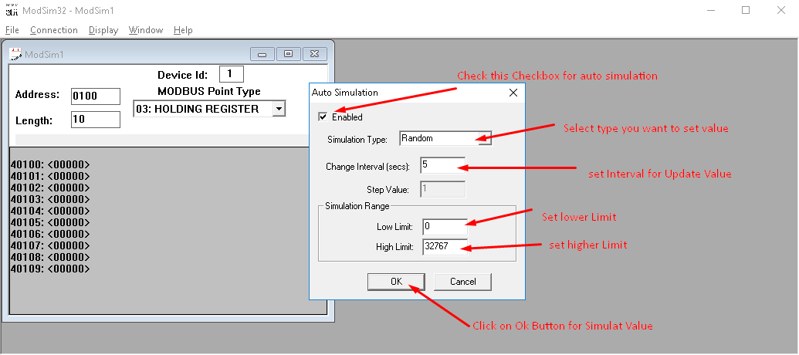

* After that auto simulated value display on register.

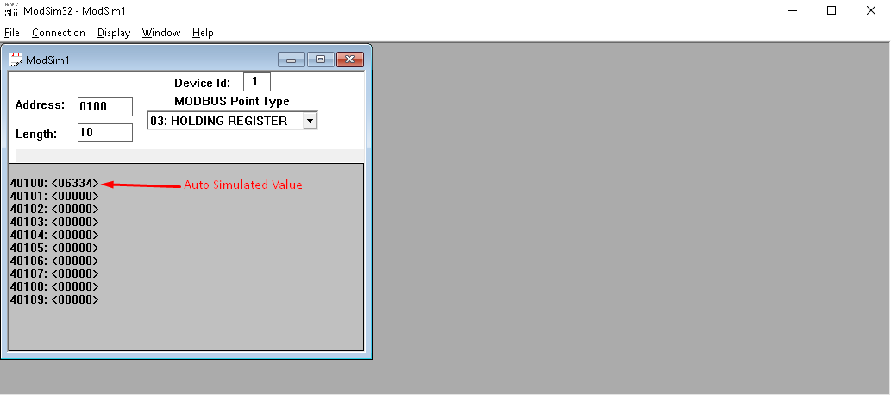

* If you want to show data in different format then go to Display menu and select type in which you want to show your data.

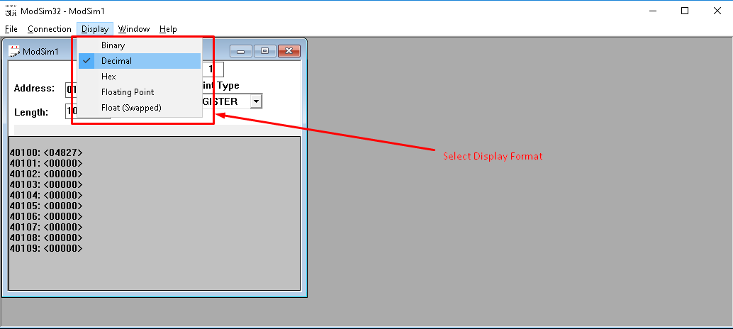

* To Save your created files go to File Menu and click on Save Test Config.

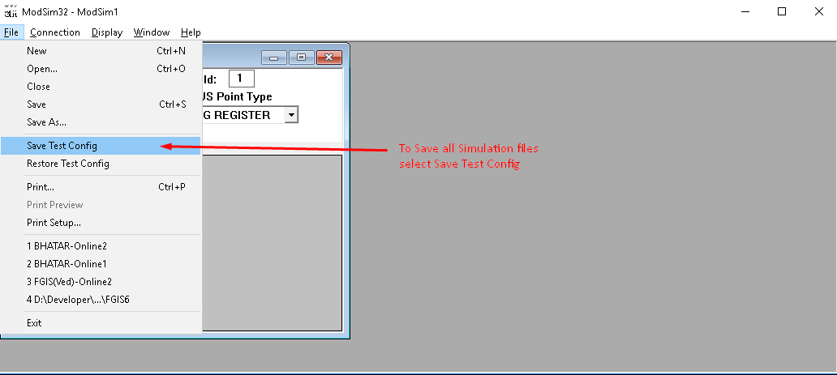

* Give File name and remember one thing that don’t remove extension of file.

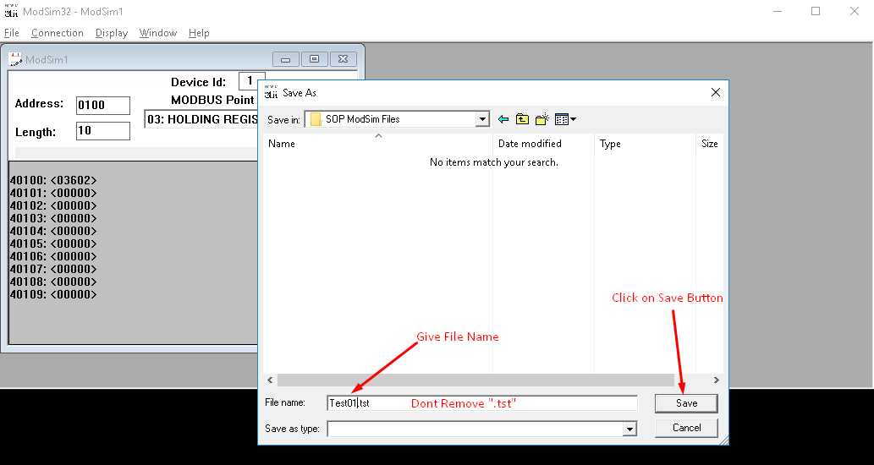

* To restore your saved file go to file menu and select Restore Test Config. And select your file and click on open button.

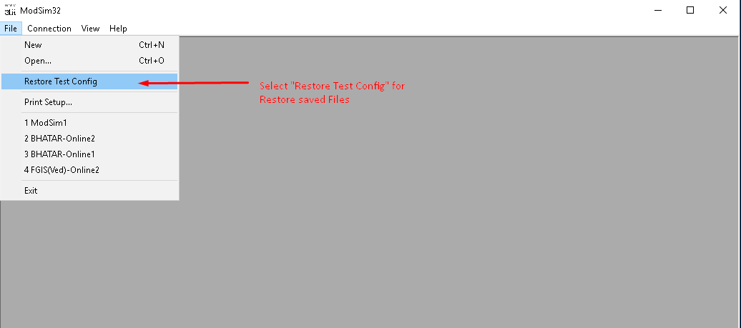

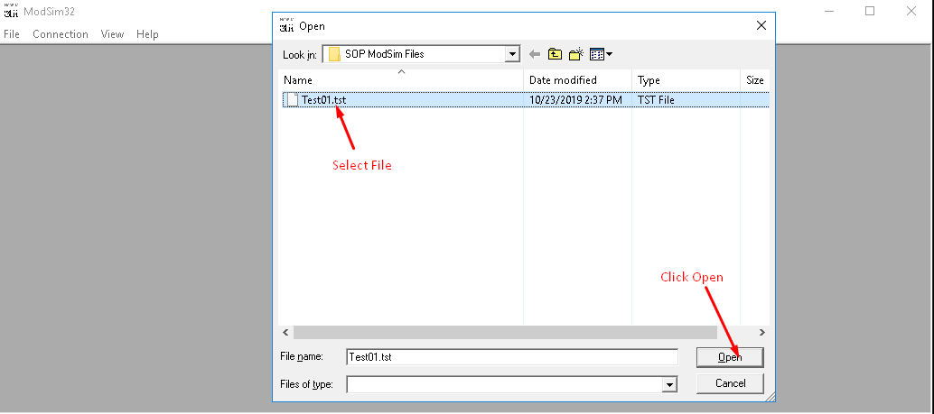

* To Disconnect ModSim go to connection menu and select disconnect and after that select your port.

