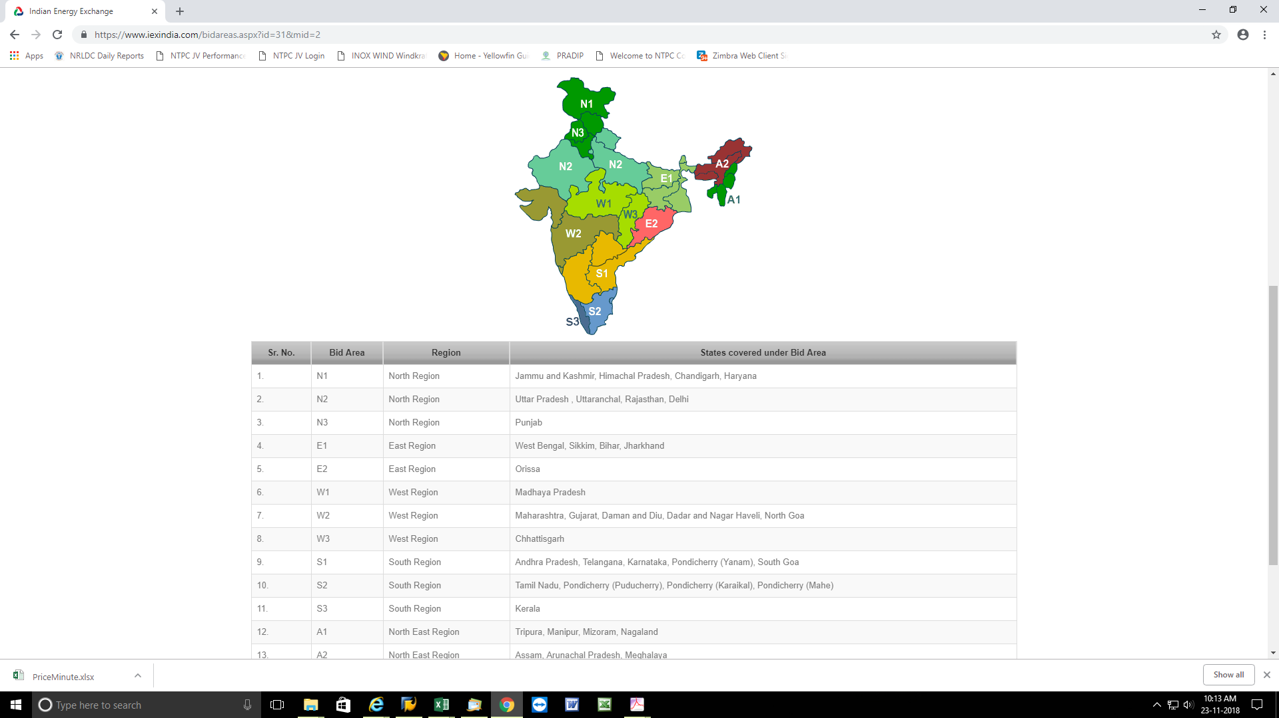

Station may please see the area in which station is located as per IEX exchange area accordingly daily average ACP may be taken for next days calculation for determining the next days DSM rate at 50.00 Hz freq.

IEX Web Site Address :
https://www.iexindia.com/marketdata/areaprice.aspx

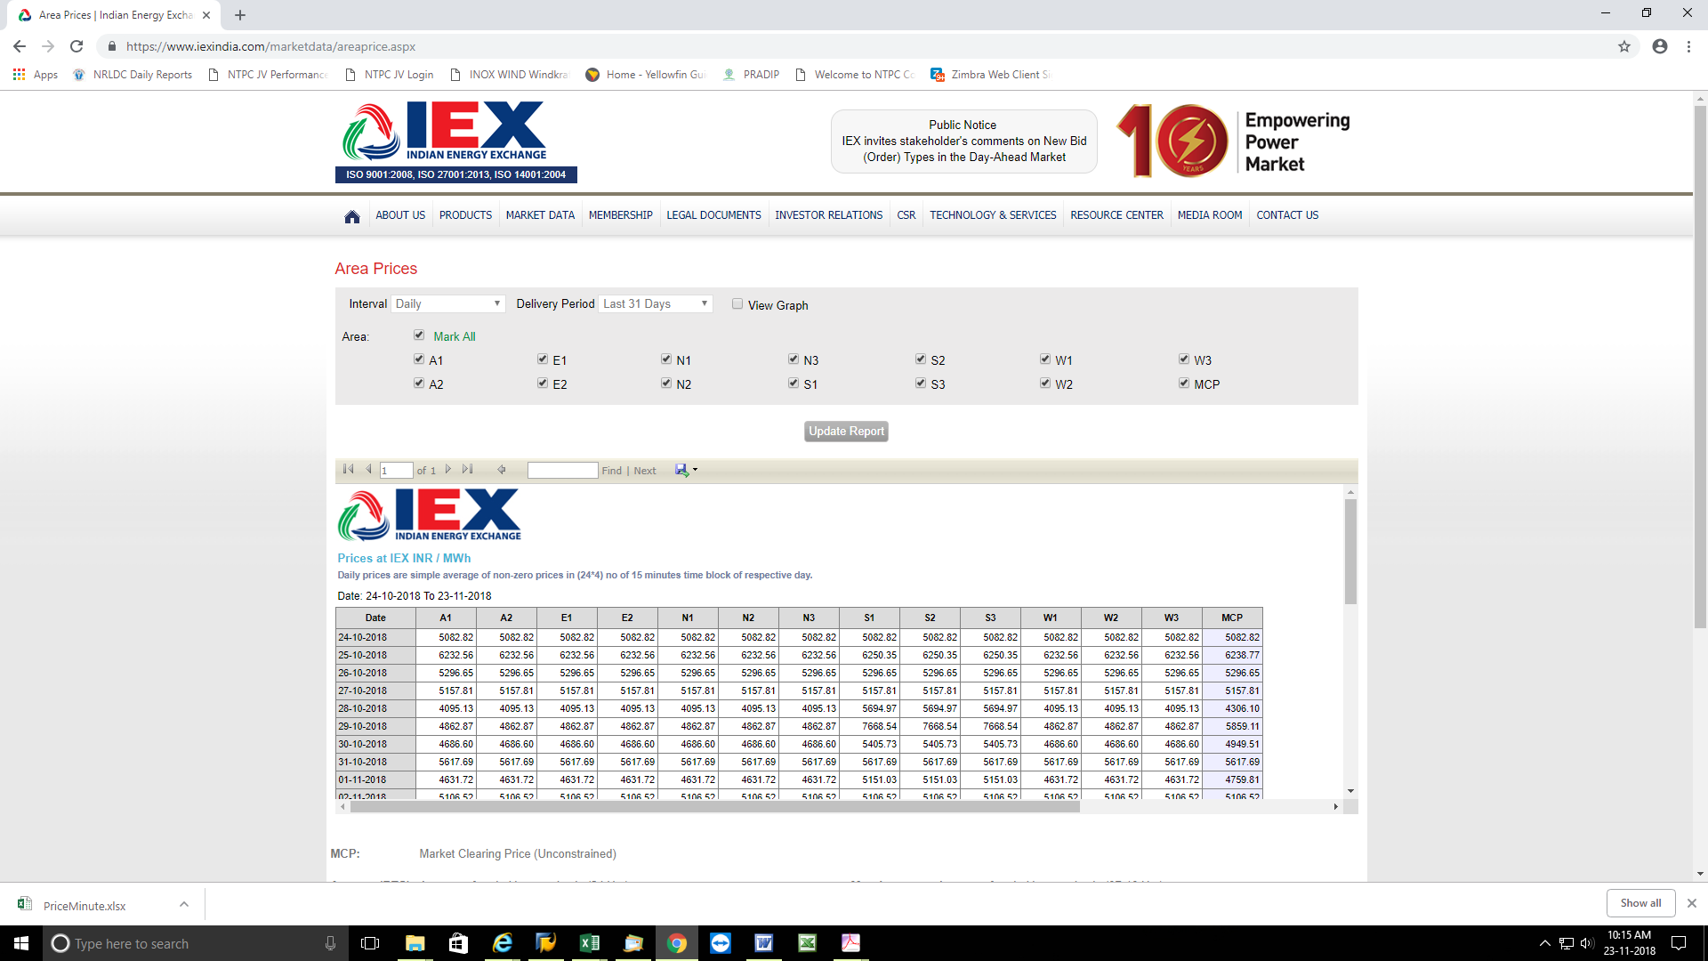

Day Ahead Market (DAM) price will be published at Power Exchange web site at 05:00 PM. Same may be taken for next days DSM rate at 50.00 Hz freq.

