SOP For ModScan

Rohit Soni

Rohit.soni@ssminfotech.com

SOP For ModScan

* How to Configure ModScan
* First Start ModSim Application

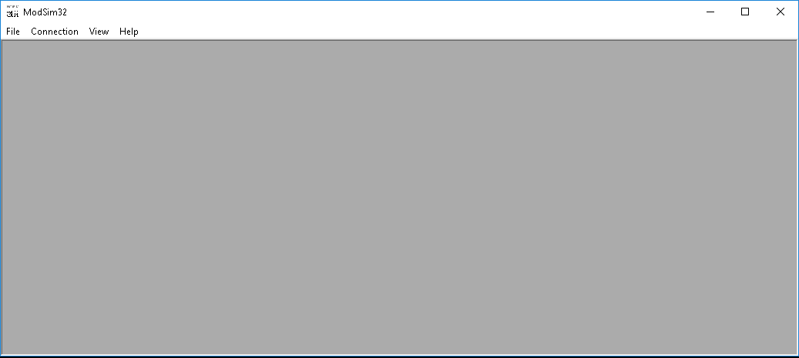

* Then Go to File Menu and Click on New or Press (ctrl + N).

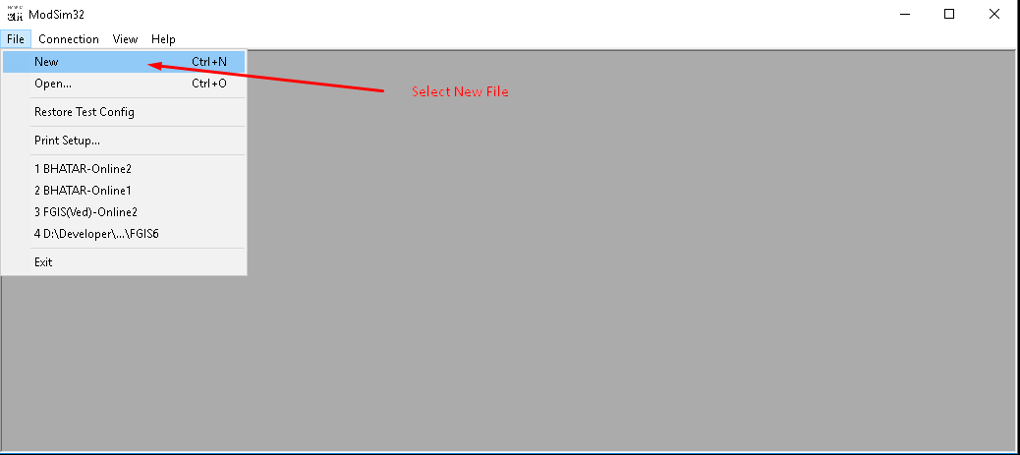

* After click on new File open a file in ModSim application

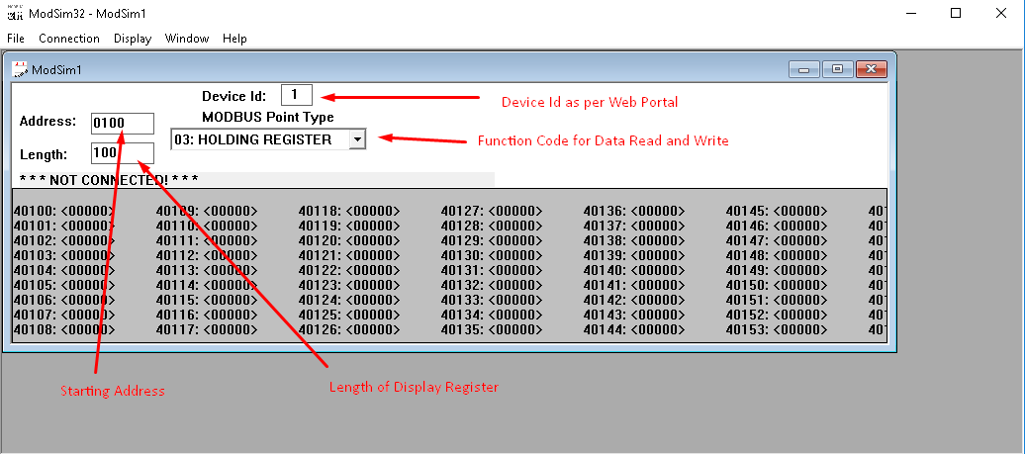

* Configure the following parameters:
  + Address
  + Length
  + Device ID
  + MODBUS Point Type

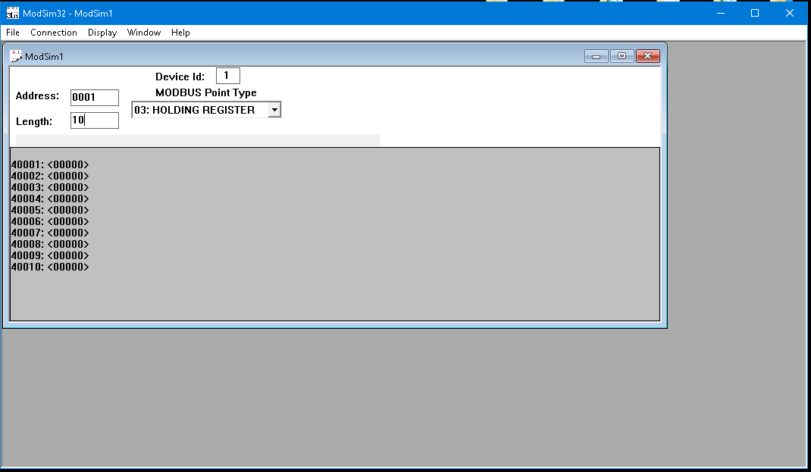

* Then go to Connection->Connect->Modbus/TCP Svr

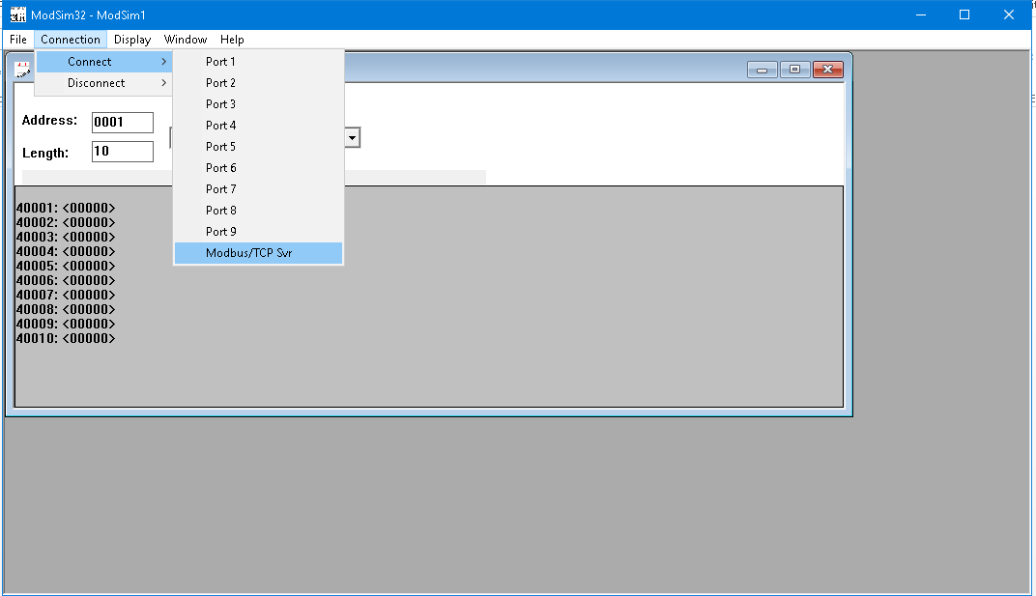

* If you’re not receiving any error message that means connection established successfully.
* After configuring Modsim open the ModScan.

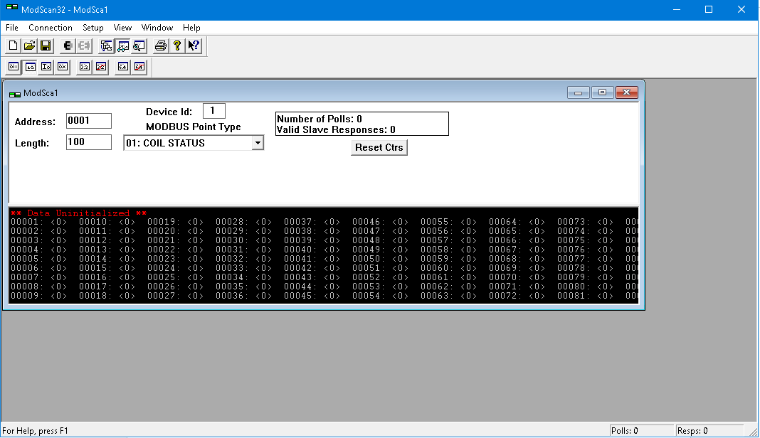

* Configure Parameters according to ModSim.

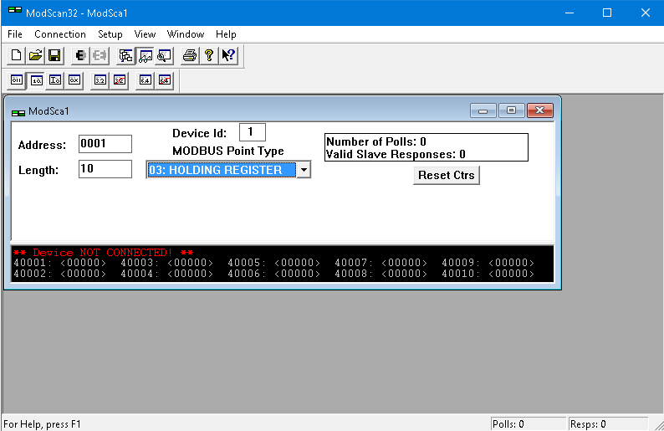

* Then go to Connection->Connect same as connected ModSim.

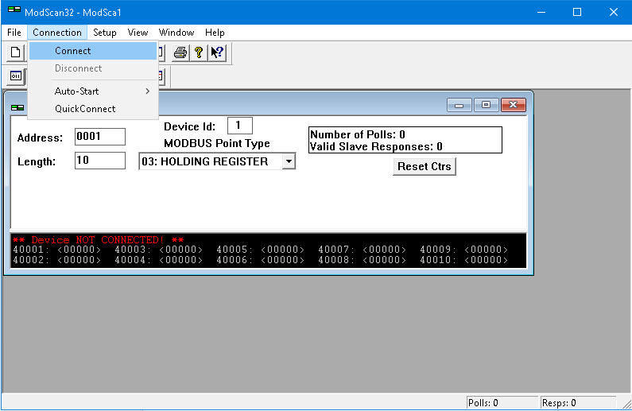

* To Connect TCP server following dialog box will appear and select IP and Port and press on OK.

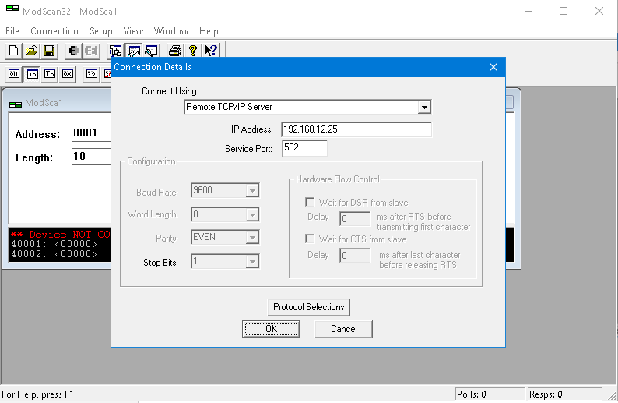

* If you’re stopped receiving error message that means you’re connected with meter.
* Then perform change in any one reflected on another.

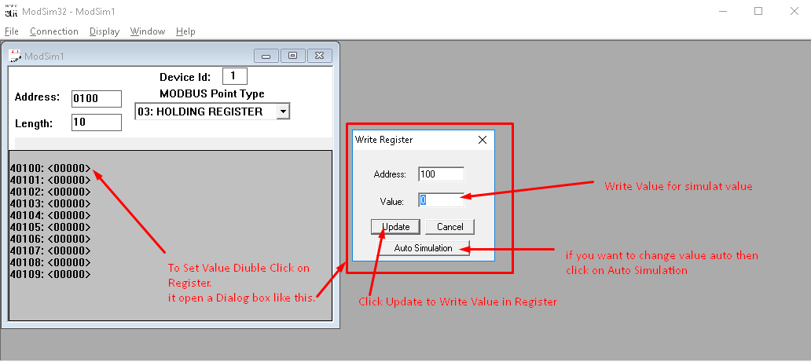

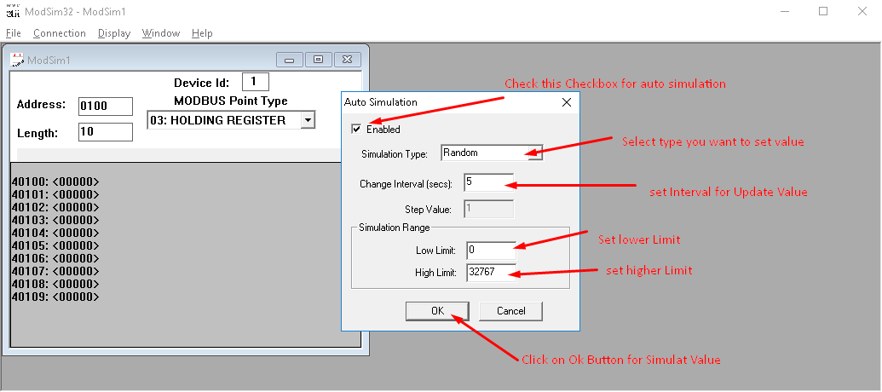

* After that auto simulated value display on register.

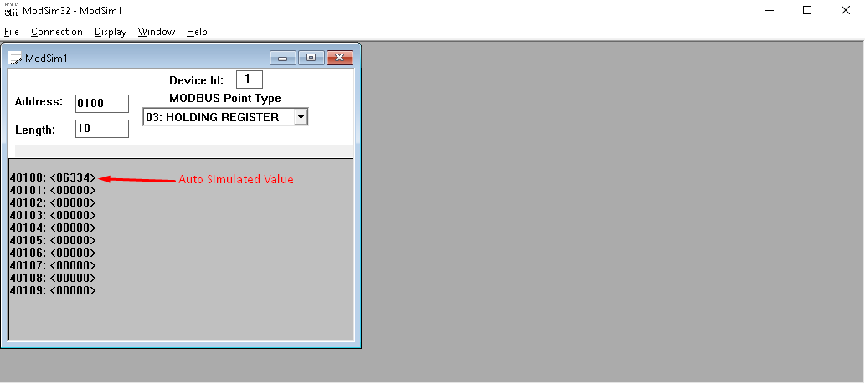

* The Changes reflected in ModScan.

