SOP For

OPC-DA

Test Client

Dhruv Savaj

Dhruv.savaj@ssminfotech.com

SOP For OPC-DA Test Client

* How Configure OPC-DA server Test Client
  + Open OPC-DA Test Client

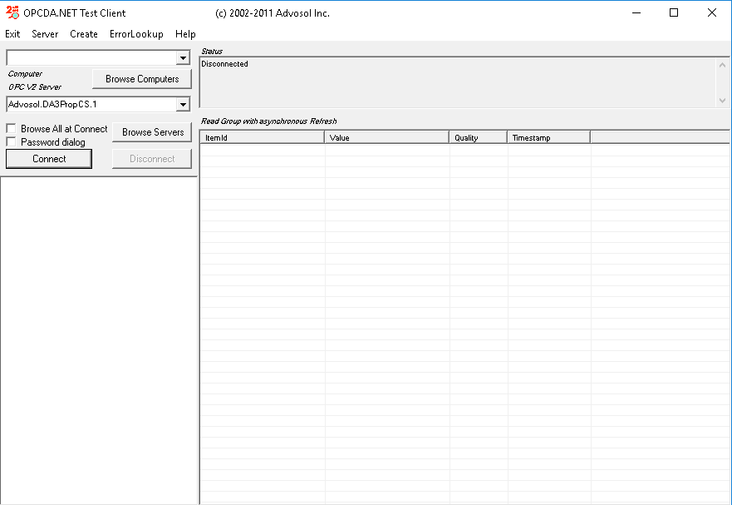

* + After that Click on Browse Computer. It will all Available browse OPC-DA Server.

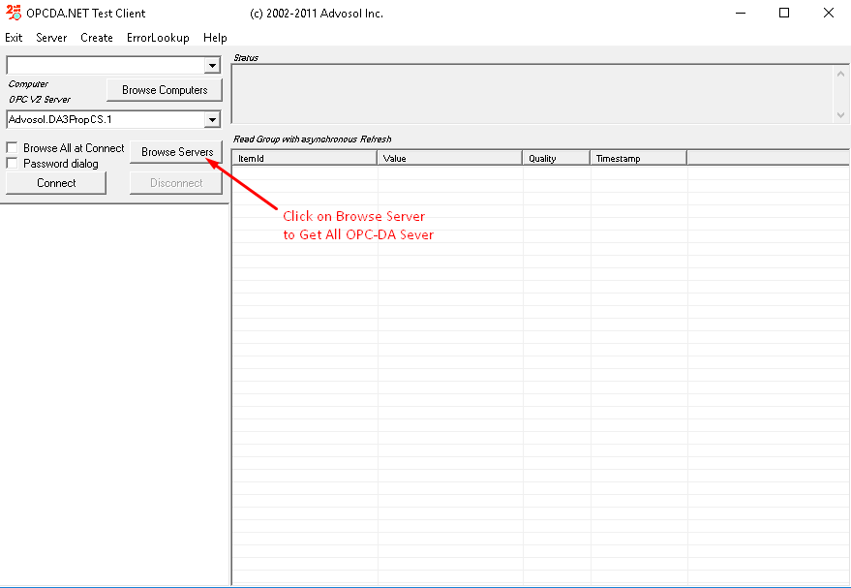

* + Select Your OPC-DA Server and click on Connect button.

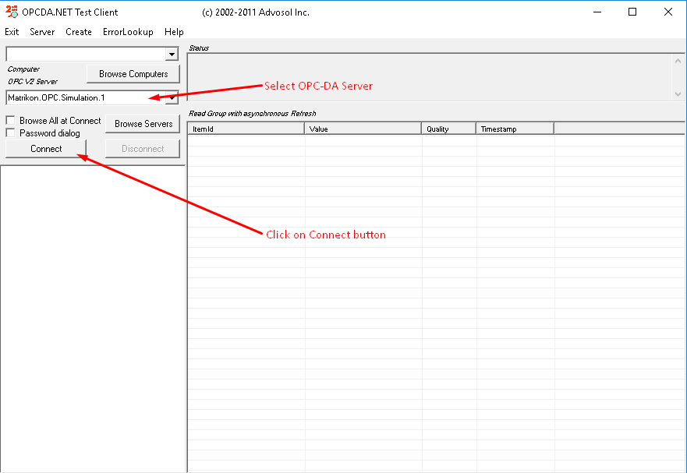

* + If connection was success then it list some items. Double click on configured aliases.

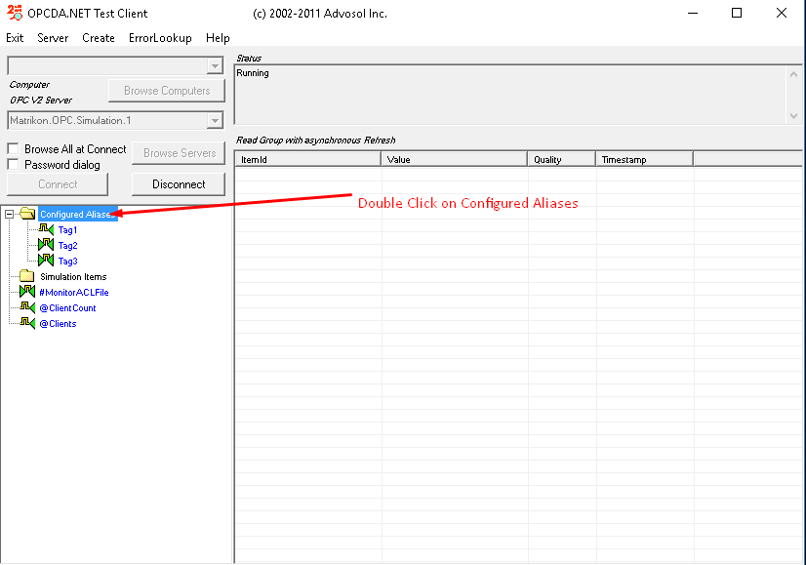

* + Click on listed Tag, after that open a dialog in which you can perform various operation like read value, write value, etc.
  + To add tag in refresh group click on add to refresh group button and then ok button.

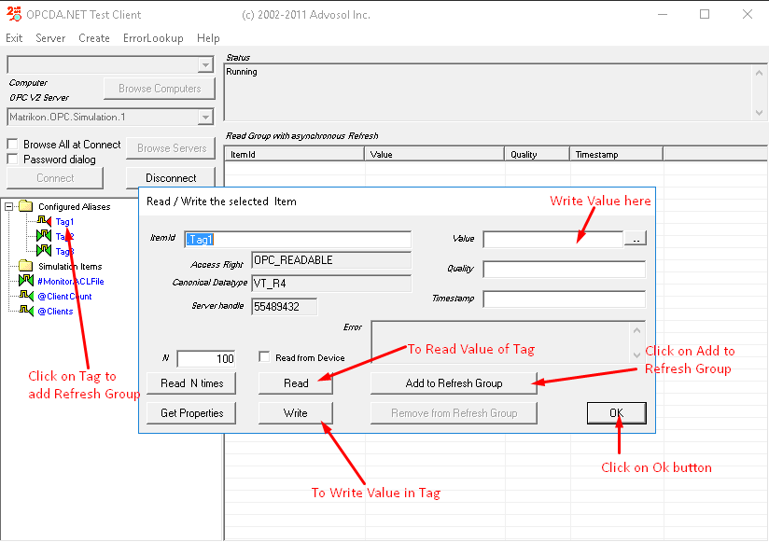

* + After adding tag on refresh you can see live value in refresh group.

