**User Manual for Modbus Utility**

Operation Manual

Prepared By: Santvijay Sahani

2019

SSM INFOTECH SOLUTION PVT. LTD.

Contents

1. Modbus Utility 2

1. Modbus Utility :

Modbus utility will collect all the data from energy meter same as Modscan. Modbus utility is display parameter value with all mapping style. so we can directly find that which mapping style parameter value is coming perfect.



* Double click on that application.

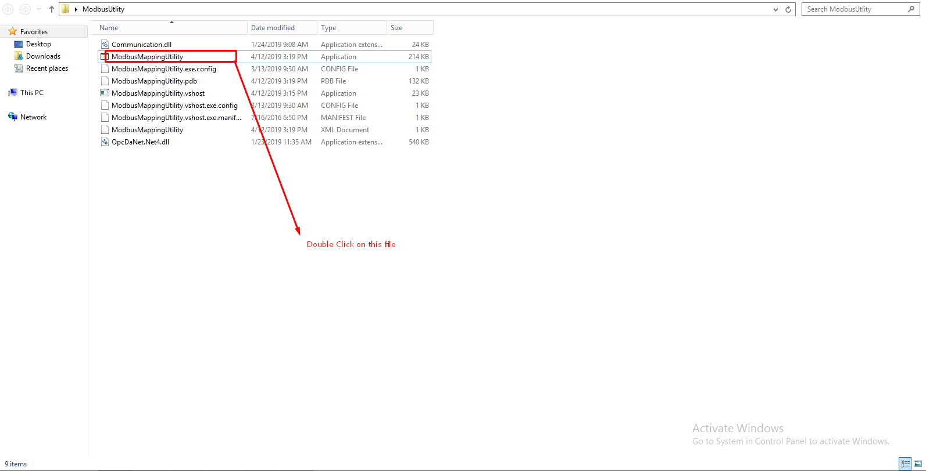

* Below window will get open.

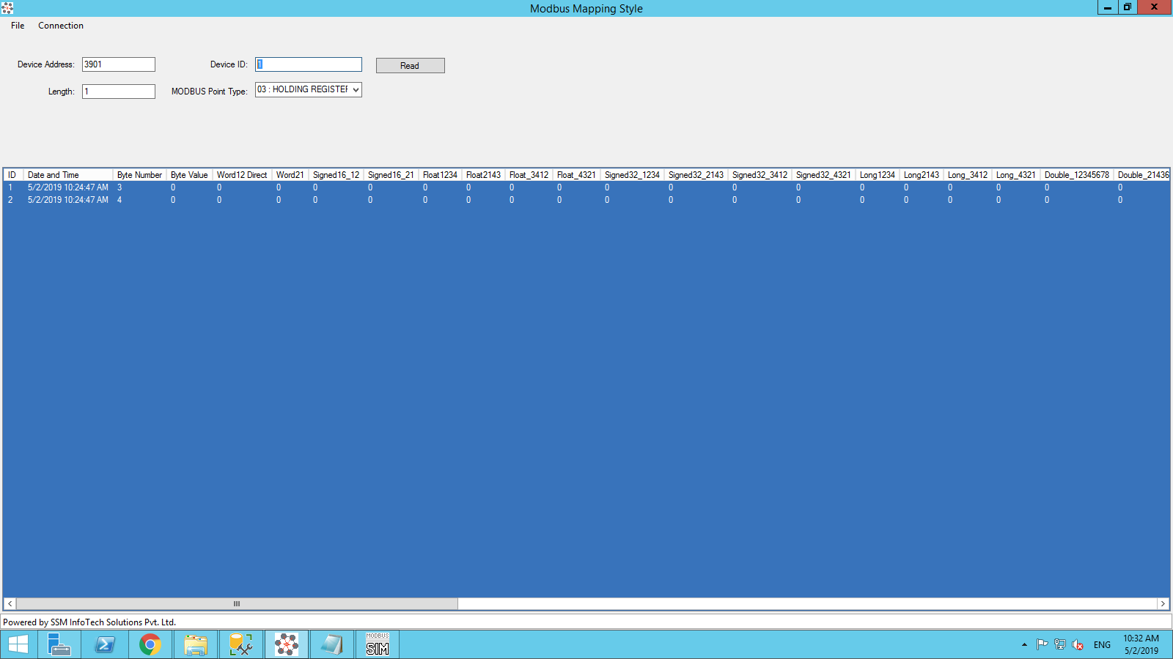

* Now, click on the connection-->Connect

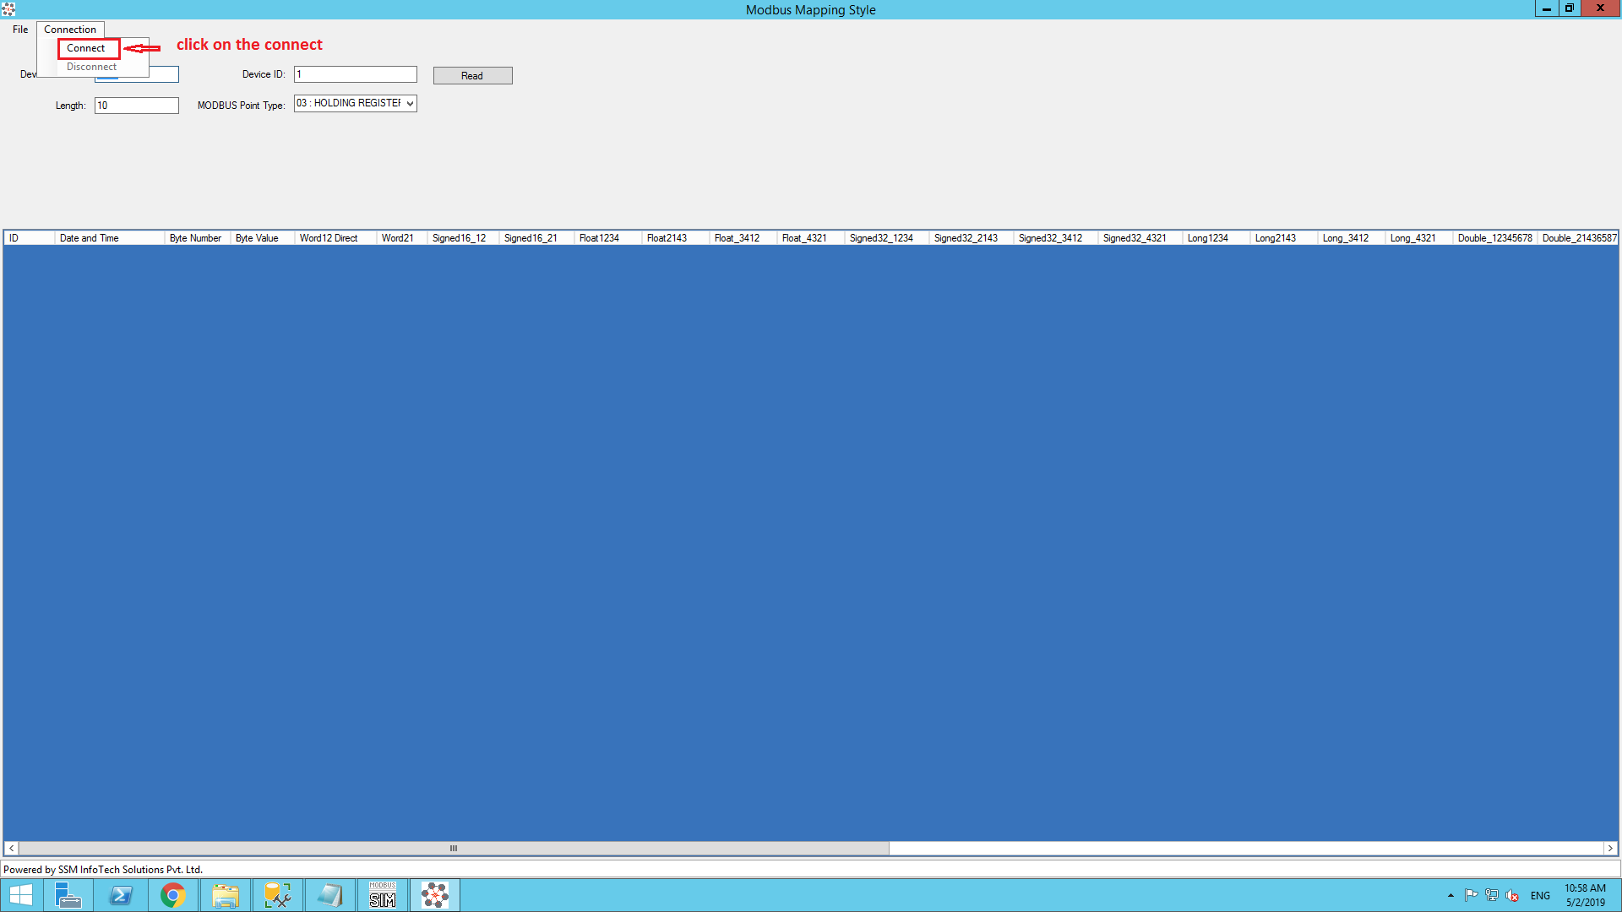

* Please select connection type as per your requirement i.e. Serial or TCP

1.1. Serial :

If you are selecting serial as a connection, it will show below window where certain details are required like Serial Port ,Baud Rate ,DataBits ,Parity and Stop bits. These parameters should same as setup in energy meter.

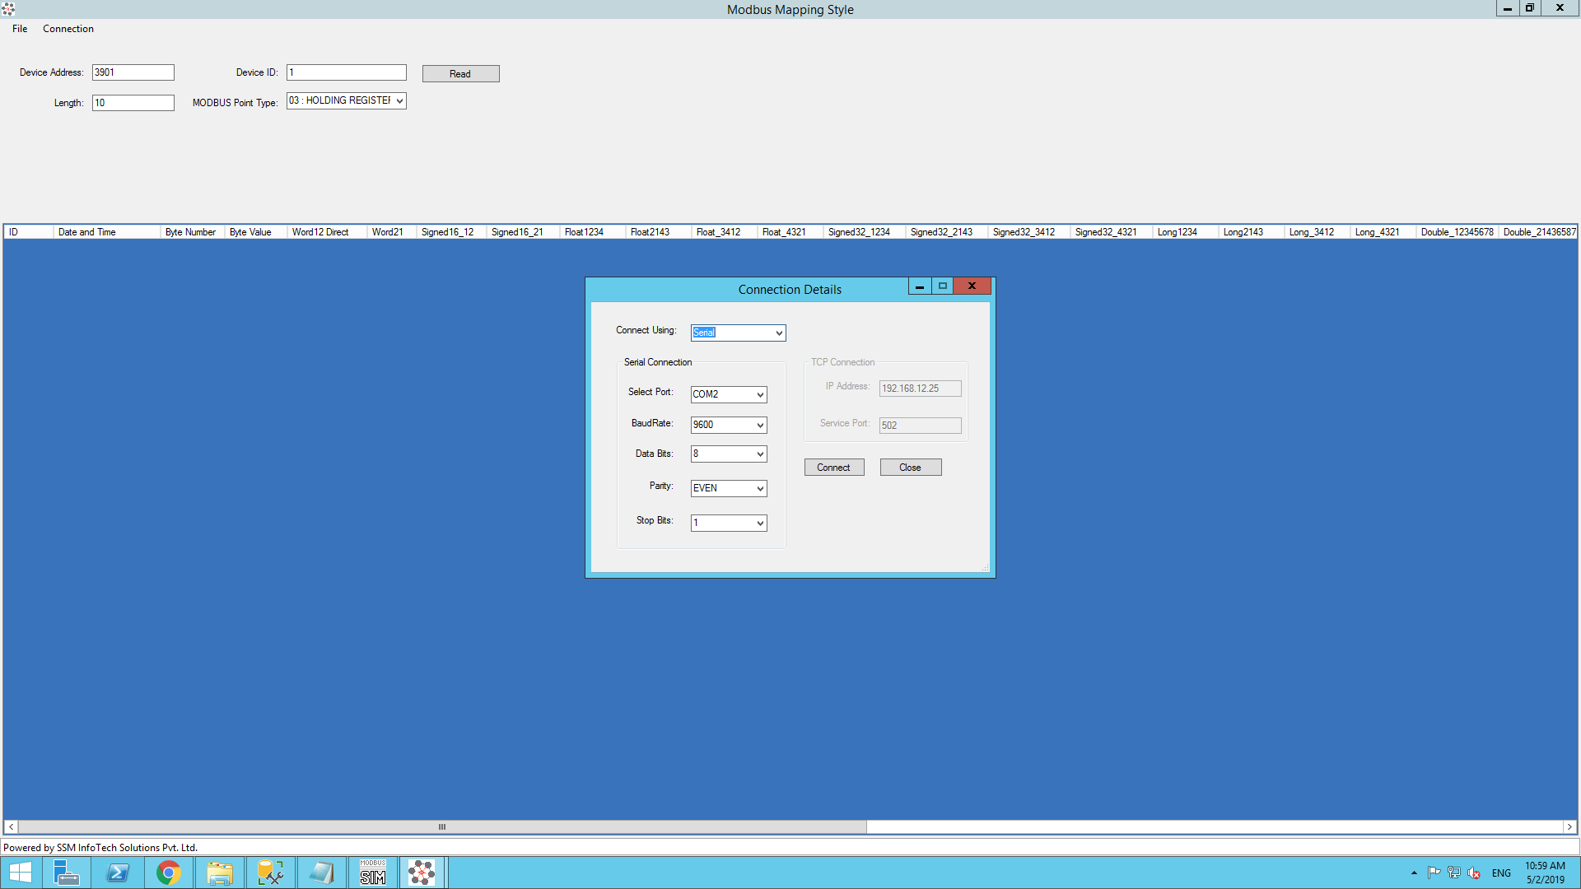

* After fill All the Required Fields Click on the Connect button. so you are going to see message "Serial port connection Open" then click on ok.

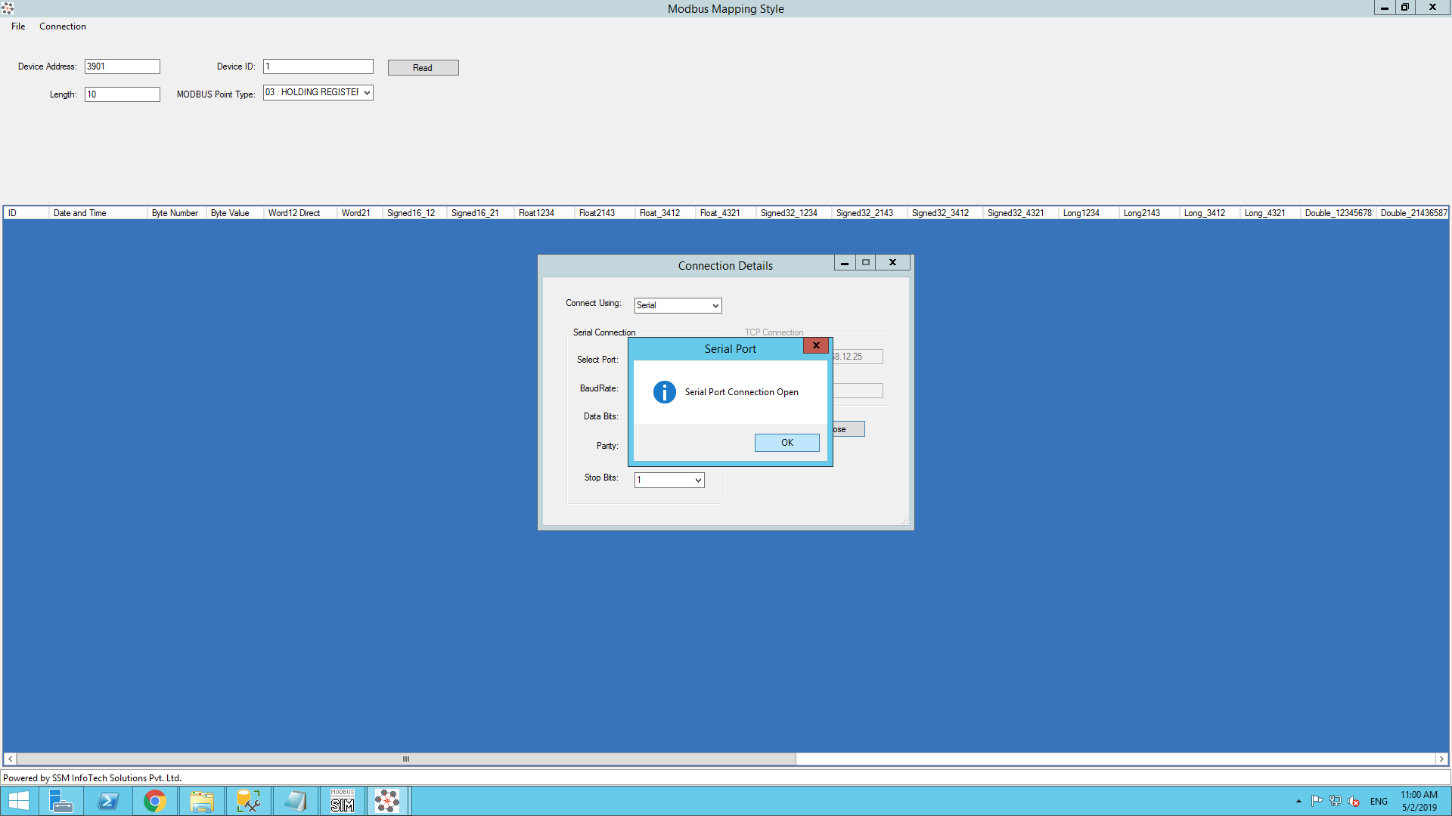

* Now you should enter the Device Starting Address , Device ID ,Length ,Modbus Point type. Then Click on the Read Button so you can see the all mapping style values.

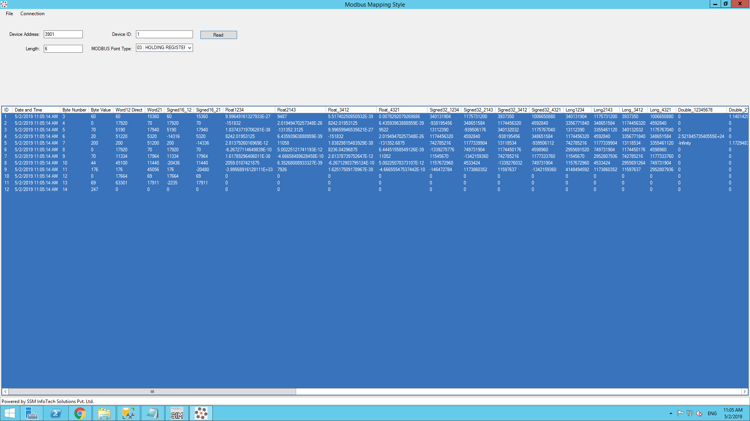

* You can verify values which mapping style value matches with Energy meter value. So it will save your time to identify mapping style and correct value of parameter fetched from energy meter.

1.1. TCP :

* In case of selecting TCP as connection type, Then below screen will get populated where certain details are required like IP Address and Serial Port. These parameters should same as setup in energy meter.

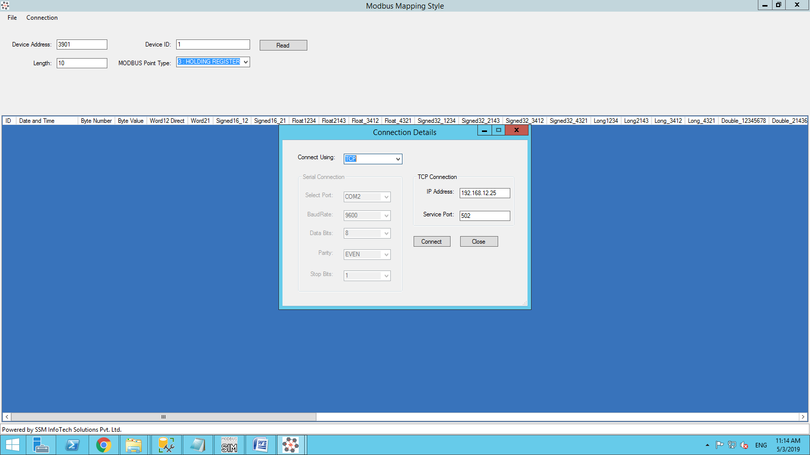

* After fill All the Required Fields Click on the Connect button. so you are going to see message "TCP connection Open" then click on ok.

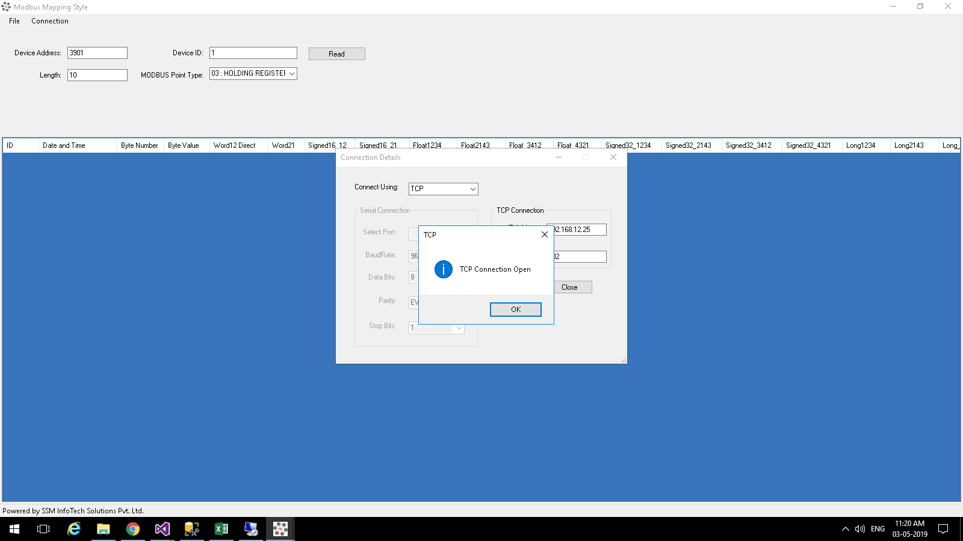

* Now you should enter the Device Starting Address , Device ID ,Length ,Modbus Point type. Then Click on the Read Button so you can see the all mapping style values.



* You can verify values which mapping style value matches with Energy meter value. So it will save your time to identify mapping style and correct value of parameter fetched from energy meter.