**Backup and Restoring Standalone application**

1. **Backup of the Stand-alone application**

We can take Backup of the standalone application by coping the in touch application folder and path of the application can be retrieved in the application manger.

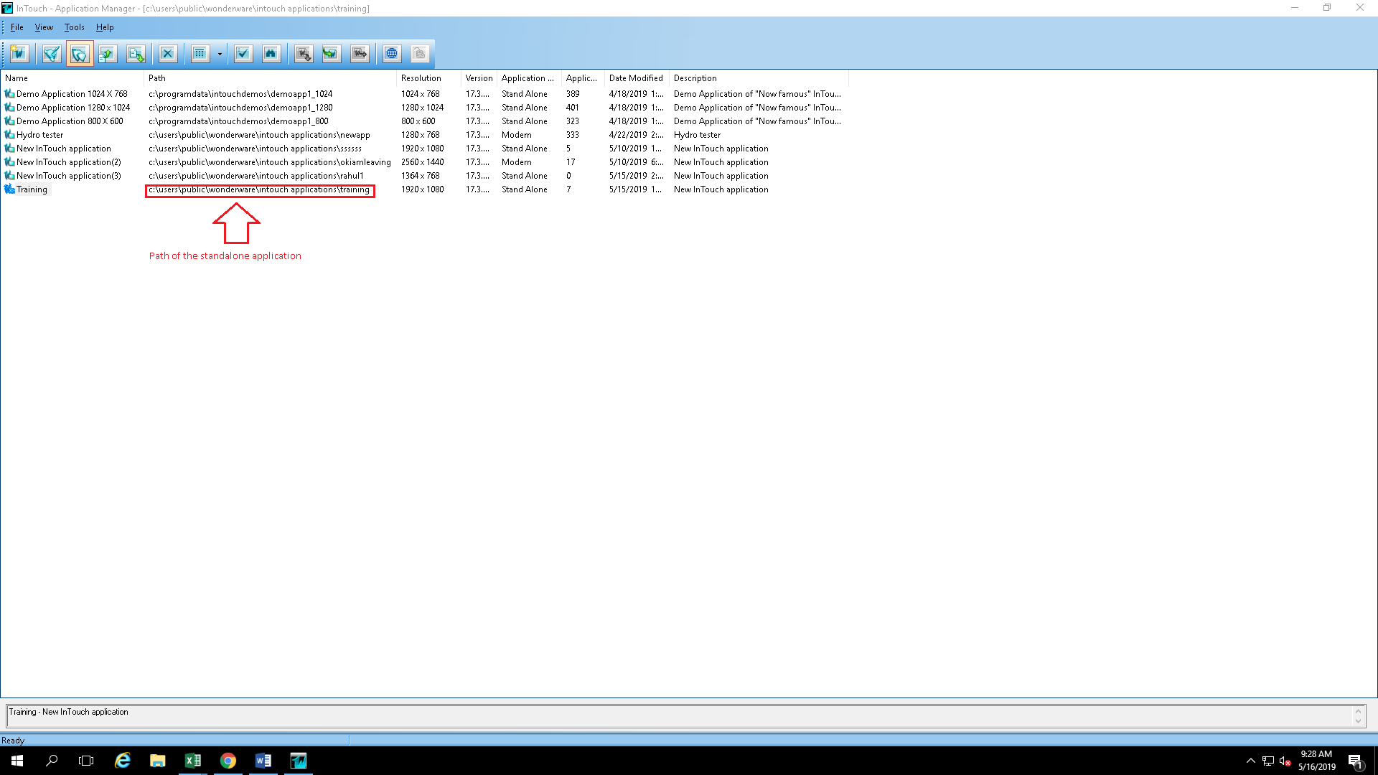

Or we can know that location of the application folder by right clicking and going to properties

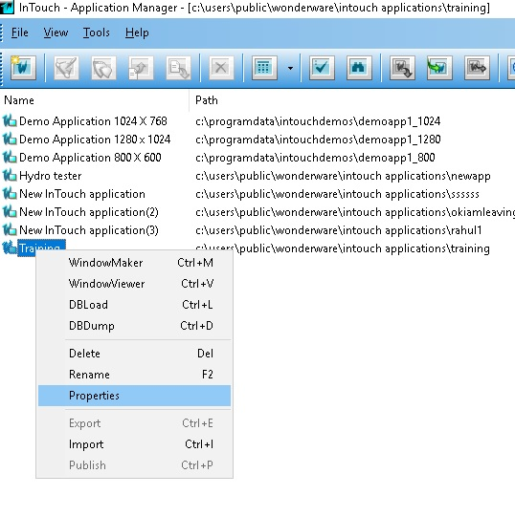

Note: Default location for application directory is C:\Users\Public\Wonderware\Intouch Applications

1. **Restoring standalone application**
2. Open application manager and go to find option

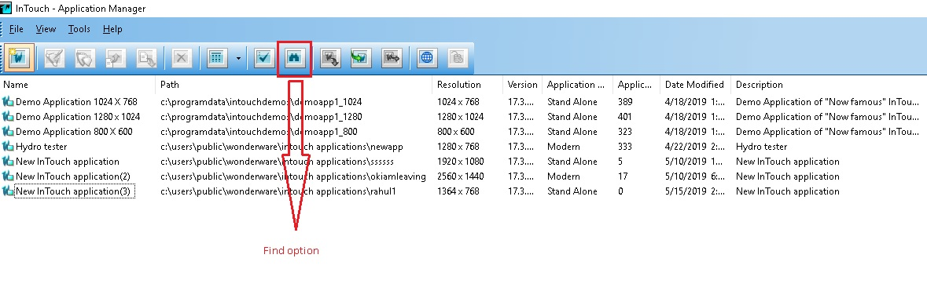

1. Click on find option and select application directory

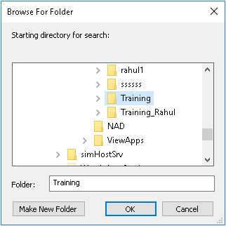

Note: Deleting standalone application from application manager will delete only shortcut in application manager which can be restored by finding that application.

Deleting Modern Application from the application manager will delete shortcut from application manger and delete SQL Database if we don’t have Backup of modern application we cannot restore it.