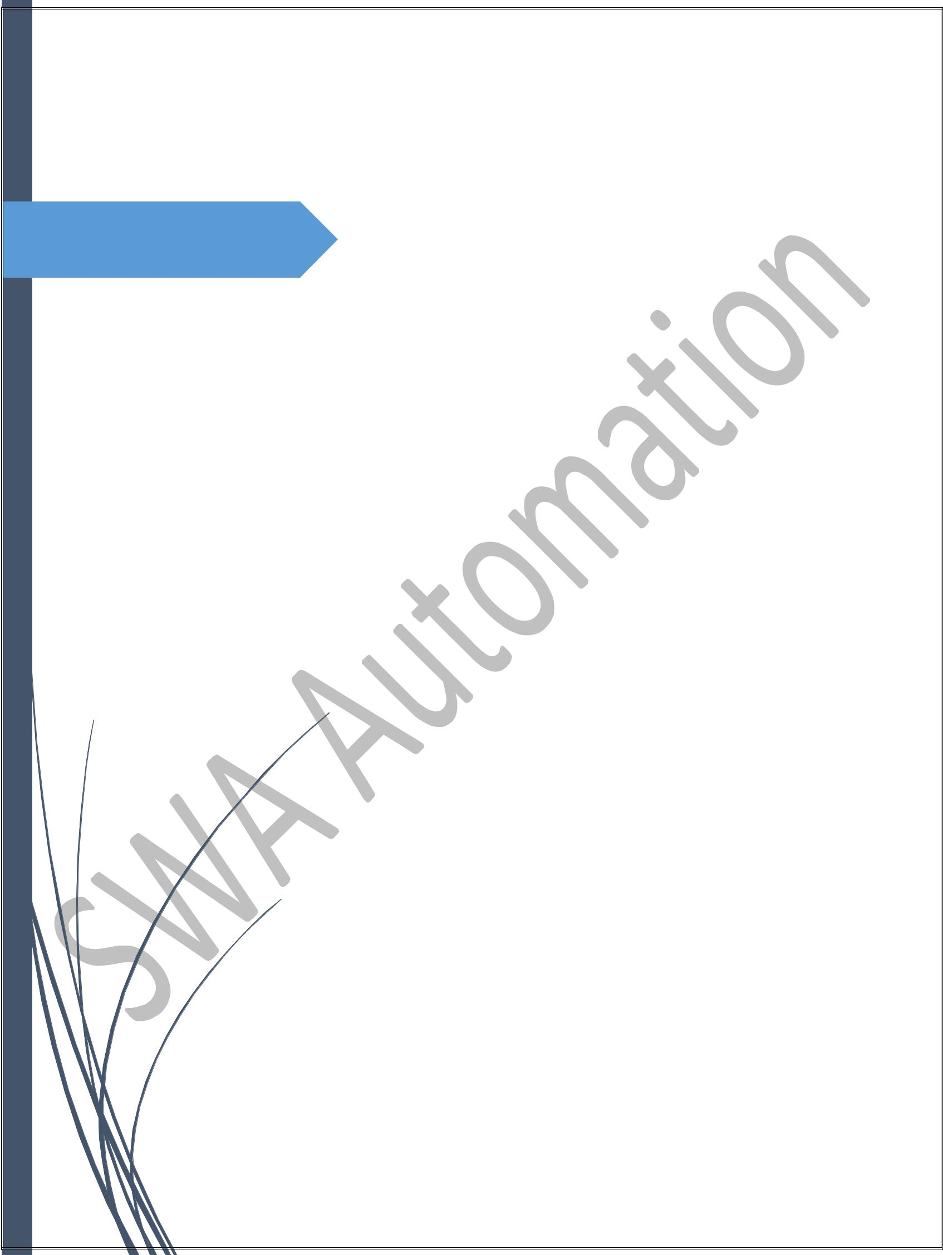

Maestro GPRS Modem and ADAM Module Configuration for Wireless Data Communication using Static IP Sim Cards

SWA AUTOMATION PVT. LTD.

C-501, PRESIDENT PLAZA,

NR. R.T.O. RING ROAD,

SURAT, GUJARAT, INDIA – 395001

**1**

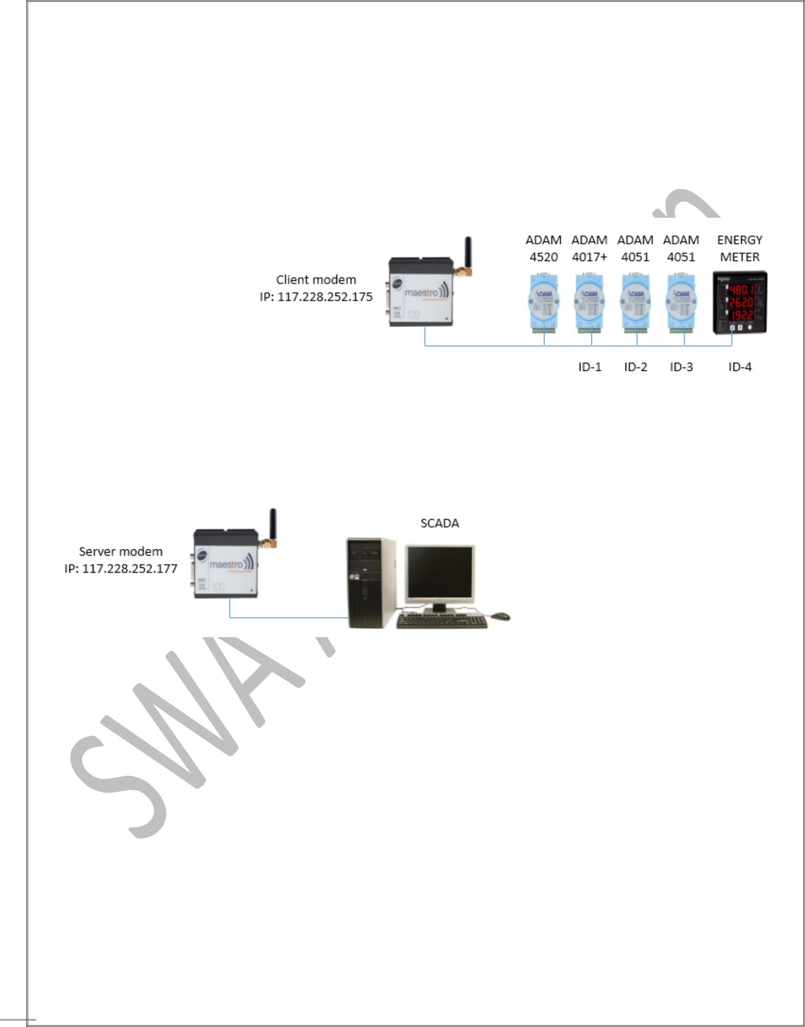

* SYSTEM ARCHITECTURE

1



**2**

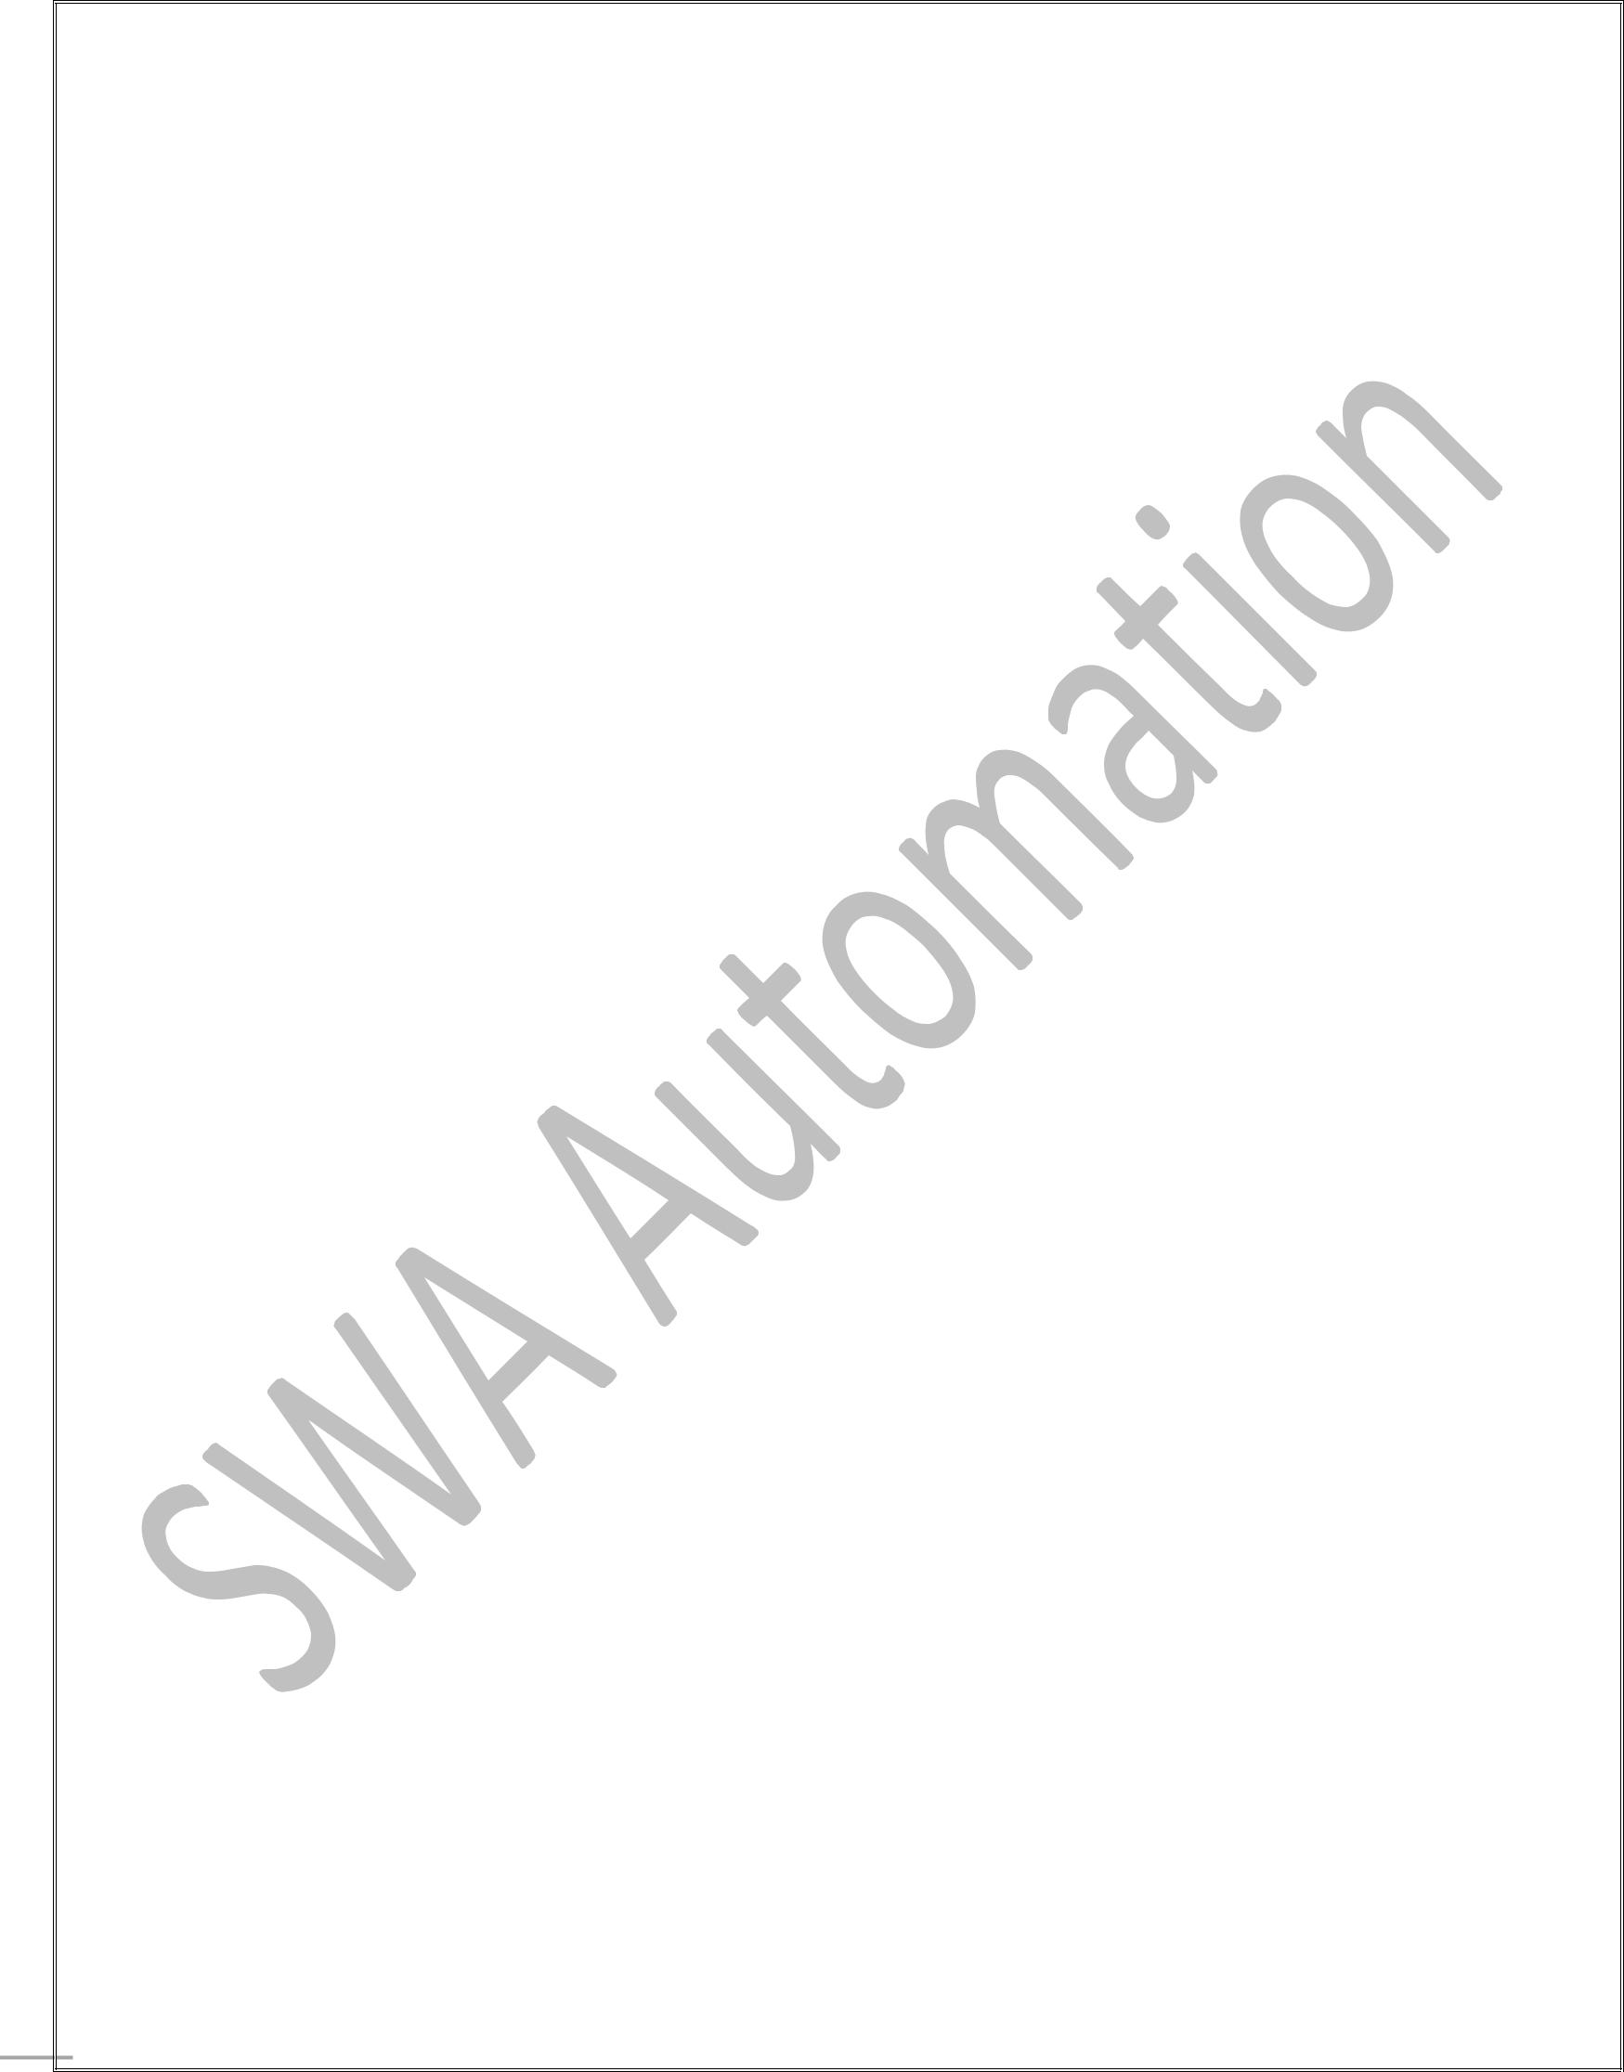

* GPRS Modem and ADAM Module Configuration for Wireless Data Communication
* Require Instruments
  1. Maestro Modem
  2. ADAM Module 4520 / RS232 to RS485 Converter
  3. ADAM Module 4017+ / Analog Signal
  4. ADAM Module 4051 / Digital Input
* Require Softwares For Communication
  1. Maestro Configuration Software
  2. Advantech Adam.NET Utility
* We Have Two GPRS Modems. In this two modems one will act as a server and other will be client.
* For starting communication or troubleshooting modem communication first ensure that your both sim

card having Internet Connection and STATIC IP at server modem.

* Now we have to set configuration data of GPRS Modem with the use of Maestro Configuration Software.

2



**3**

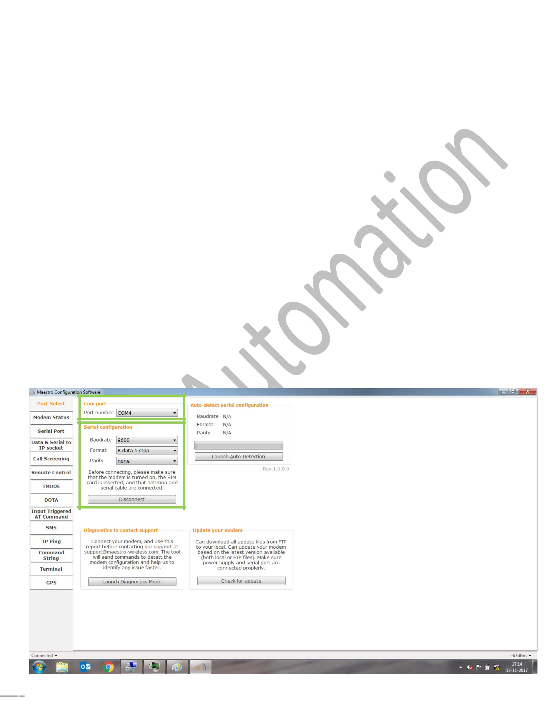

Maestro M100 3G Setup Procedure

As a Server

* Install Maestro Configuration Software
* Please start Setup.exe and follow below instruction.
* Port Select
  1. **Com Port** : Select the Correct COM Port to Use. Selected COM Port Will Be Saved AfterConnection.
  2. **Serial Configuration** : Select the Correct Setting for Serial.

**Baud Rate** : 9600

**Formate** : 8 data 1 stop

**Parity** : None

* 1. After Setting this Configuration Connect Modem. Once Modem is connected then Switch to Modem Status.

3



**4**

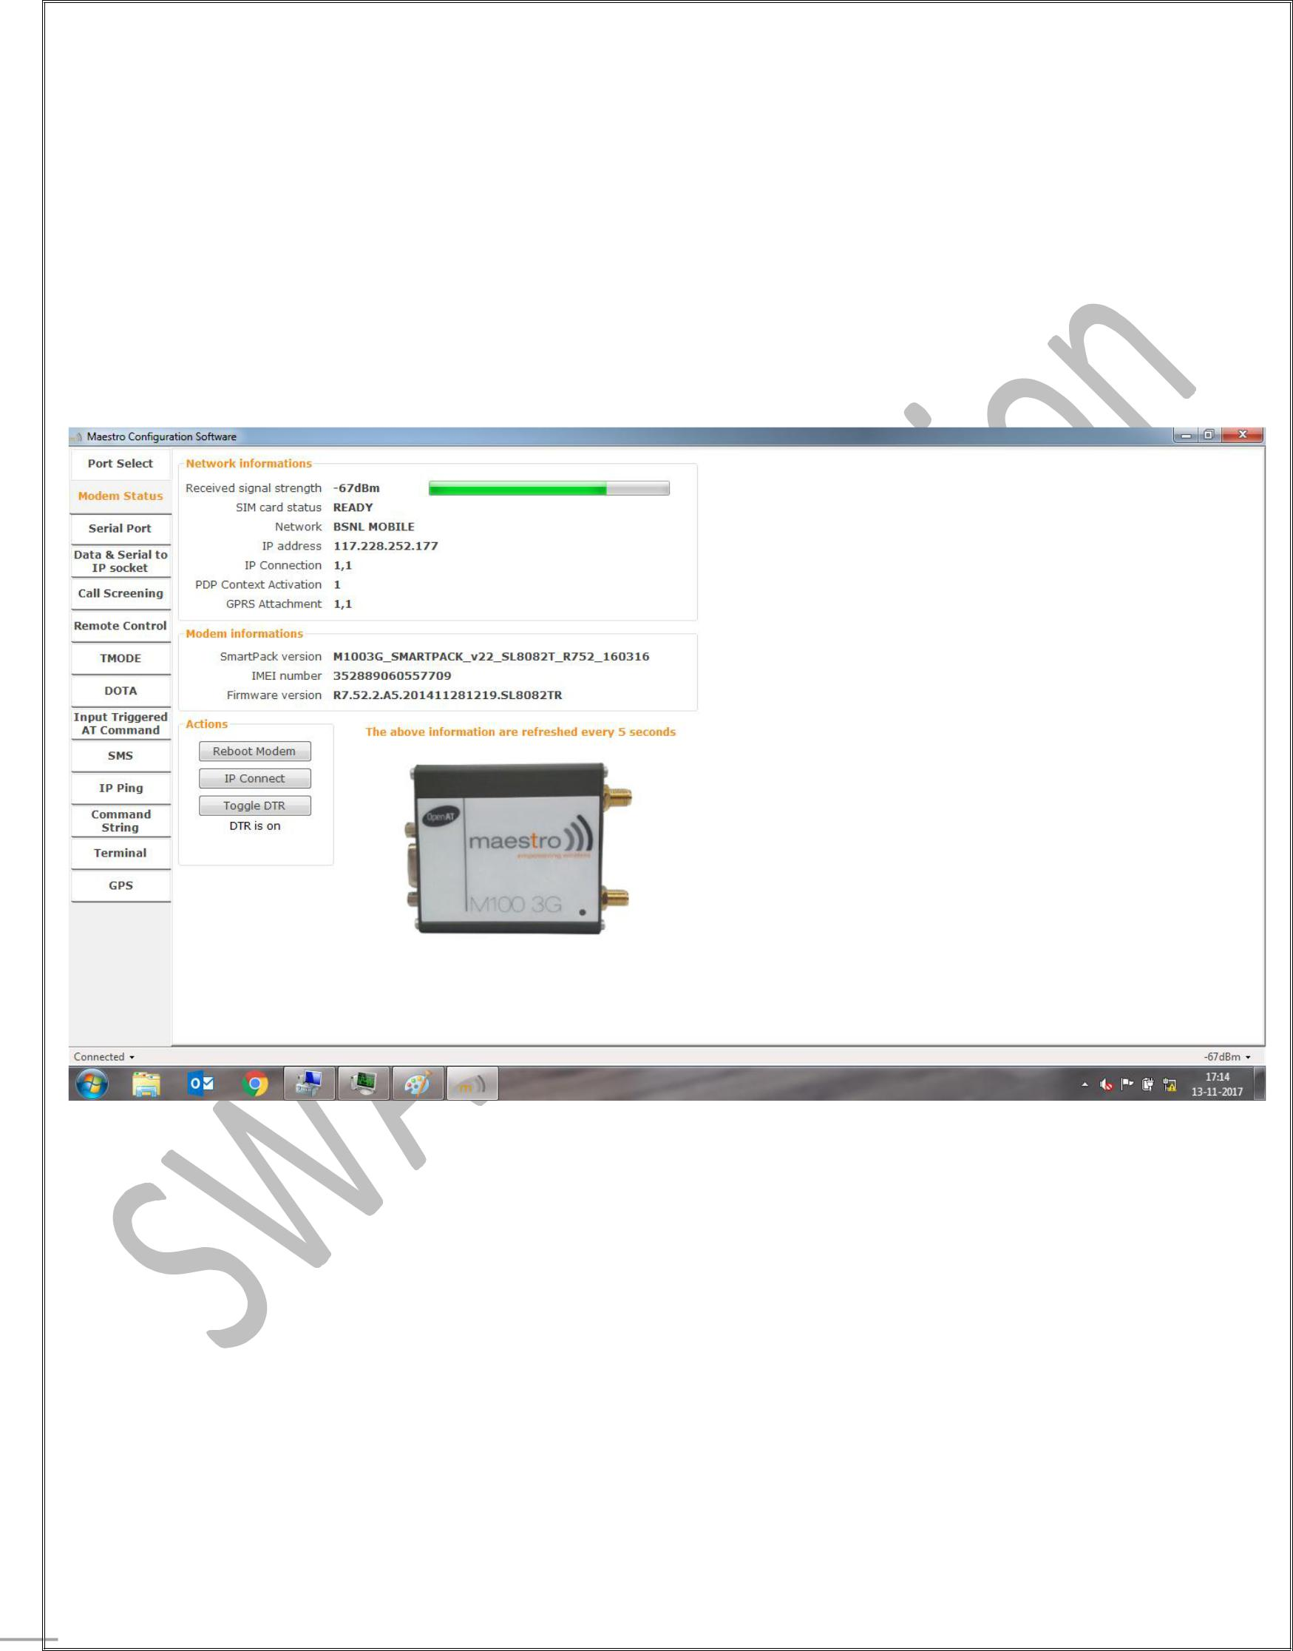

* Modem Status :

1. **Network Information :** It Shows the Received Signal Strength, SIM Card Status, SIM Card Name.You can see the IP address and IP Connection in below image. If IP address is displays and IP Connection=1,1 then It Means your Modem is Connected with internet.
2. **Actions :** If IP is not display then you can press either IP Connect Button or Reboot Modem forRefresh.

4



**5**

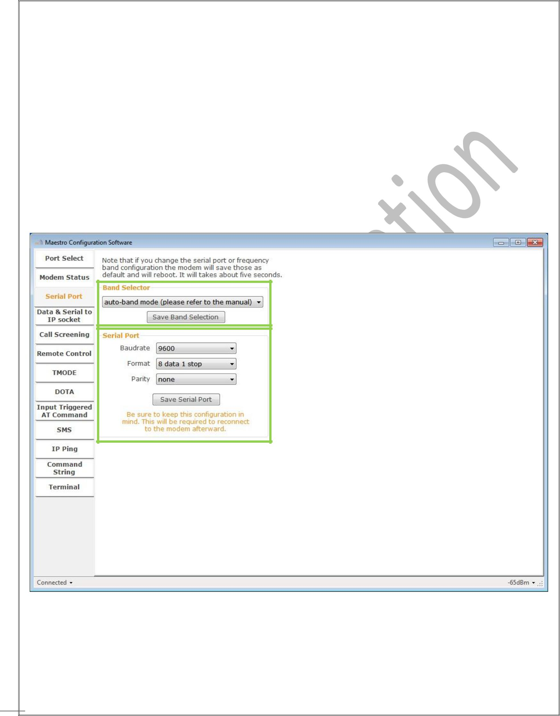

* Serial Port :

1. **Band Selector :** Select “auto-band Mode” and Save Band Selection.
2. **Serial Port :** Select the Correct Setting for Serial.

**Baud Rate** : 9600

**Formate** : 8 data 1 stop

**Parity** : None

* Save Serial Port Settings.

5



**6**

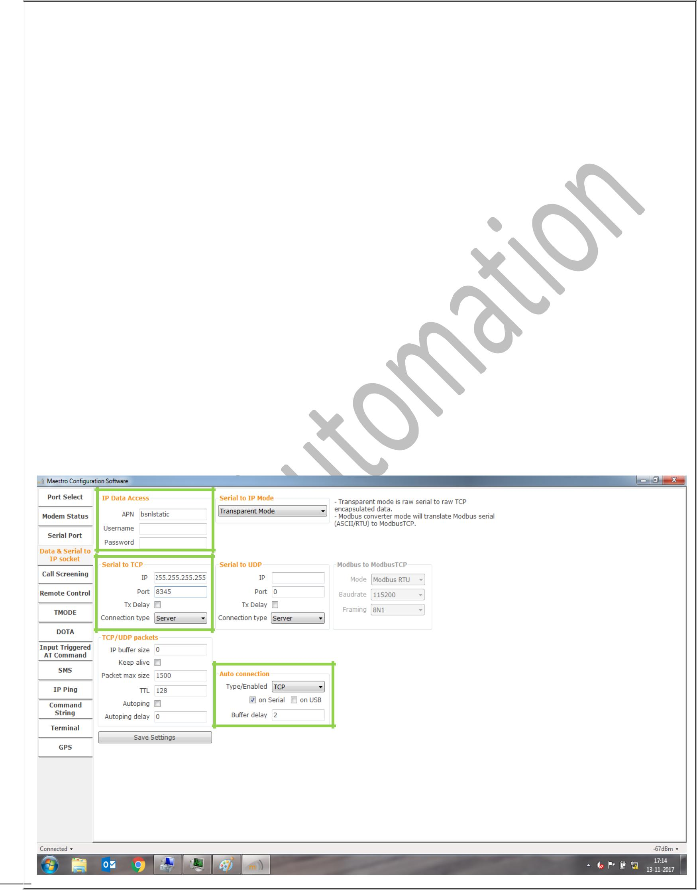

* Data & Serial to IP Socket :

1. **Data Access :** Fill the APN of BSNL which you used in Modem.
   * **BSNL :** bsnlstatic ( for static IP)
2. **Serial to TCP : IP:** 255.255.255.255

**Port :** Define port for communication. At the time of communication port will open when Connection isEstablish.

**Connection Type :** Server

1. **Auto Connection : Type/Enabled :** TCP **Buffer Delay :** 2

* Save upper settings and you can see in below image.

6



**7**

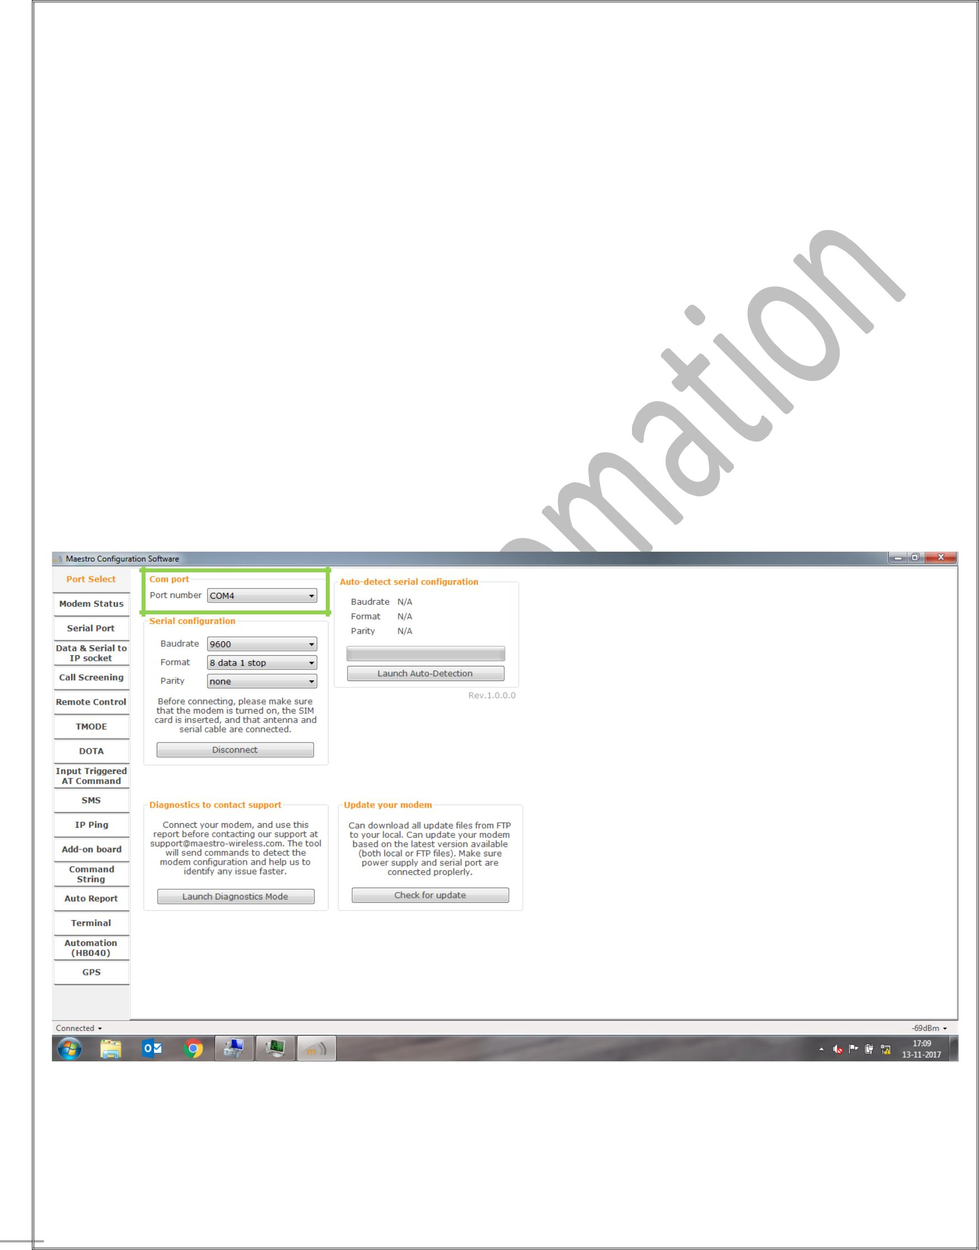

Maestro M100 3G Setup Procedure

As a Client

❖ Port Select

1. **Com Port** : Select the Correct COM Port to Use. Selected COM Port Will Be Saved AfterConnection.
2. **Serial Configuration** : Select the Correct Setting for Serial.

**Baud Rate** : 9600

**Formate** : 8 data 1 stop

**Parity** : None

1. After Set this Configuratin Connect Modem. Once Modem is connected then Switch to Modem Status.

7



**8**

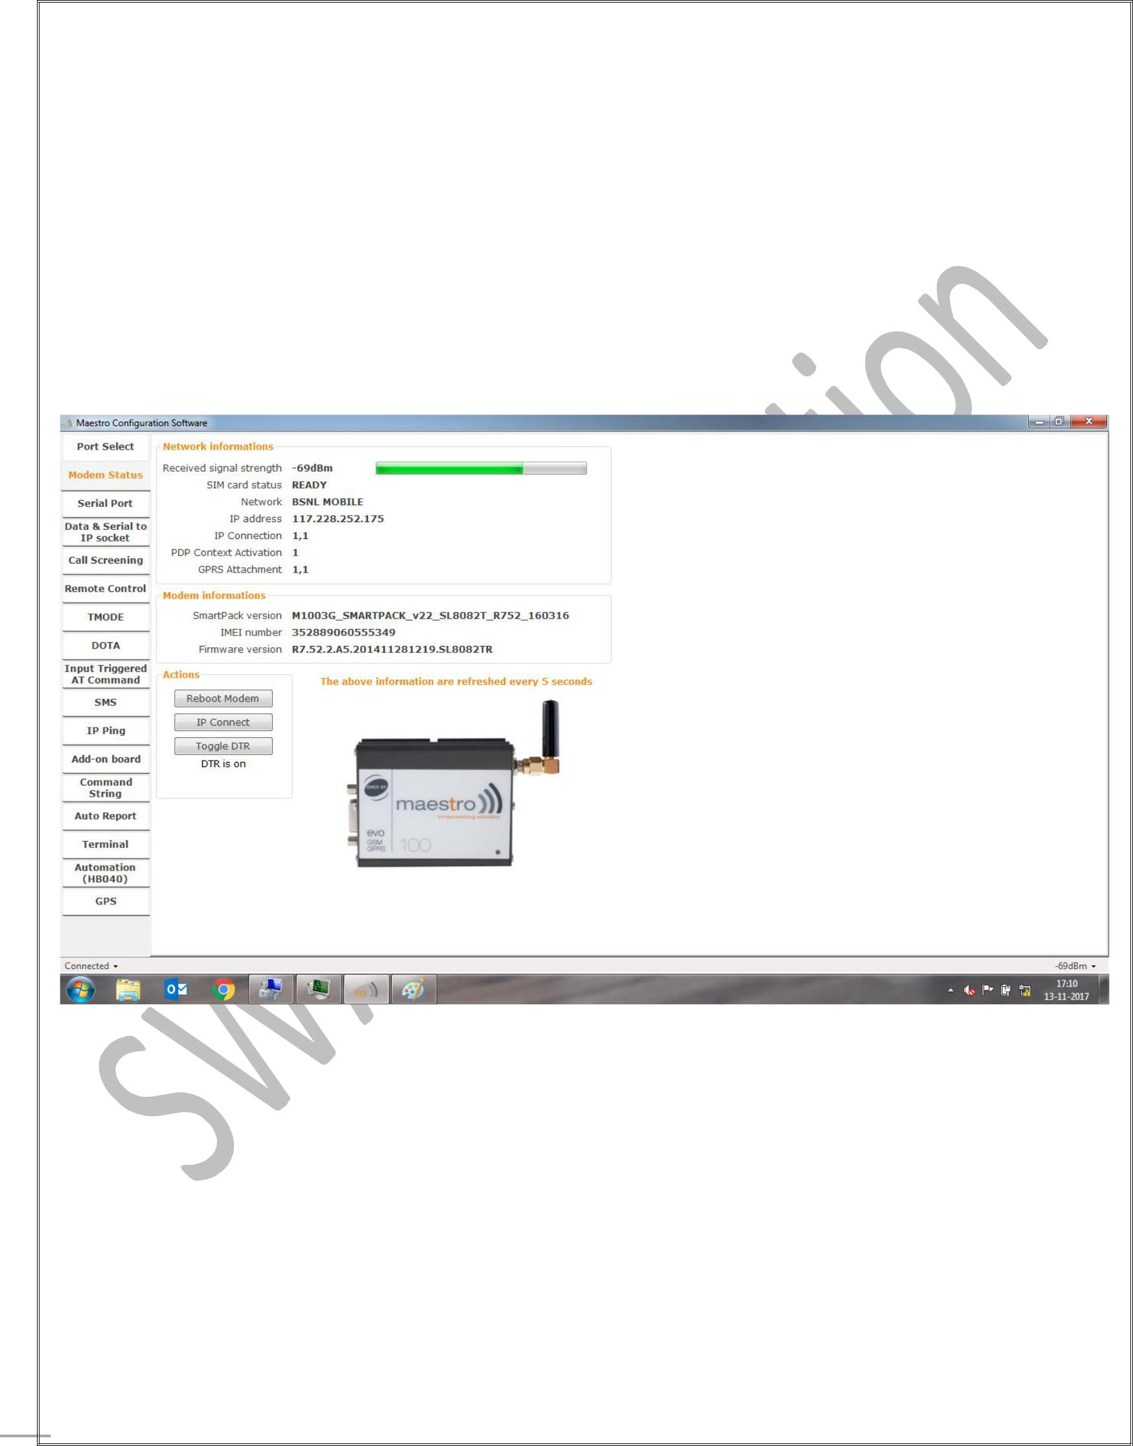

* Modem Status :

1. **Network Information :** It Shows the Received Signal Strength, SIM Card Status, SIM Card Name.You can see in below image that IP address doesn’t show and IP Connection=1,0 that means either your Modem can’t connected with internet or you don’t have data plan in this SIM Card
2. **Actions :** If IP is not display then you can press either IP Connect Button or Reboot Modem for Refresh.

8



**9**

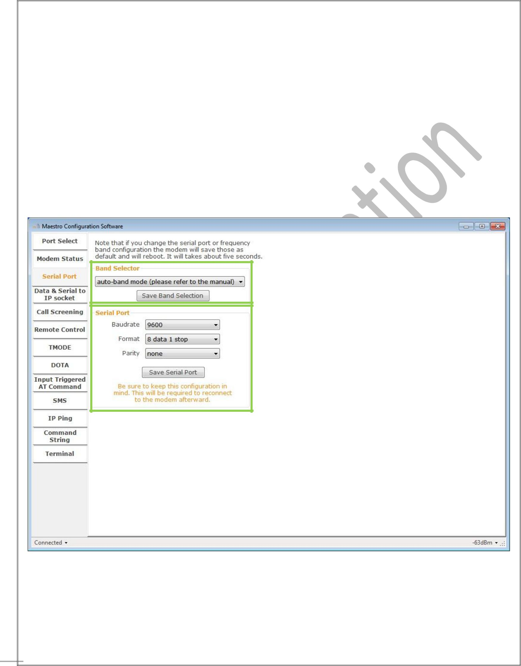

* Serial Port :

1. **Band Selector :** Select “auto-band Mode” and Save Band Selection.
2. **Serial Port :** Select the Correct Setting for Serial.

**Baud Rate** : 9600

**Formate** : 8 data 1 stop

**Parity** : None

* Save Serial Port Settings.

9



**10**

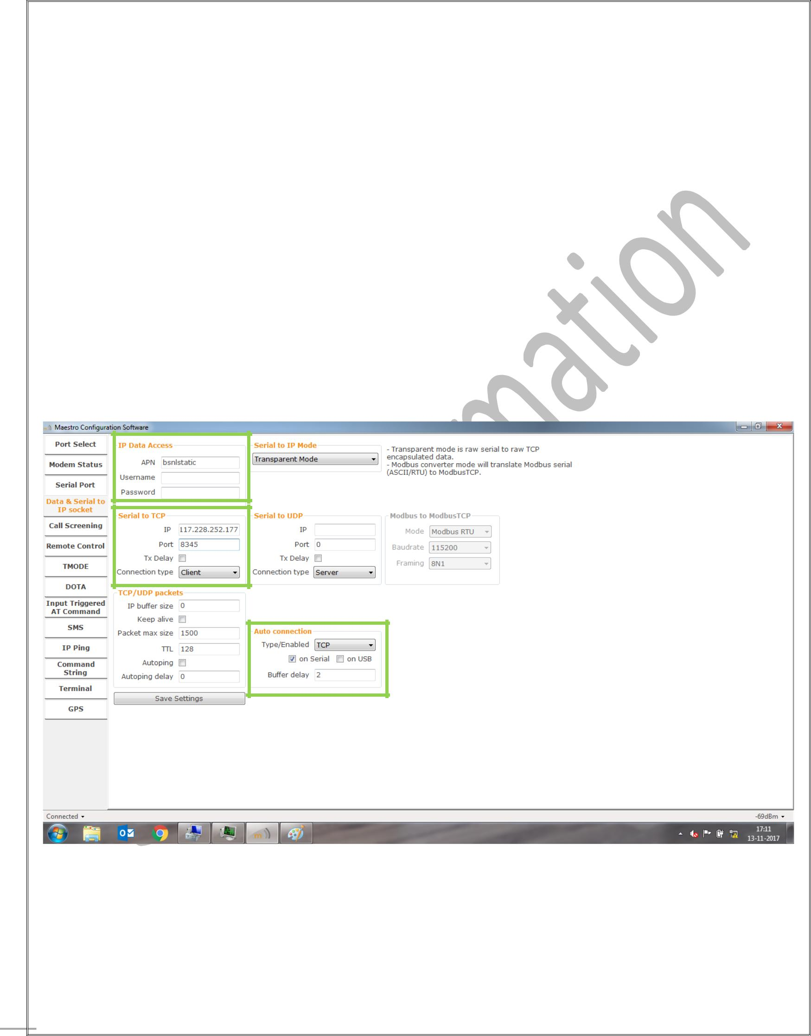

❖ Data & Serial to IP Socket :

1. **Data Access :** Fill the APN of Network Company which you used in Modem.
2. **Serial to TCP : IP:** Enter the Static IP of Server Modem , you can see in below image.

**Port :** Define port which you open for data Communication (must be same as server modem).

**Connection Type :** Client

1. **Auto Connection : Type/Enabled :** TCP **Buffer Delay :** 2

* Save upper settings and you can see in below image.

10



**11**

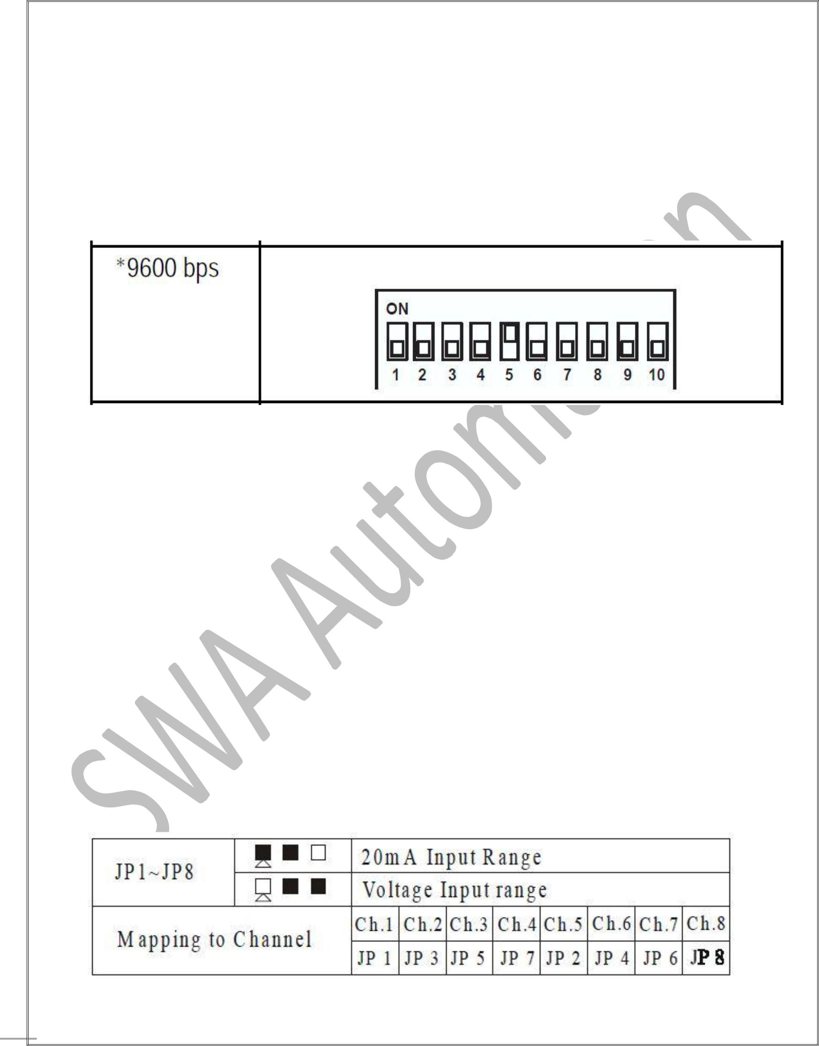

Advantech Adam.NET Utility Setup Procedure

* Open Advantech Adam.NET Utility Application.
* Ensure that your ADAM-4520, ADAM-4017+ and ADAM 4520 is connected with Data(+) and Data(-) pin and ADAM-4520 is in Normal Mode.
* Check Baudrate of Adam-4520 in inside Modem. There are 10 switches to set Baud rate.
* By default baud rate is 9600. Then also you have to check and confirm.
* Connect your Adam Module (ADAM-4520) with PC/Laptop through MOXA U-Port.
* Open Advantech Adam.NET Utility and Right Click on ADAM4000_5000 in Left Pane then click on Refresh Subnode.
* You can see your COM port where you connect yout Adam Module.
* Select com port and right click on it. Then search Module from COM X.
* If your Module connected with PC/Laptop then Module will reflect on COM Port.
* Set Module Configuration. **Baud Rate** : 9600 **Protocol** : Modbus

**Data Area** : Define Range 4 to 20 mA

* **ADAM-4017+ Hardware Setting :**
* Check your Jumper inside ADAM-4017+. Which is use for 4 to 20 mA and 0 to 10V.
* Set your Jumper in 4 to 20 mA Configuration.

11

