

1

# SOP for Master clock

* Materials require for testing:-
  1. Master clock
  2. WinDiscovery Software(In PC)
* Now Connect All hardware as per below:

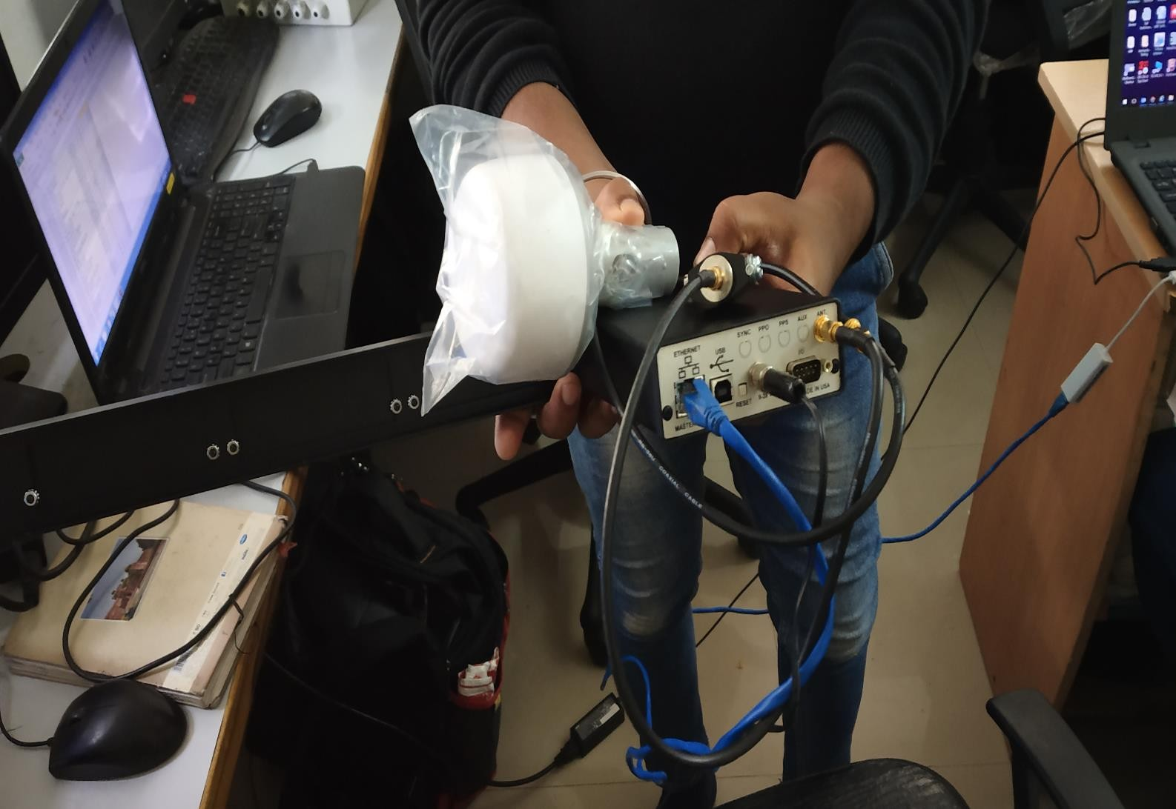

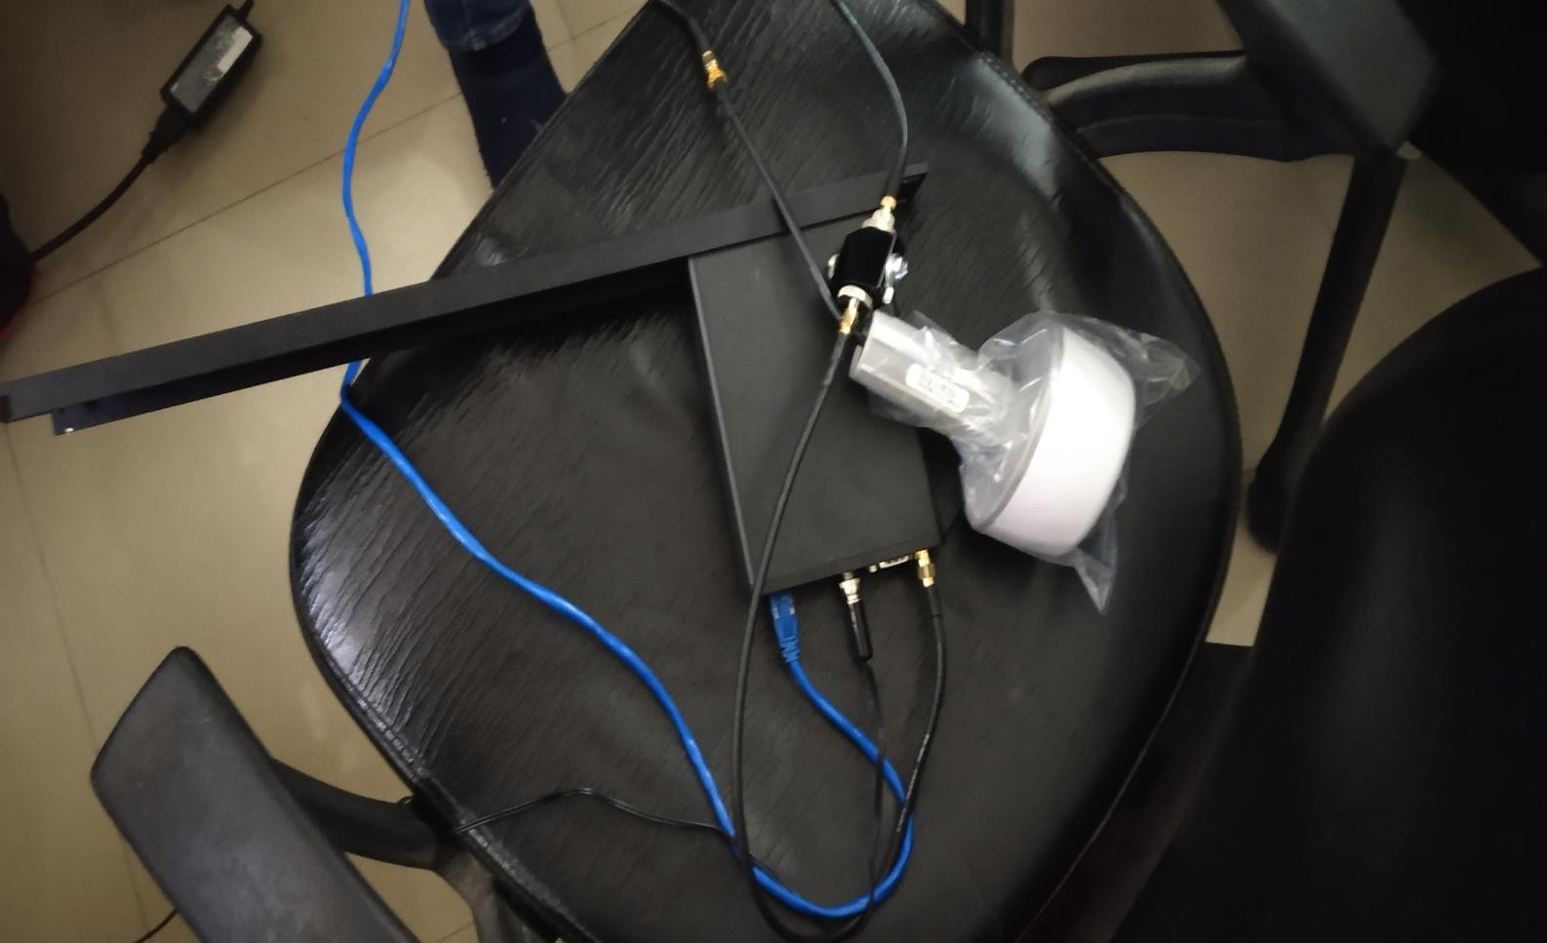

2

SOP for Master clock

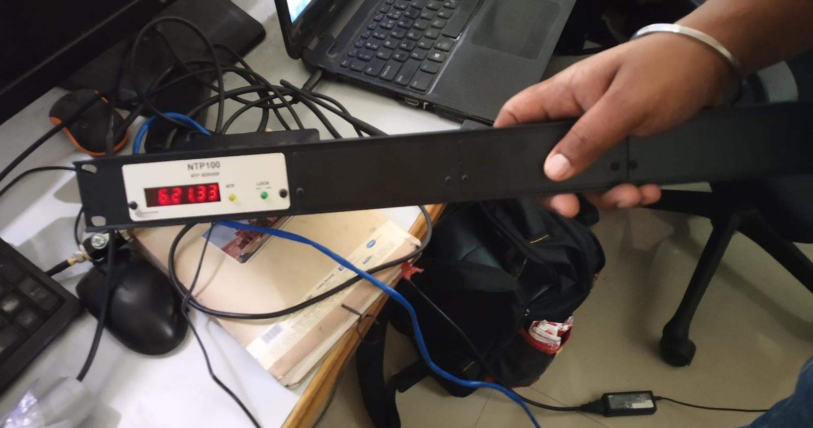



3

# SOP for Master clock

* Open Network & Security settings, Enable DHCP by going in IP settings & Set as below.

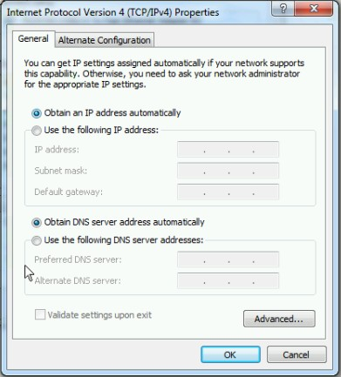



4

# SOP for Master clock

* Now Open Windiscovery software on PC.It will be as below.

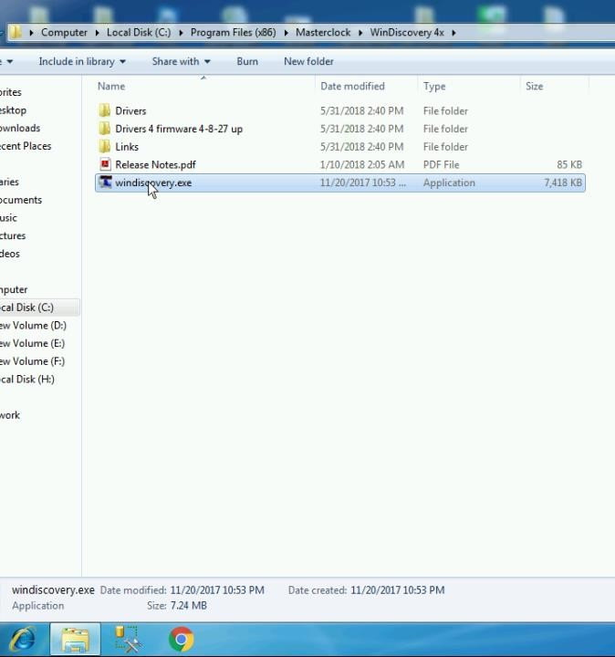



5

# SOP for Master clock

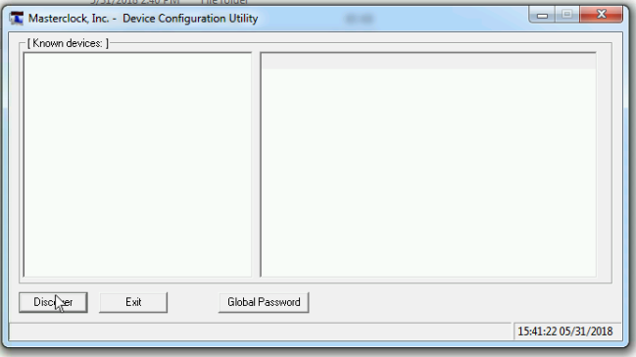

* Now click on Discover, It will show device as below.

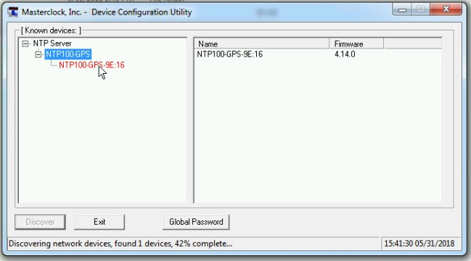



6

# SOP for Master clock

* Click on that it will show popup as below.

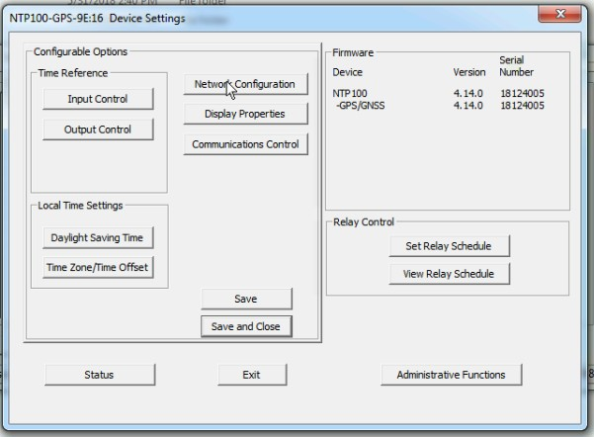

* Click on Network Configuration & set the configuration as below: (You can use any IP in the PC Range) & click on Ok.



7

# SOP for Master clock

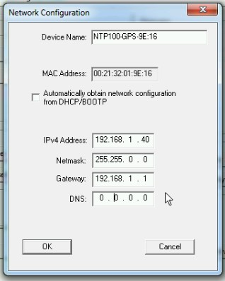

* After that click on Save. It will ask for Password. Default Password is Public.

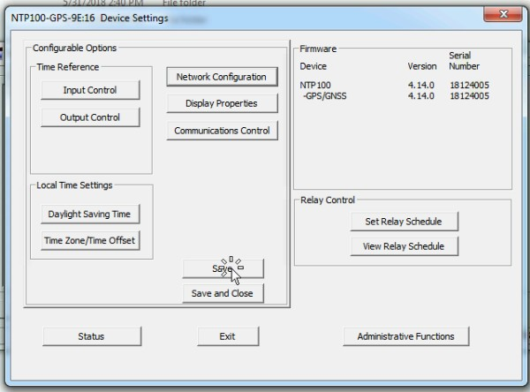

8

SOP for Master clock

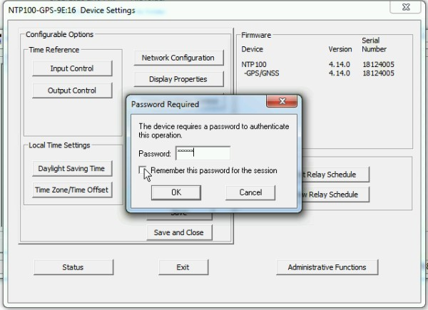

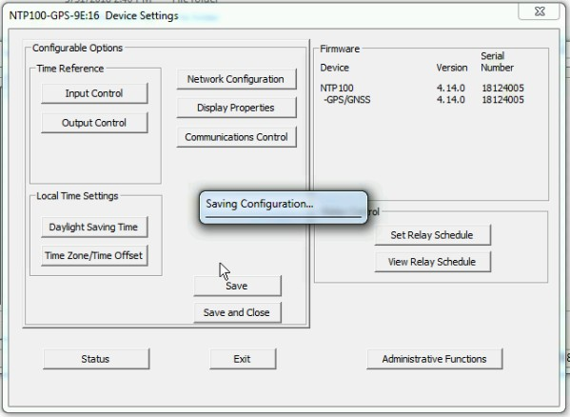

9

SOP for Master clock

* Now click on Status.

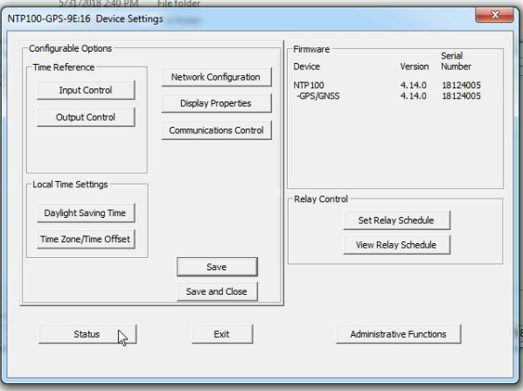



10

# SOP for Master clock

* After that click on GPS tab.Then it will show data that is obtain from the Satellite.

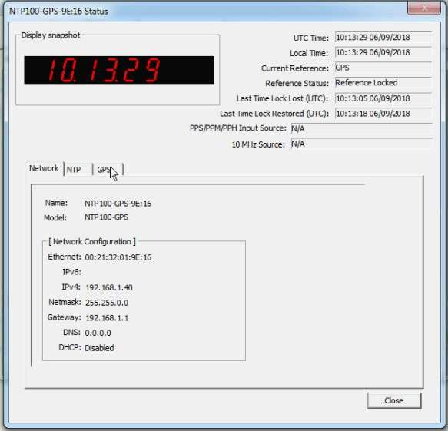



11

# SOP for Master clock

