1. **Requirement :-**

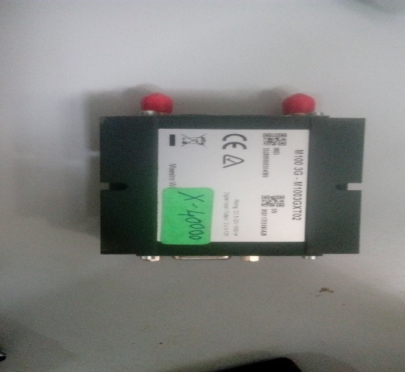 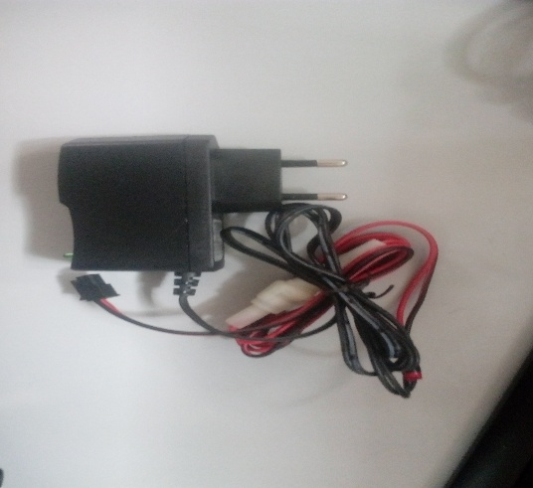

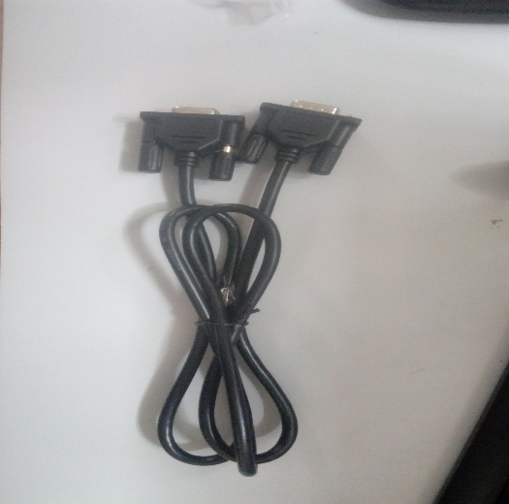 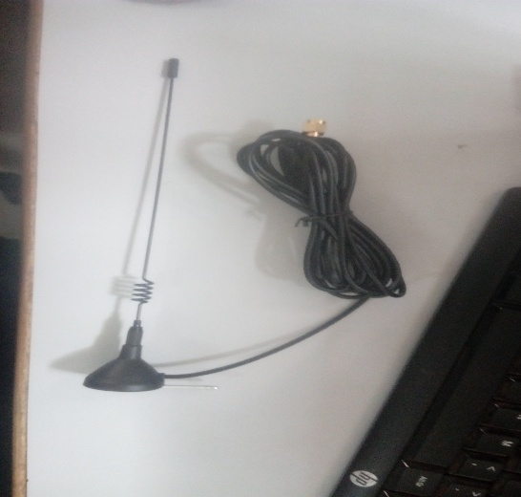

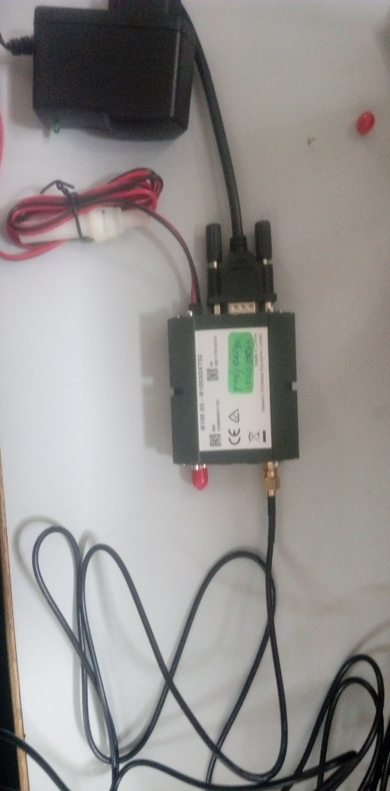

**1. Open the a Hyper Terminal Private Edition(hyper terminal.exe) .**

* 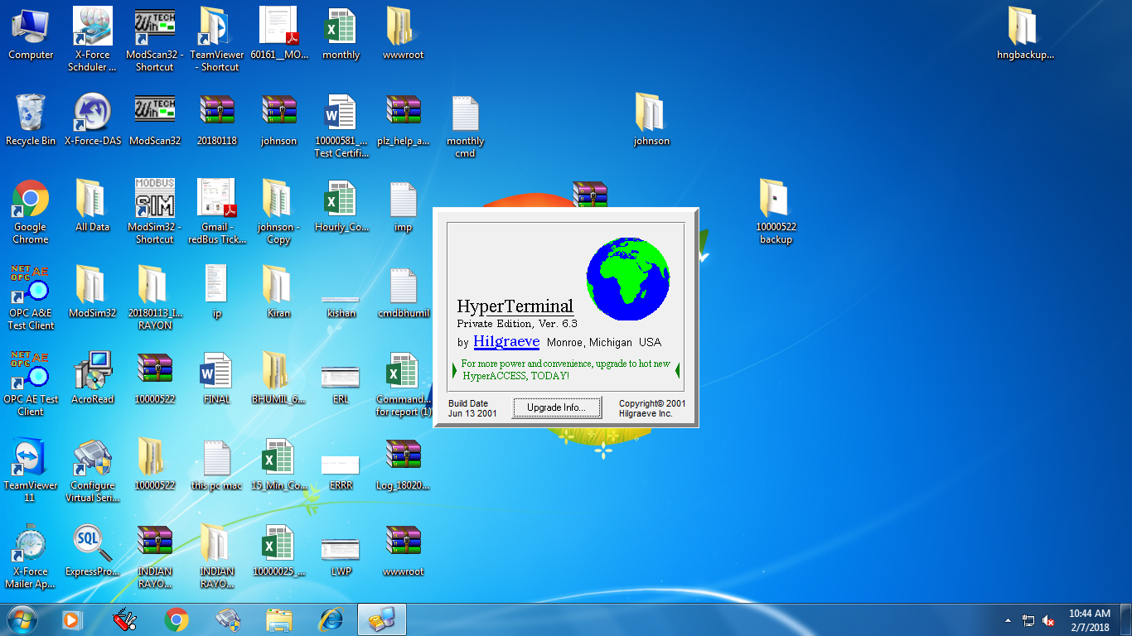

1. **Open new screen.**

**Name: Blank space Any Name type**

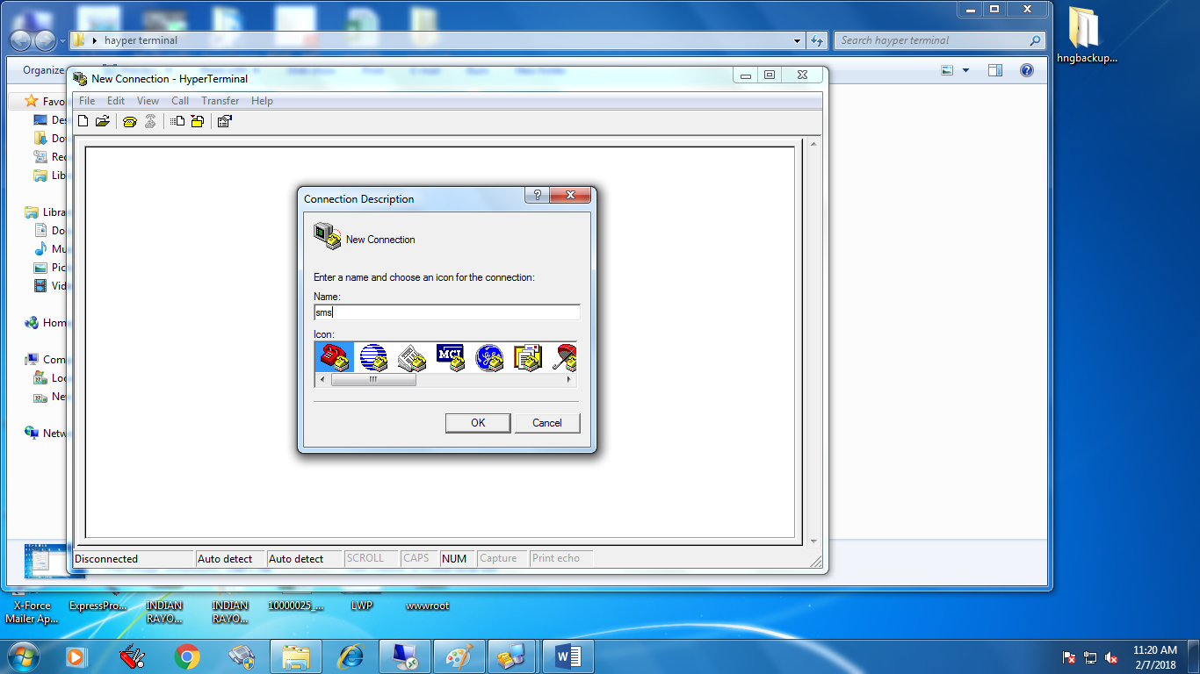

**Click on the ok Button.**

1. **Open the new screen.**

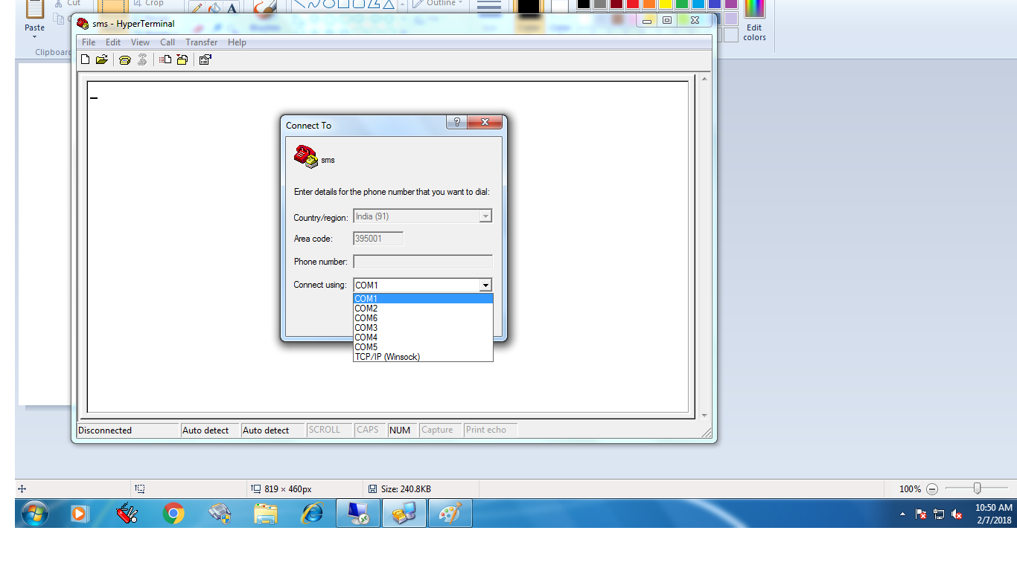

* **Select the connect Using. Ex: com1, com2, com3 etc.**

1. **Open new screen.**

**Select the information.**

**- Bits per second: 115200**

**- Data bits : 8**

**- Parity : None**

**- Stop bits : 1**

**- Flow control : None**

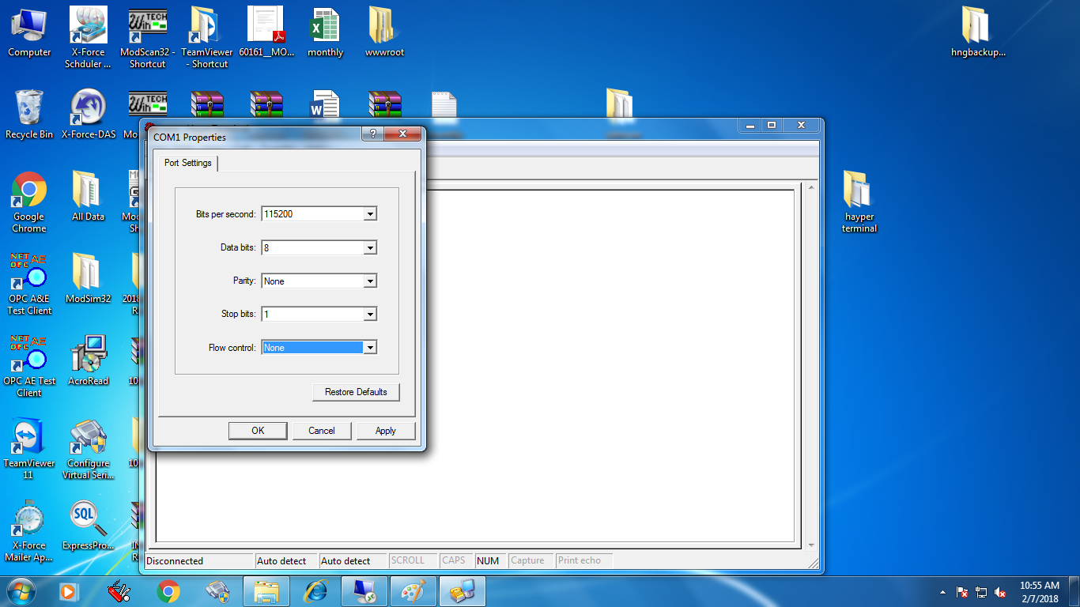

* **Click on the Apply Button.**
* **Click on the ok Button.**

1. **Open the blank screen.**

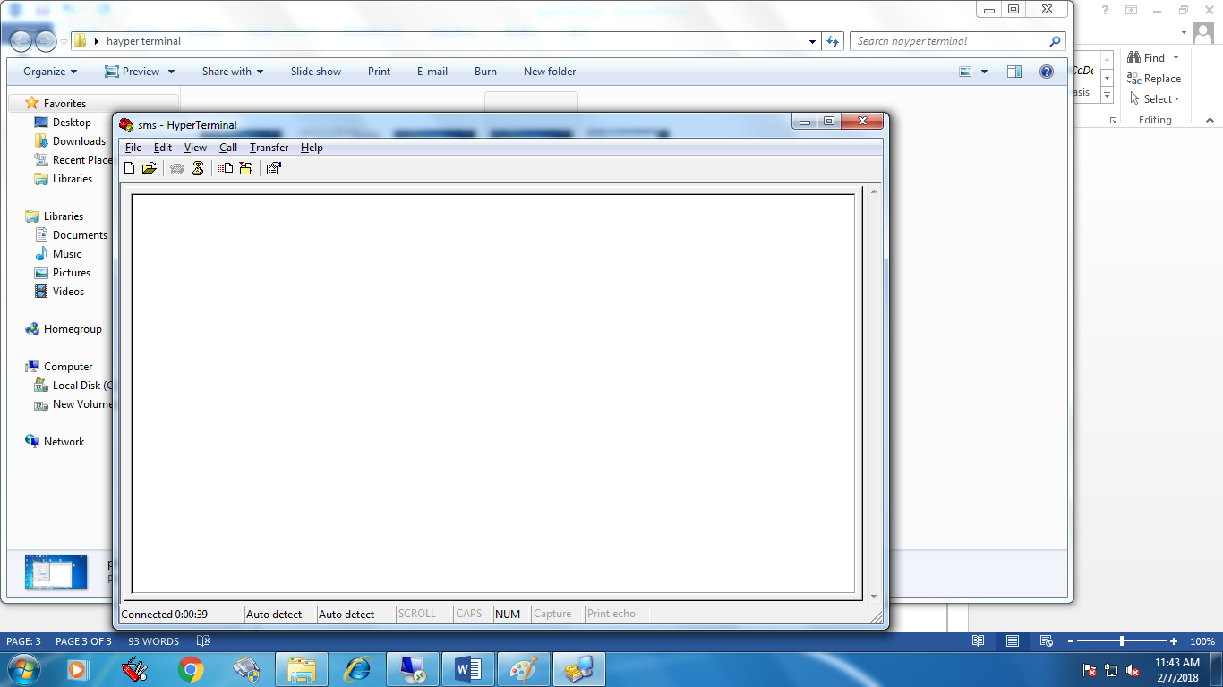

* **Check the command.**

**(1)**

**At -> click Enter Button -> ok**

**Ctrl + cmgr=1 -> click Enter Button**

**Example: 9067899556**

**(2)**

**- click on the file.**

**- Select properties.**

**- Open screen.**

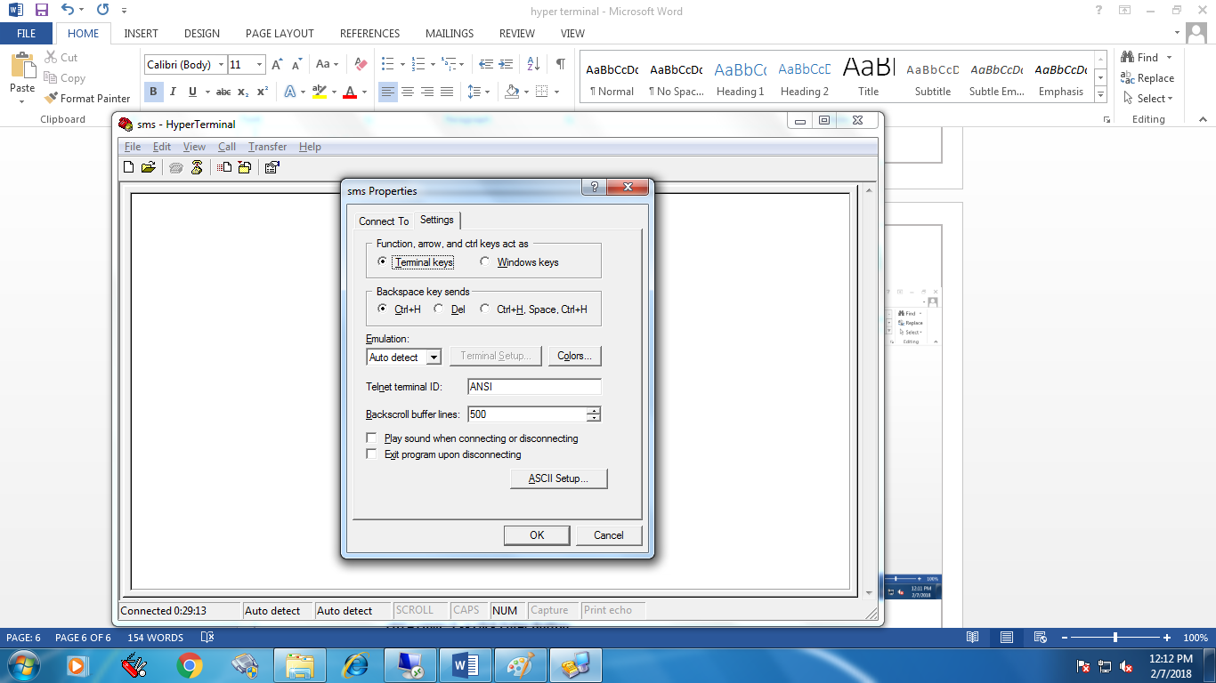

* **Two option Connect To and Setting.**
* **Click on Settings.**
* 
* **Click on ASCII SETUP button.**

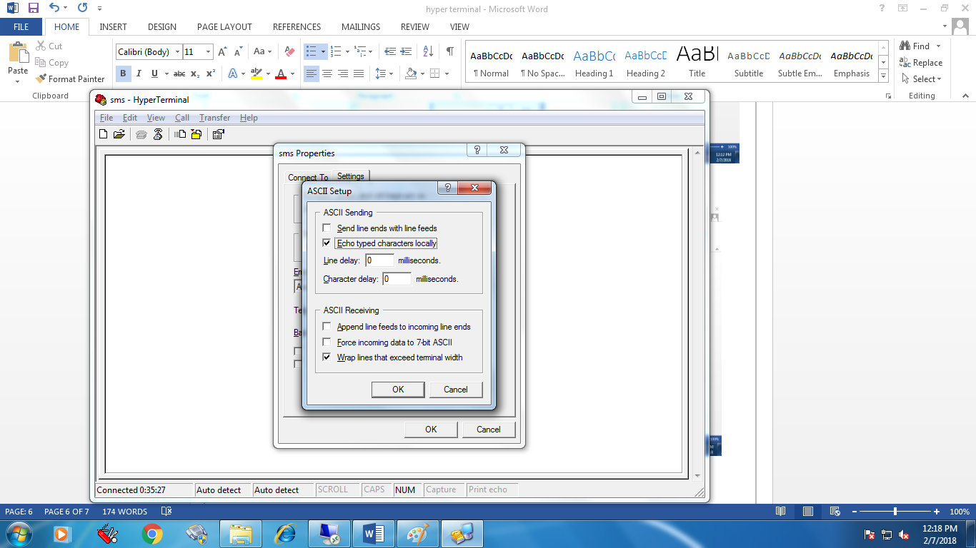

* **Select Echo typed characters locally.**
* **Click ok button.**
* **Open blank screen.**
* **Type the command.**

**(2)**

**Aatt + click Enter Button -> ok**

**Ctrl + cmgr=1 -> click Enter Button**

**Example: 9067899556**

**🡪 Next process pending ……………**