**OI ABCIP CompactLogix Configuration**

Allen-Bradley Compact logix Hardware Setup

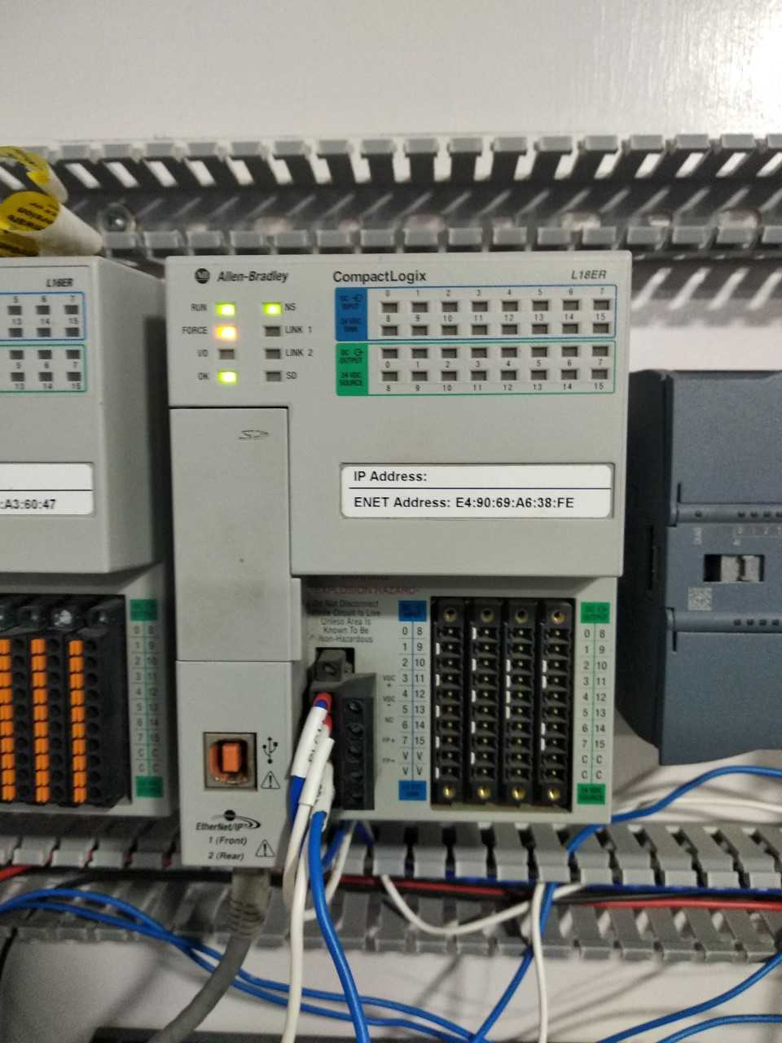

Power supply

LAN

Process

Power Supply

SMC

LAN

ABCIP

WWClient

Suitelink

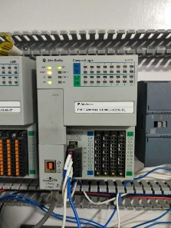

The Wonderware ABCIP OI (Operations Integration) Server is a Microsoft Windows application that allows client applications direct and indirect access to Allen-Bradley families of ControlLogix, GuardLogix, FlexLogix, CompactLogix, SoftLogix 5800, MicroLogix, PLC-5, and SLC500 controllers.

The OI Server does not require any Rockwell Software RSLinx™ package

The ABCIP OI Server communicates with supported devices either directly or indirectly across the following device networks:

* ControlNet
* Data Highway 485 (DH485)
* Data Highway Plus (DH+)
* DeviceNet
* Ethernet

The ABCIP OI Server will provide direct and indirect connectivity to the following Allen-Bradley controllers:

* ControlLogix Controllers
* GuardLogix Controllers
* SoftLogix 5800 Controllers
* CompactLogix Controllers
* FlexLogix Controllers
* MicroLogix Controllers
* PLC-5 Controllers
* SLC500 Controllers

1. Install ABCIP OI After installation it will show in the SMC.

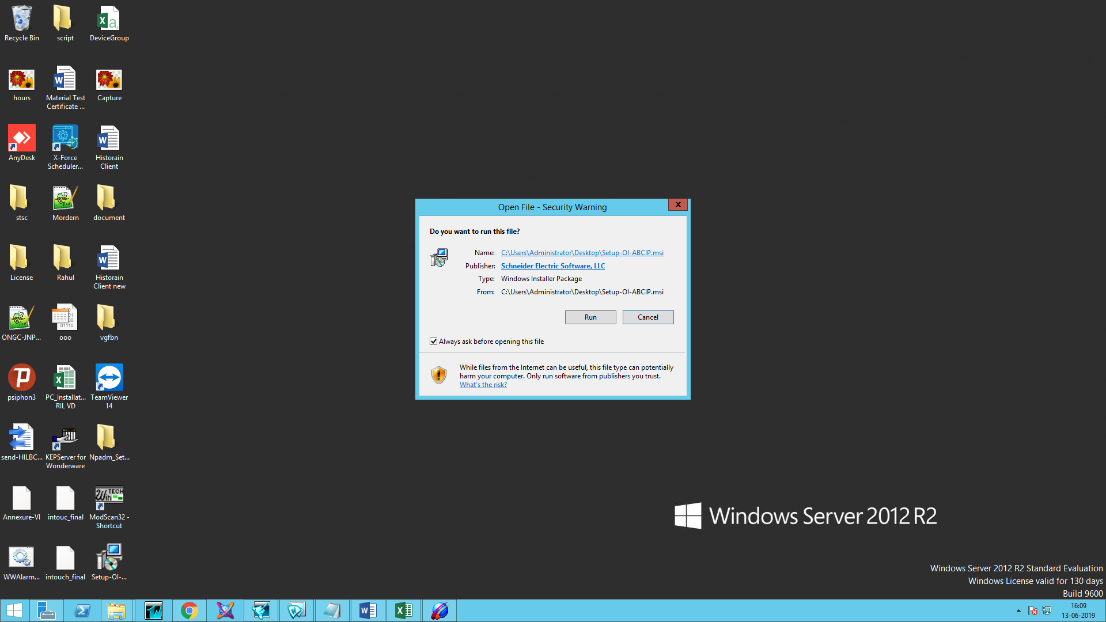

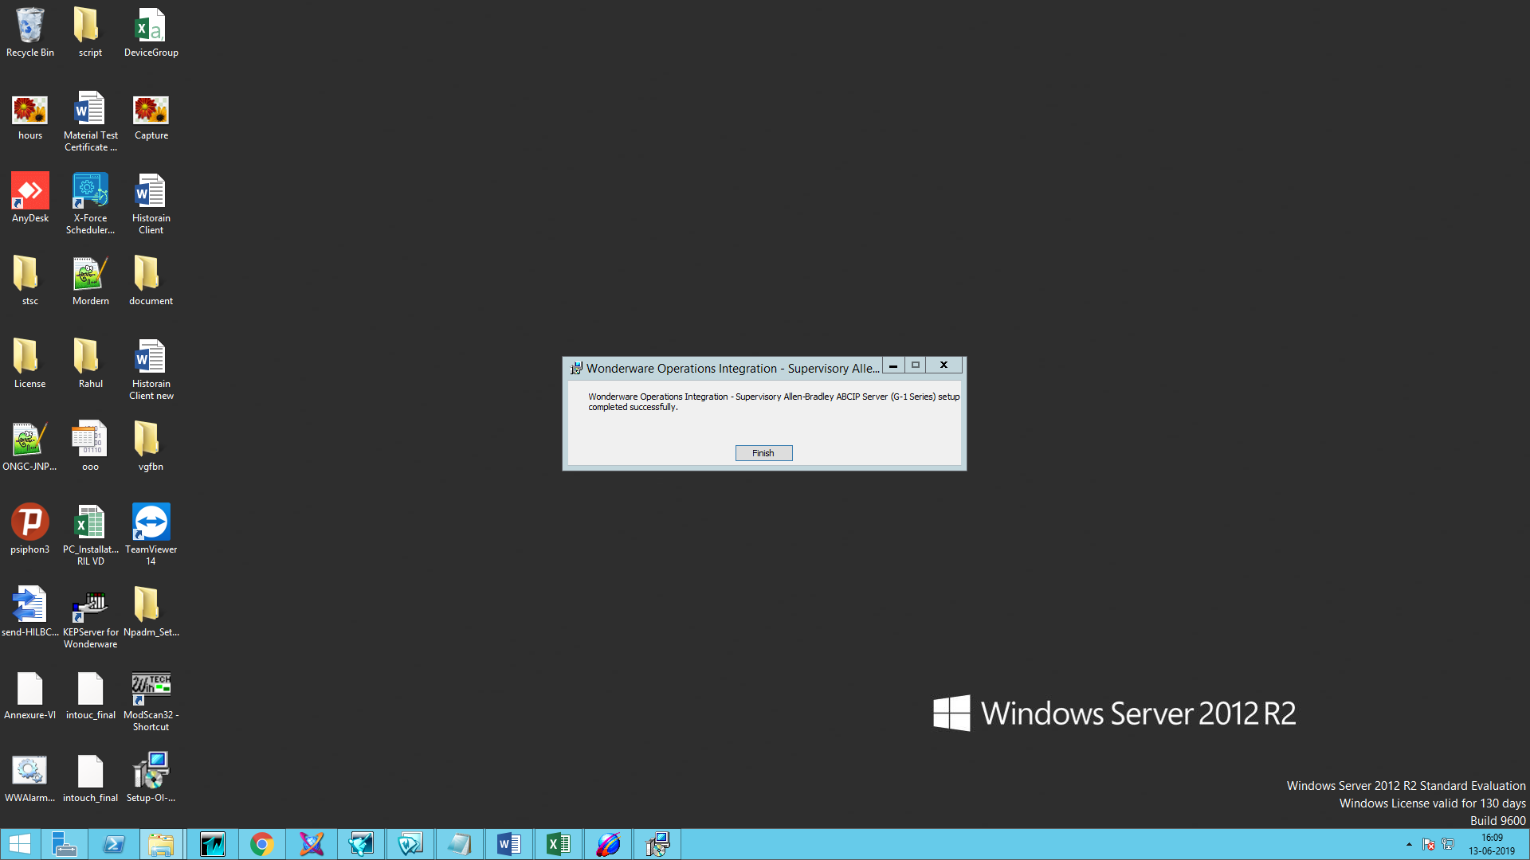

1. Navigate to the Operations Integration Supervisory Sensors – Allen- Bradley ABCIP and right click on the configuration and add PORT_CIP Connection

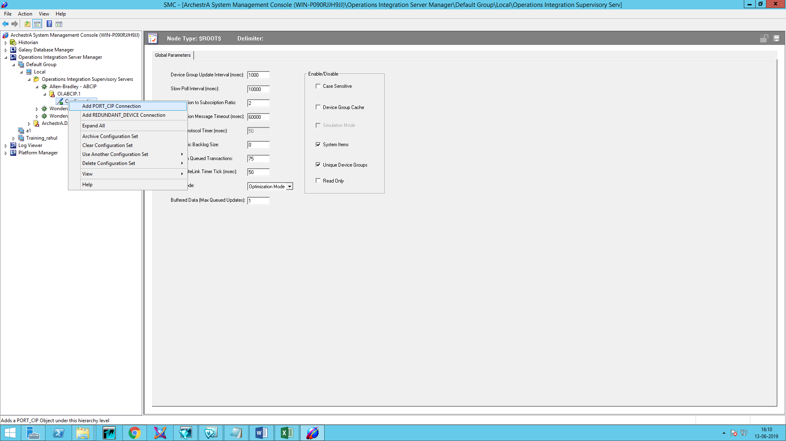

1. Add ENB_CPLX Connection (For CompactLogix)

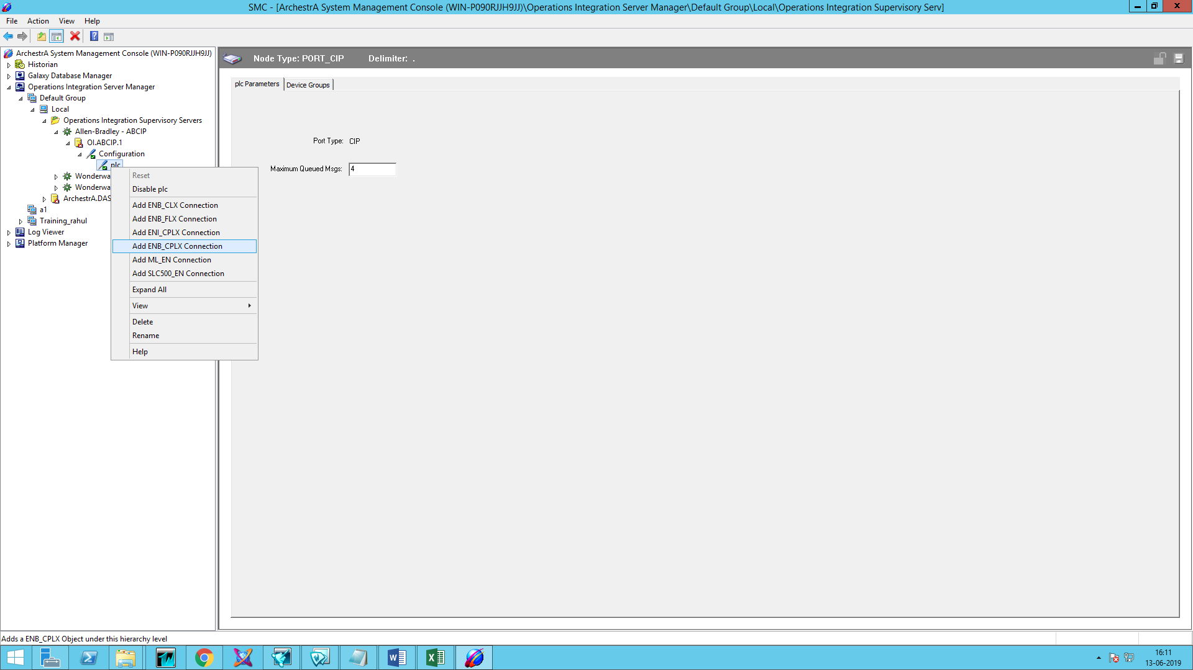

1. Enter IP Address of PLC and Save it.

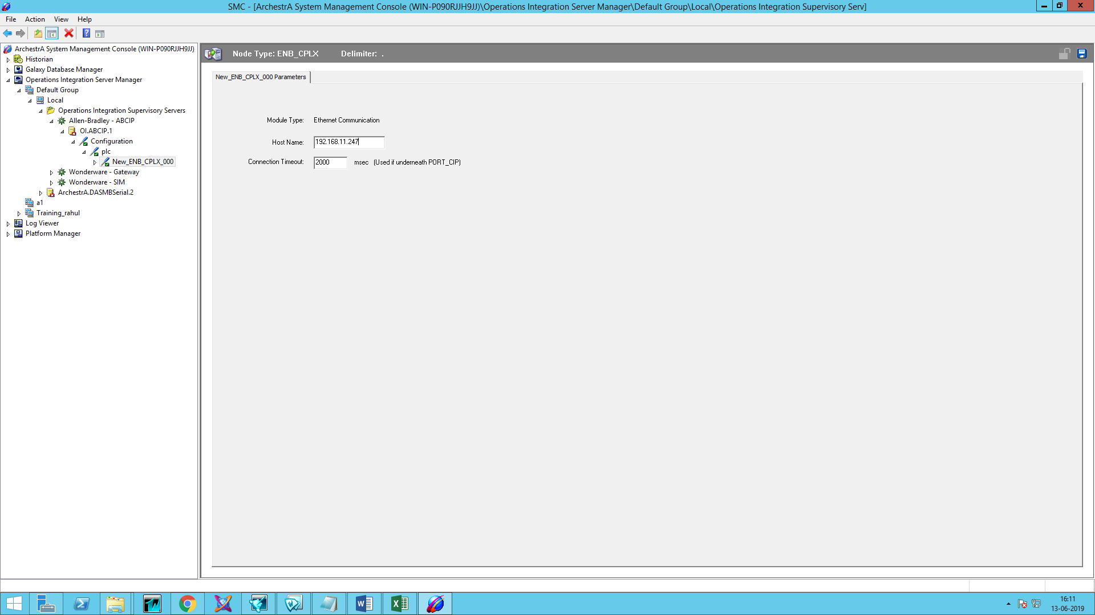

1. Add BACKPLANE_CPLX connection

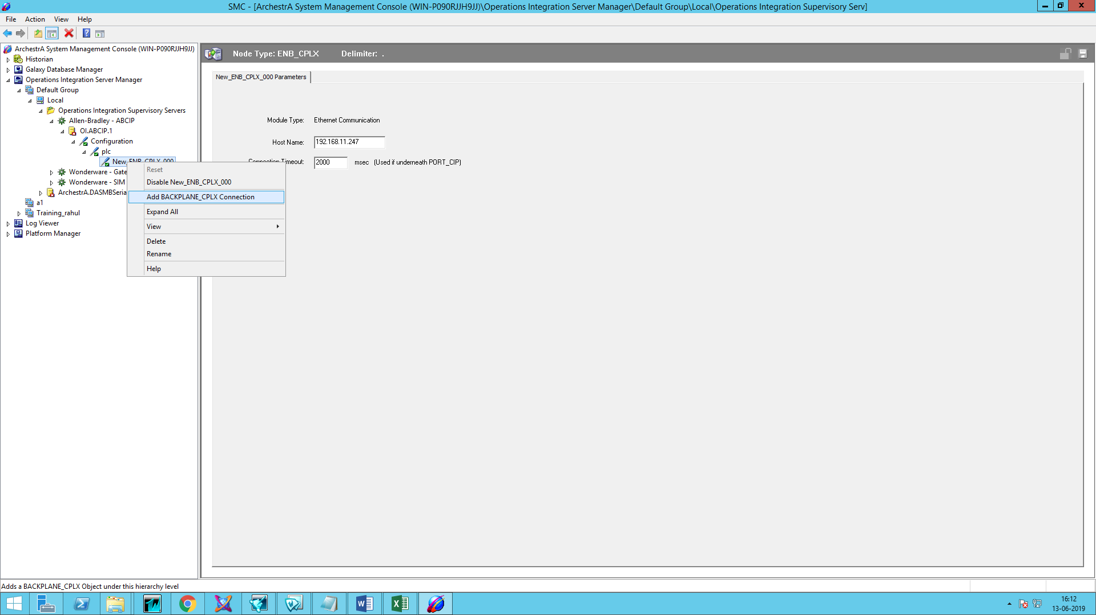

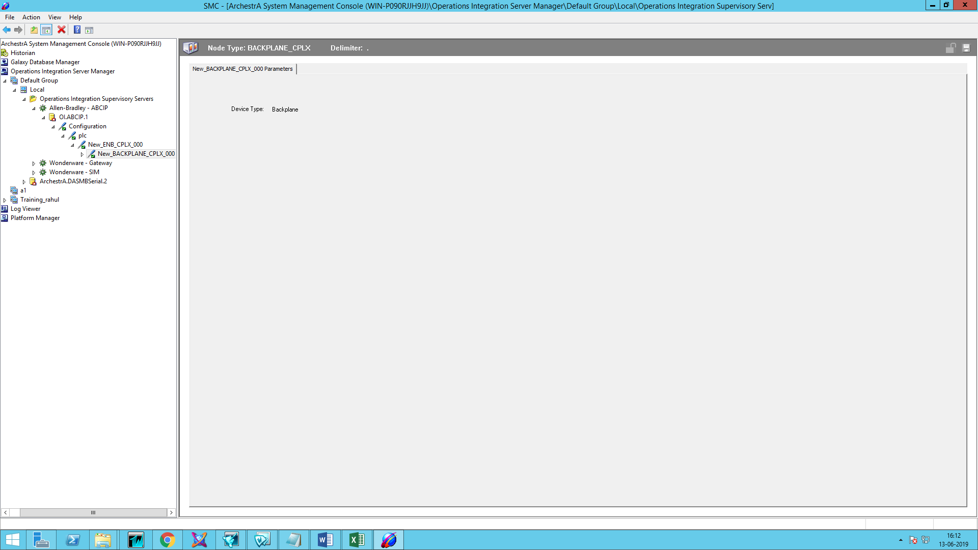

1. Add Logix_CPLX Connection.

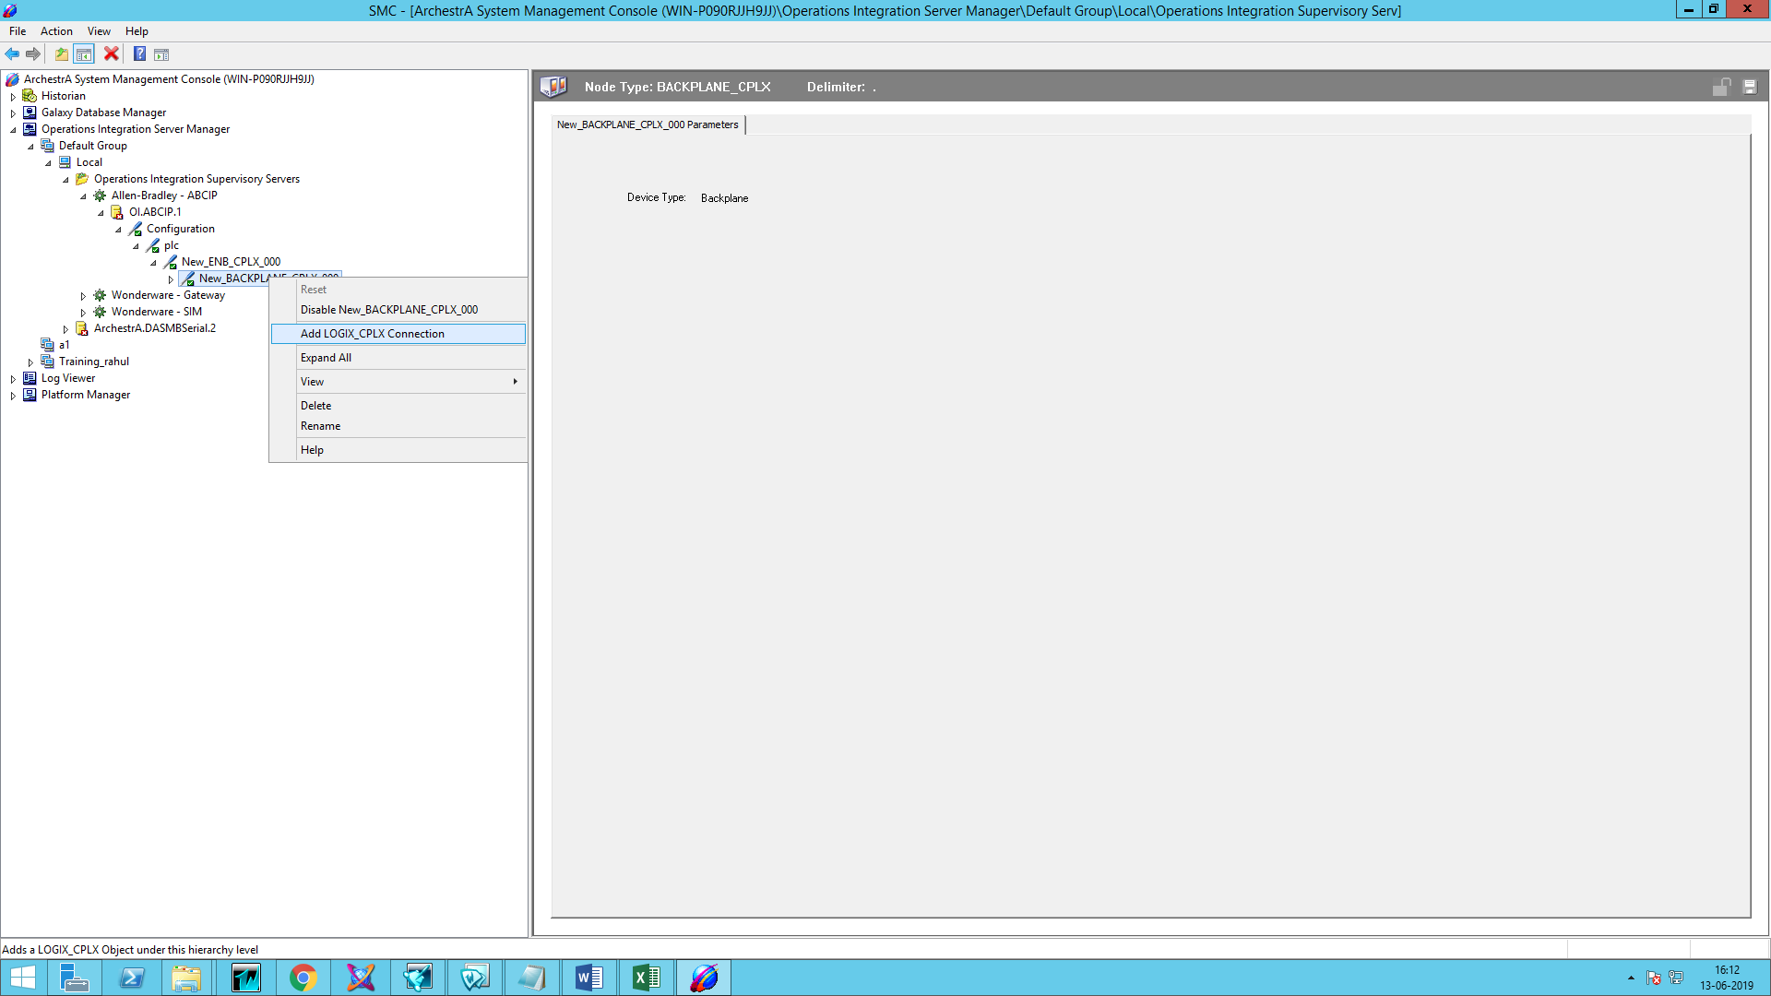

1. Add Device Group and device items

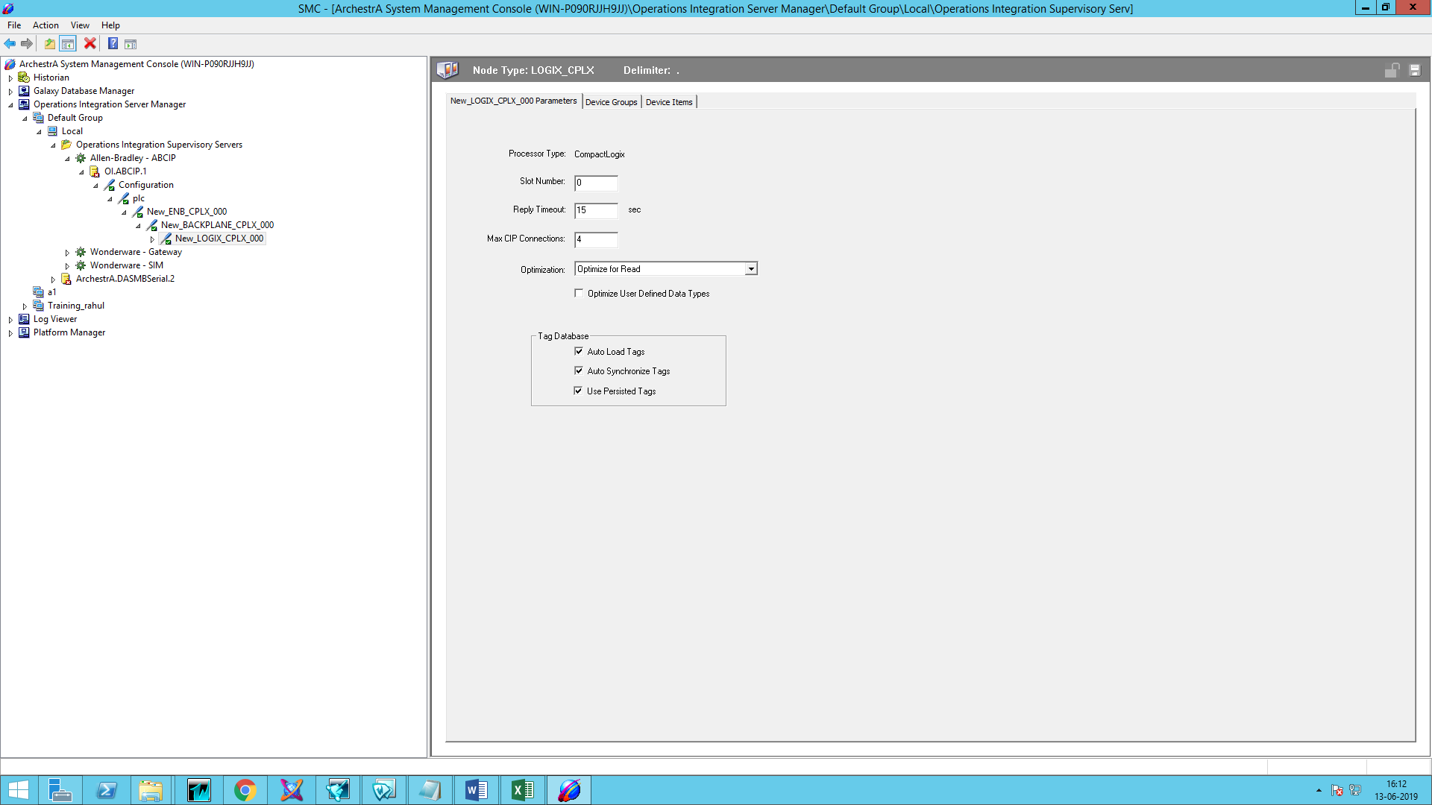

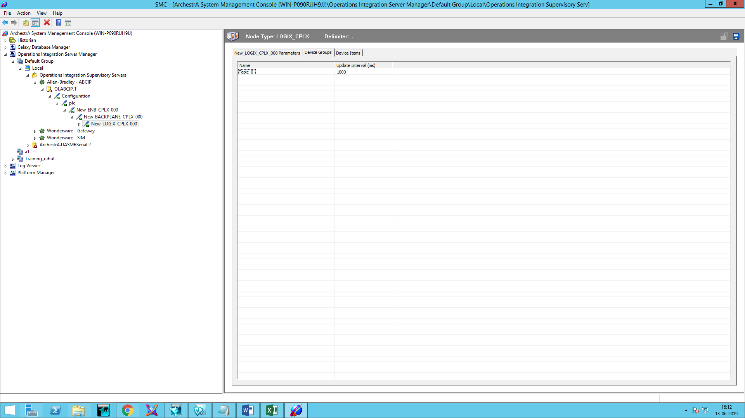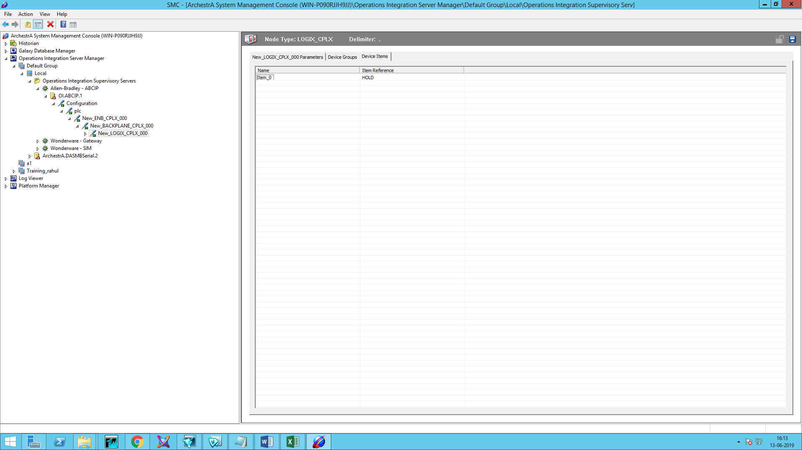

1. Activate OI ABCIP Server

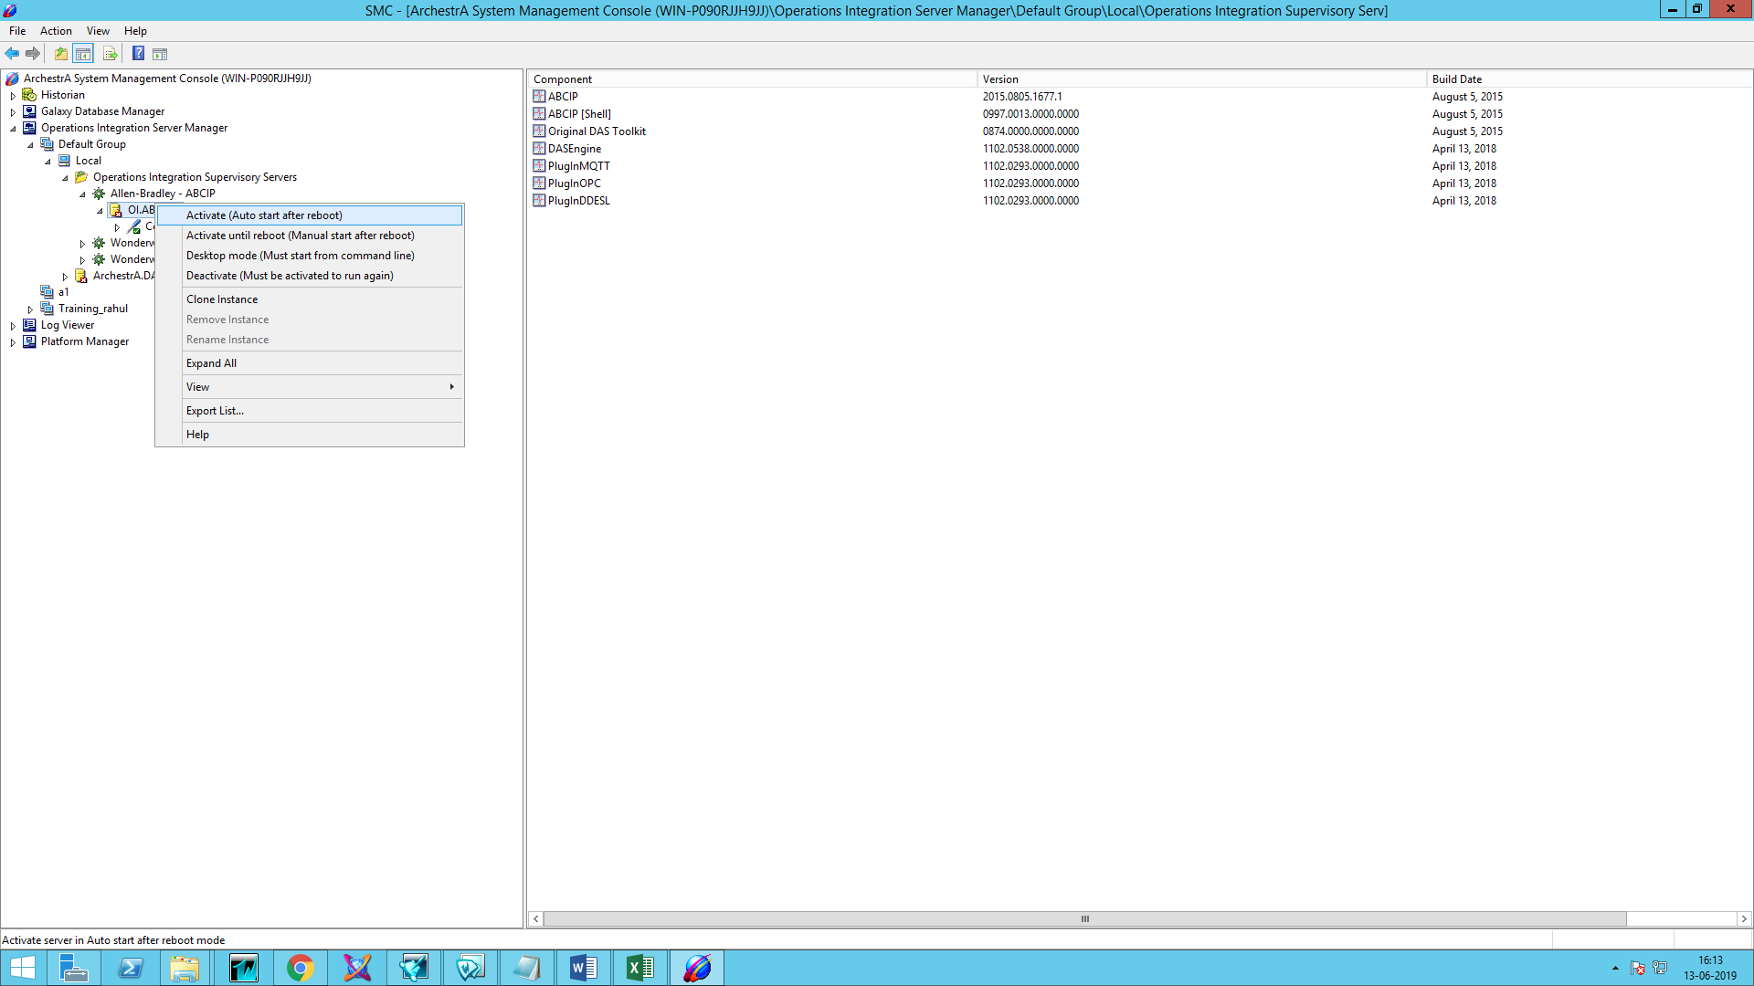

1. Open WW Client.



1. Go to connection and create connection.

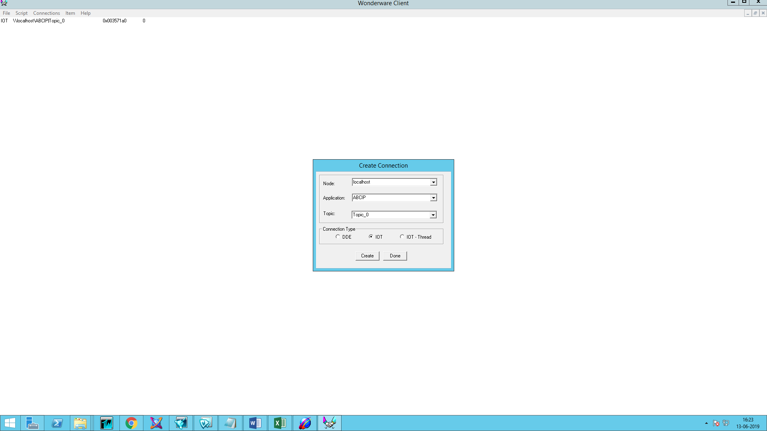

1. Go to item and add item.

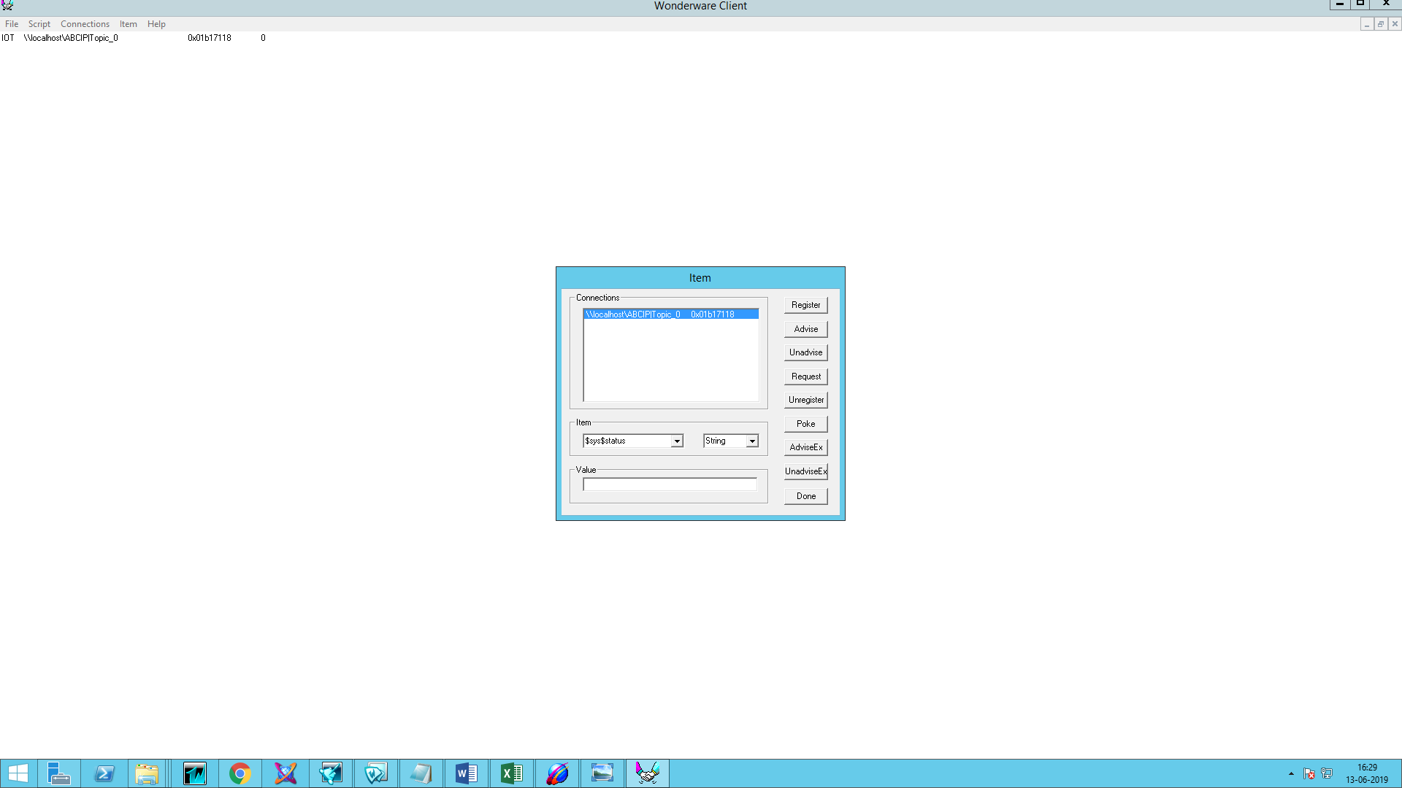

1. Now tags will show in the wonderware client.



1. You can also view that data in SMC in Diagnostics.

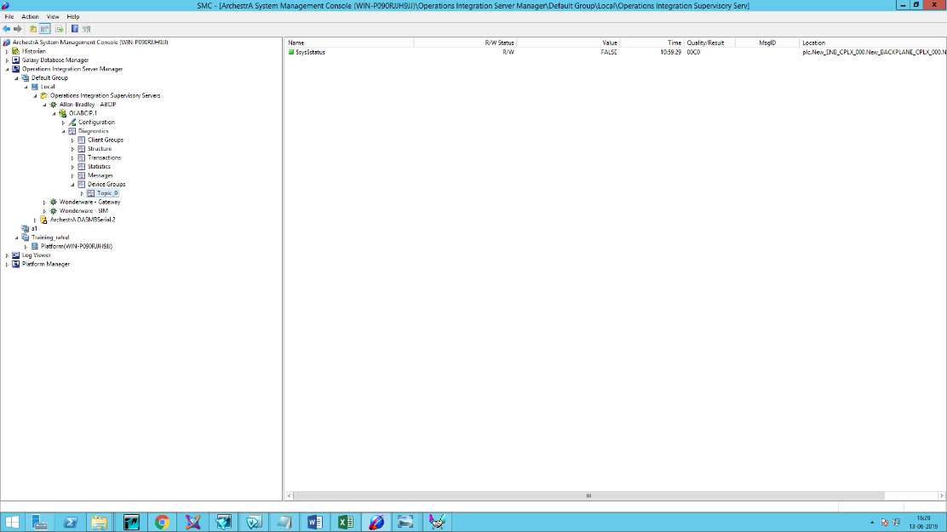

**OI ABCIP ControlLogix Configuration**

Allen-Bradley Control logix Hardware Setup

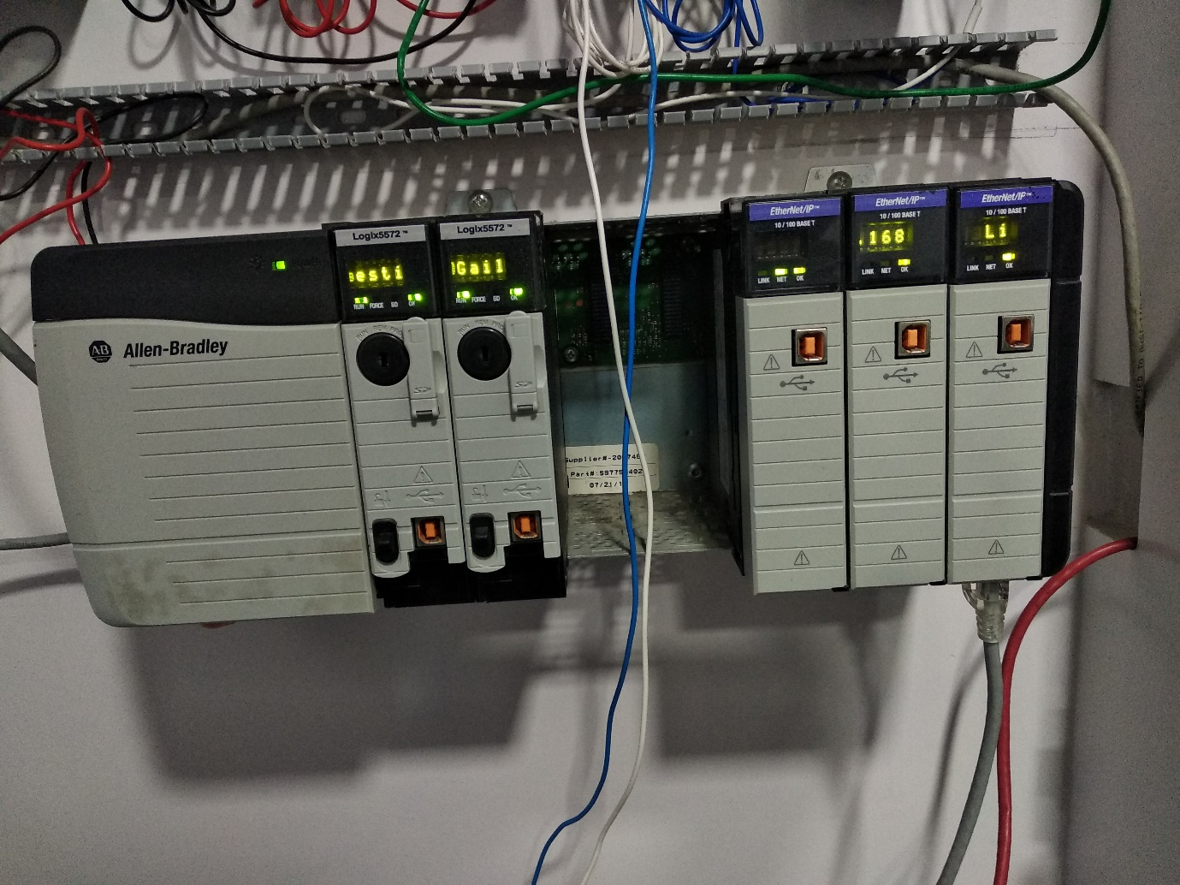

LAN

Process

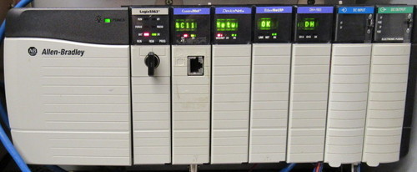

Power Supply

SMC

LAN

ABCIP

WWClient

Suitelink

1. Install ABCIP OI After installation it will show in the SMC.





1. Navigate to the Operations Integration Supervisory Sensors – Allen- Bradley ABCIP and right click on the configuration and add PORT_CIP Connection



1. Click on PLC and add ENB_CLX Connection

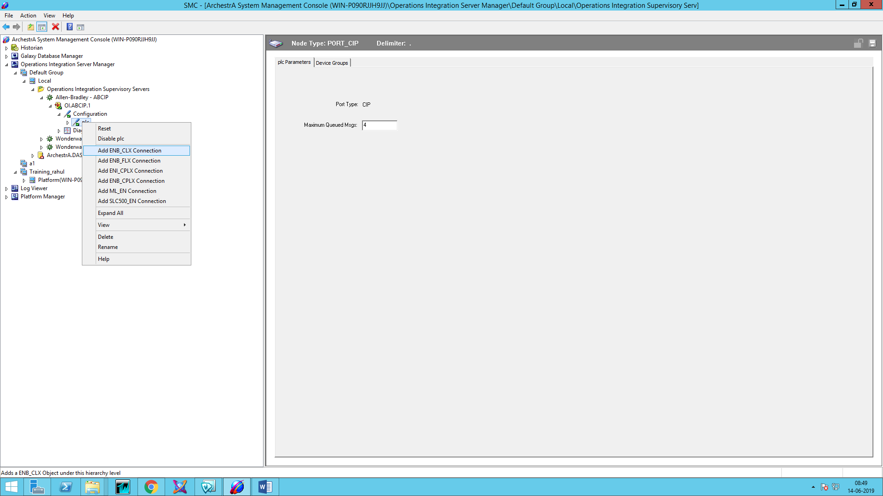

1. Enter IP Address of PLC

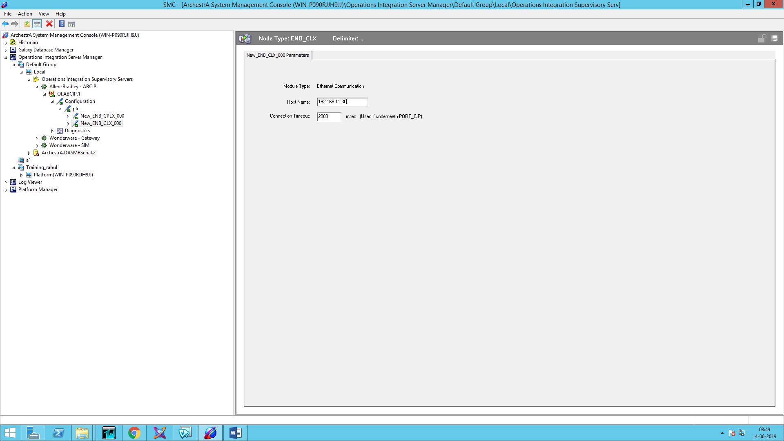

1. Right click on ENB_CLX_000 and Add Backplane_CLX Connection

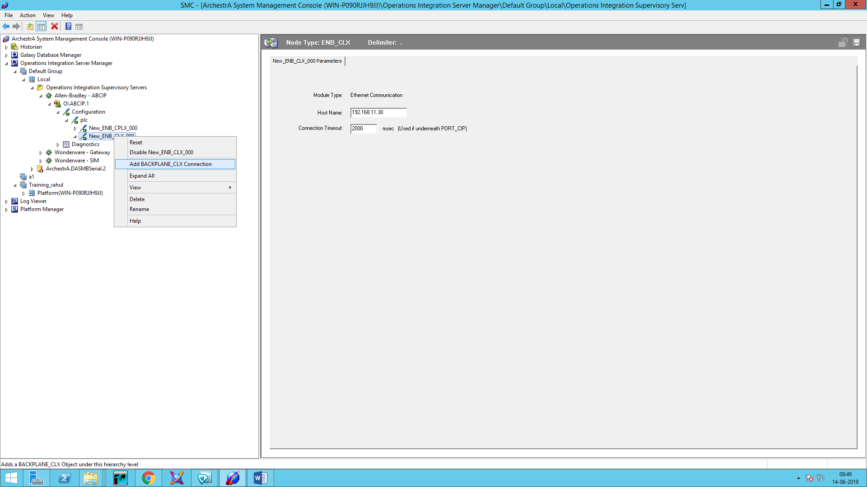

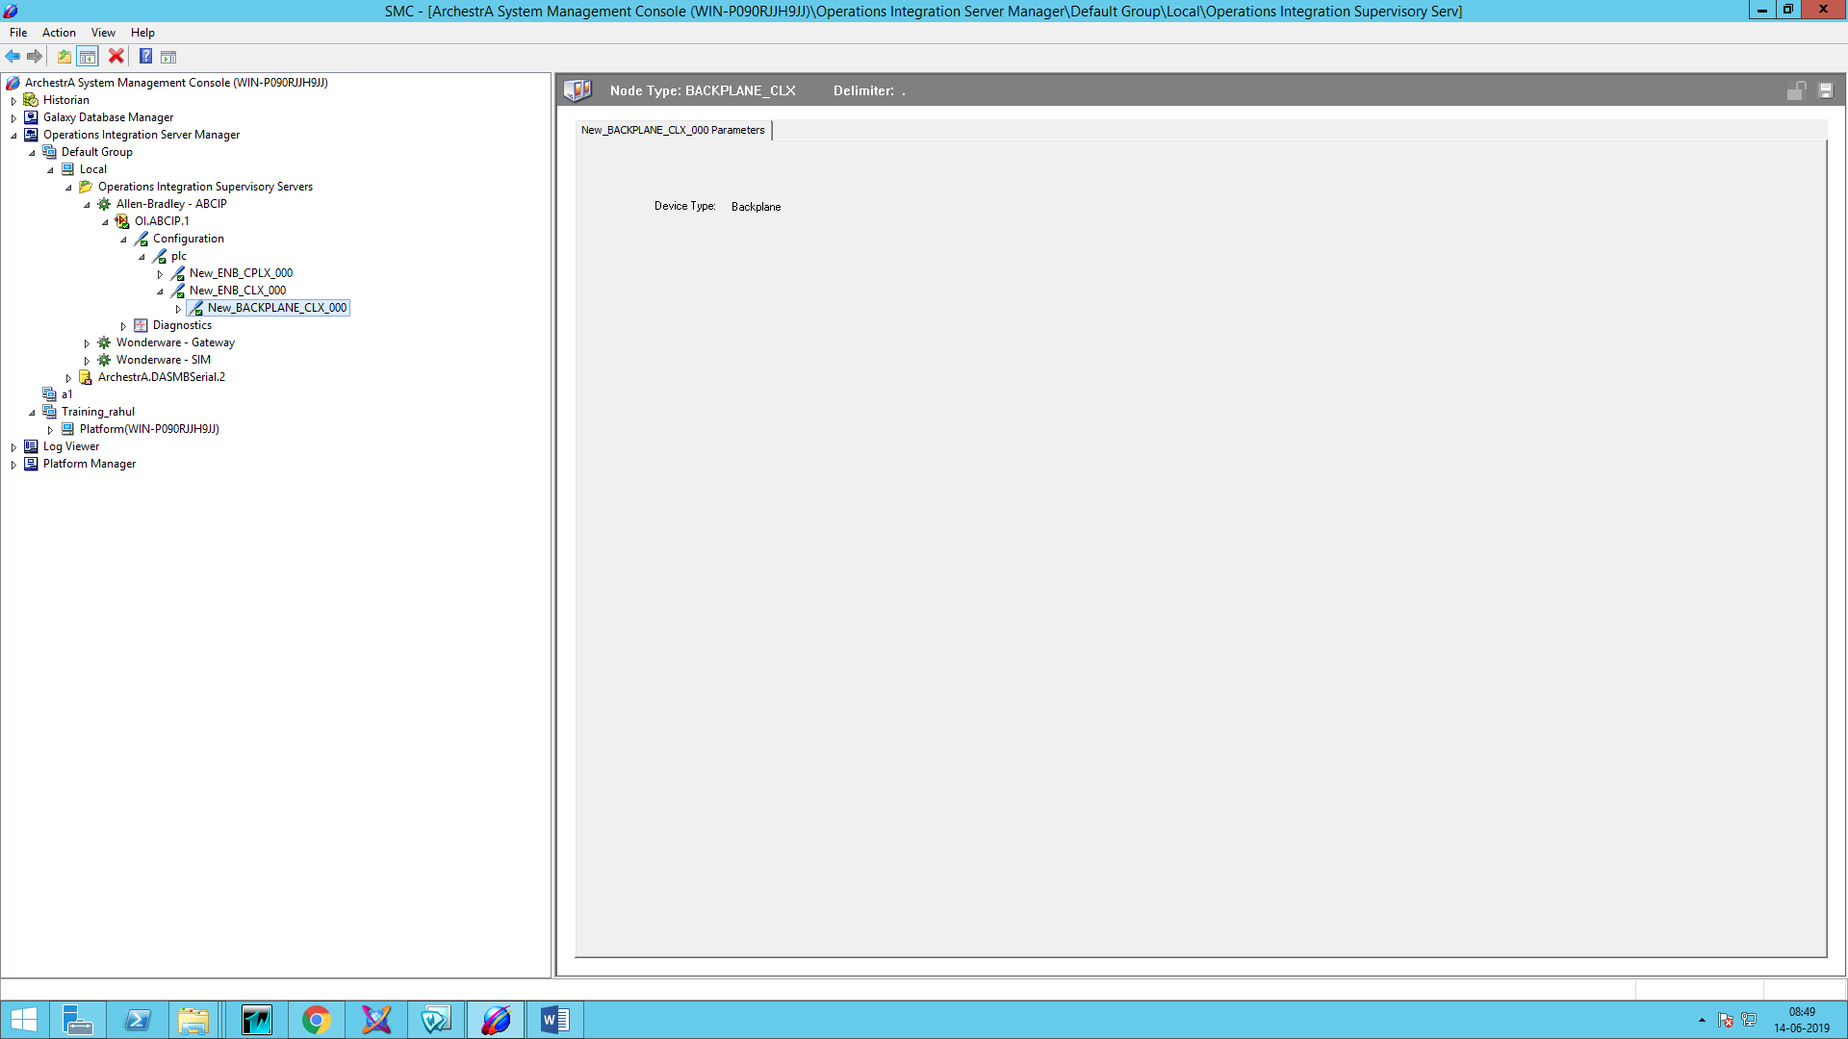

1. Right Click on Backplane and add Logix 5000 Connection and add device Group and device items.

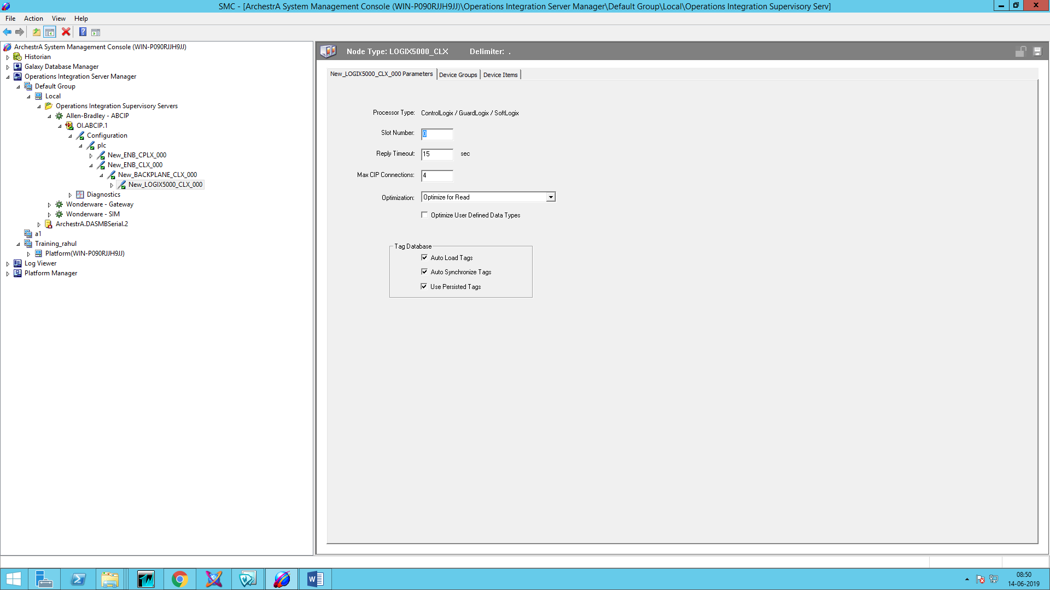

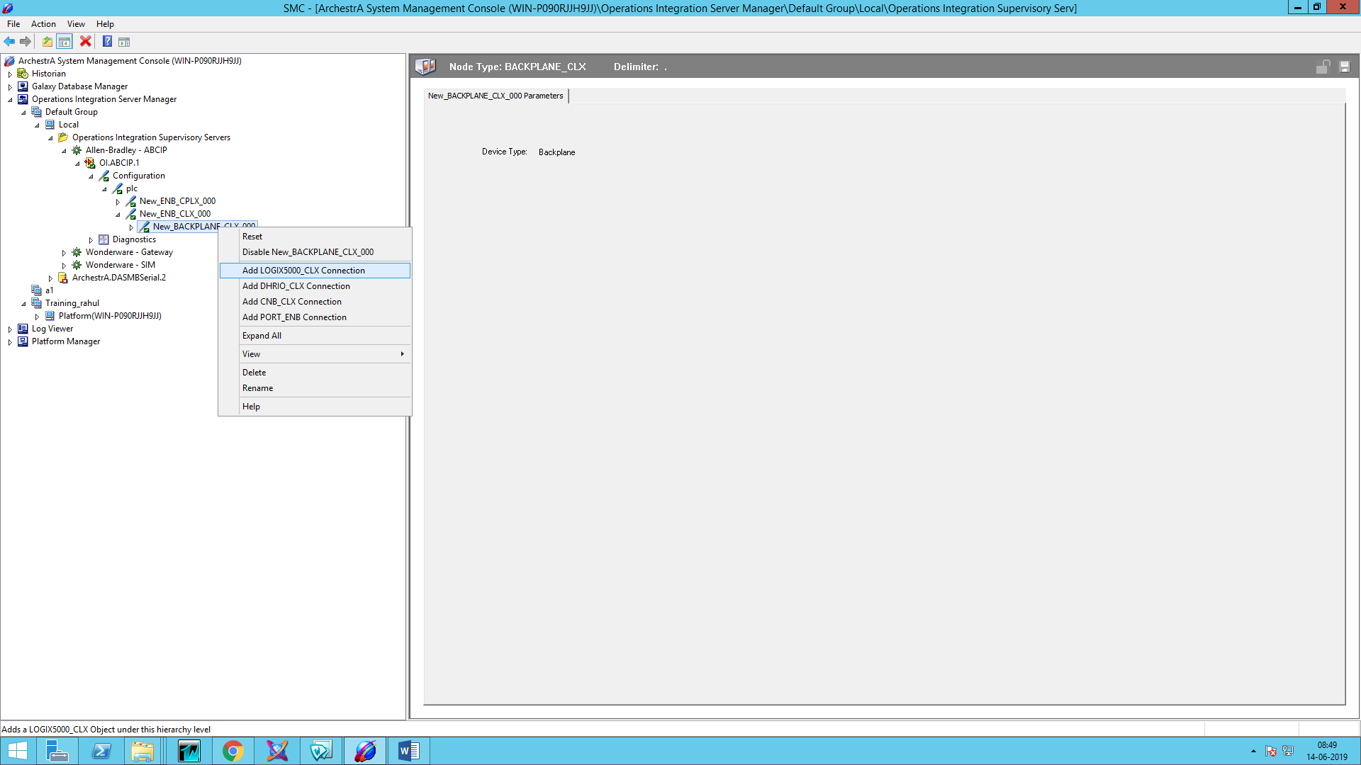

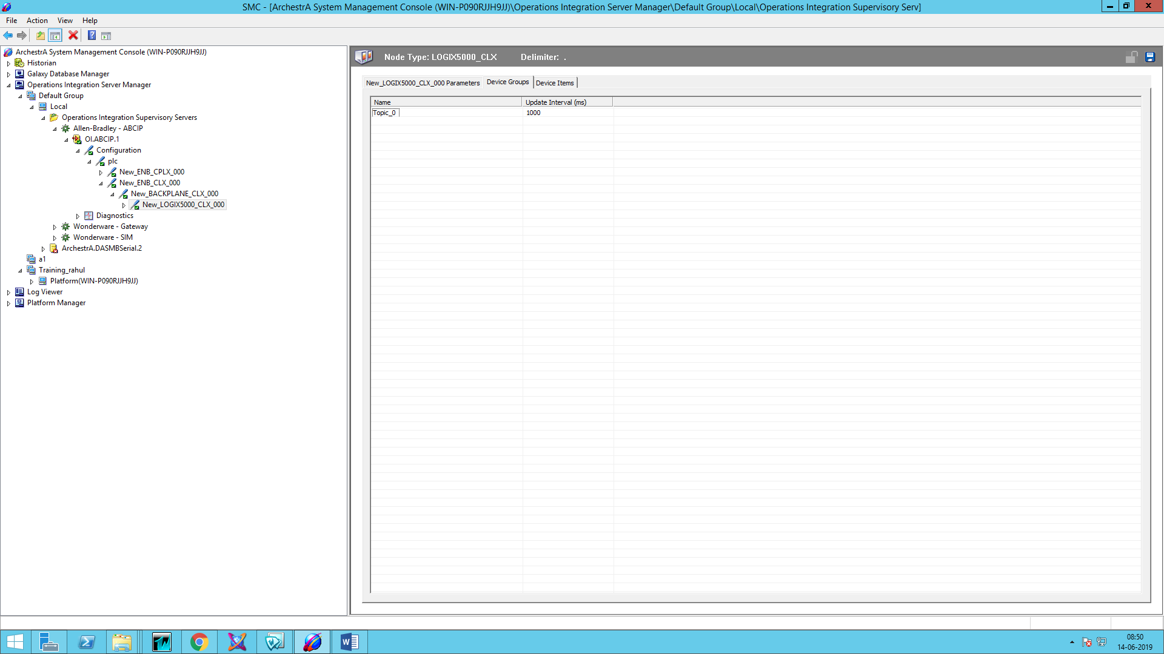

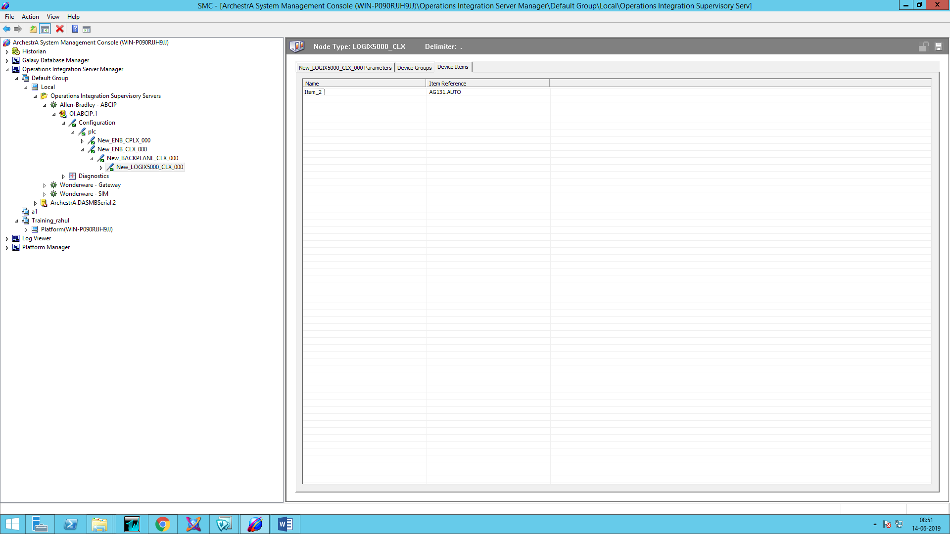

7. Now open WW Client and check connectivity of tags as described above.