**Energy meter Looping Connection:-**

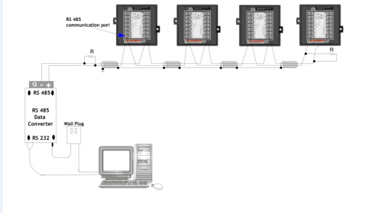

**Fig.1**

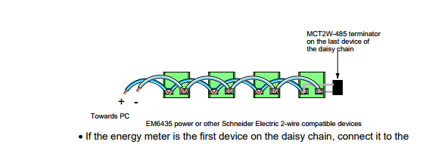

**Fig. 2**

**Loop structure of energy management system is seen in above fig 1.All the energy meter’s RS 485/232 port is in loop is connected parallel with each other (maximum 32 energy meter take in loop as per the standard).**

**Possibility of Fault in Loop:-**

|  |  |  |
| --- | --- | --- |
| No | Fault | Step to correct |
| 1 | Cross connection in Loop | Manually check connection between +ve to +ve and –ve to –ve. |
| 2 | Continuity Problem in loop | Step by step test loop by using the multi meter  If continuity breaks between two meter, then check the connection of RS 485. |
| 3 | Terminal box(TB) short | Step by step check by using multi meter if continuity obtains between TB’s +ve and –ve terminal then replace it. |
| 4 | DB9 connector | Check DB9 connector 3, 4, 5 number pin (+, - , GR). |
| 5 | Due to External Factor | Provide proper protection to loop cable. |
| 6 | Fault in MOXA port | Check loop by using U-port, if all meter are given response then change N-port MOXA port and also change in database new assign port and Restart X-force DAS. |
| 7 | If more than one loop commutation fail in same N-port MOXA | Ping the same N-port MOXA on assign IP,if destination host unreachable than check LAN connectivity. |

|  |  |
| --- | --- |
| **RS232 Communication** | **RS485 Communication** |
| **2,3,5 (+,-,GR)** | **3,4,5 (+,-,GR)** |