**Alarm DB Restore Utility**

1. Start the Alarm DB restore utility as seen below. Complete the credentials as seen below. Click the Test Connection button to confirm that the newly created WWALMDB database has been created.

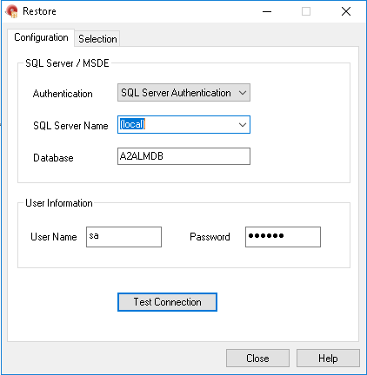

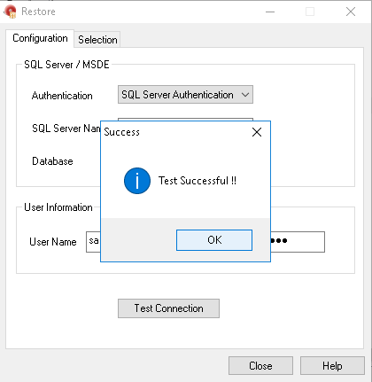

1. Click the Selection Tab and select a Restore from date via the Calendar. Enter folder path and log file path.

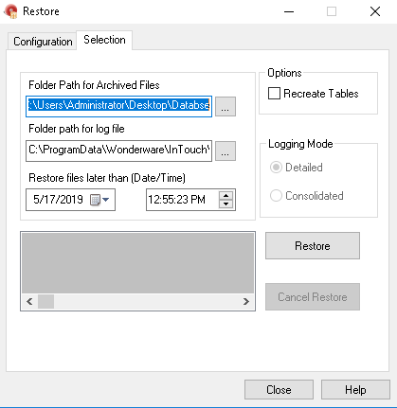

1. Click on the restore it will restore data

