SOP For Configuring MOXA N-Port

**SOP For Configuring MOXA N-Port**

Open Network and Sharing Center as shown below.

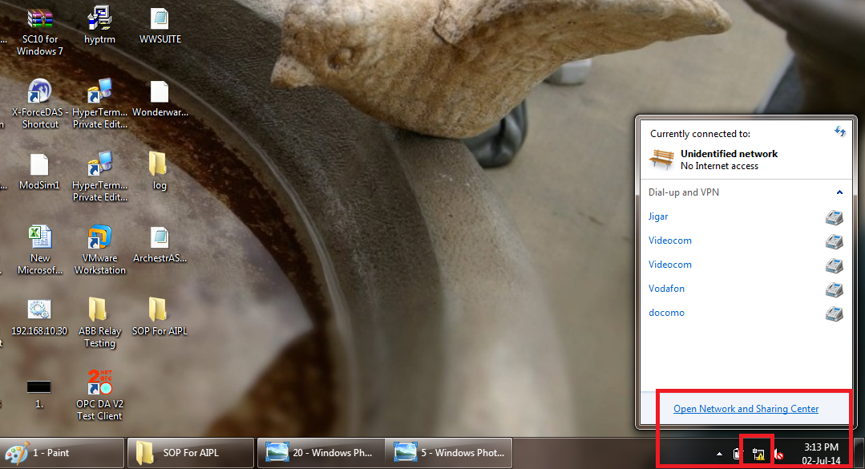

Click on Local Area Connection as shown below.

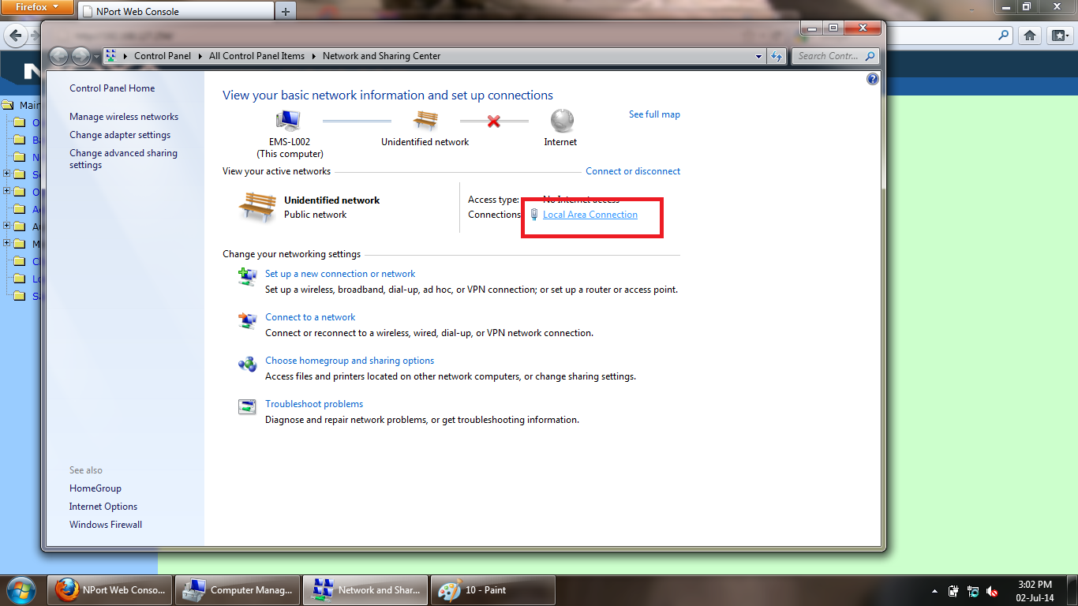

Click on Properties as shown below.

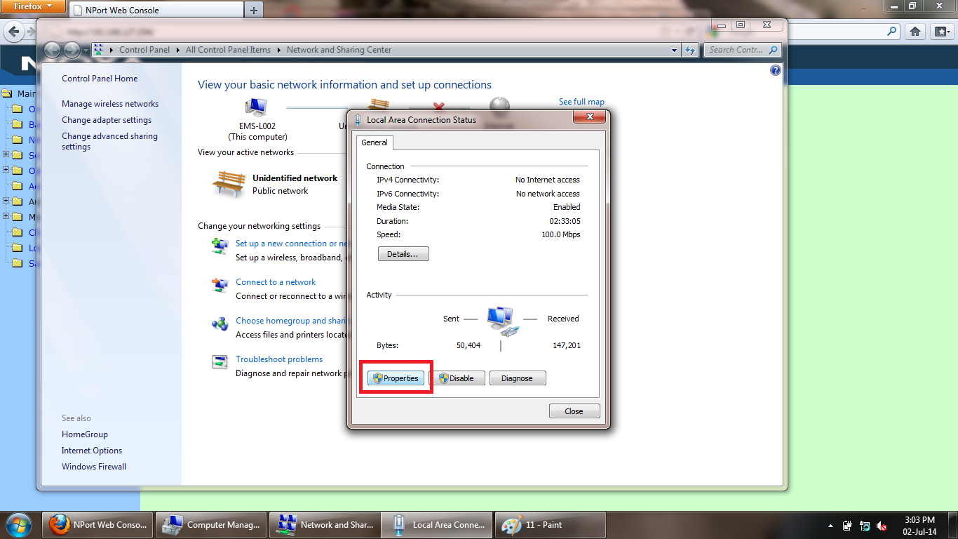

Click on Internet Protocol Version 4 as shown and open properties.

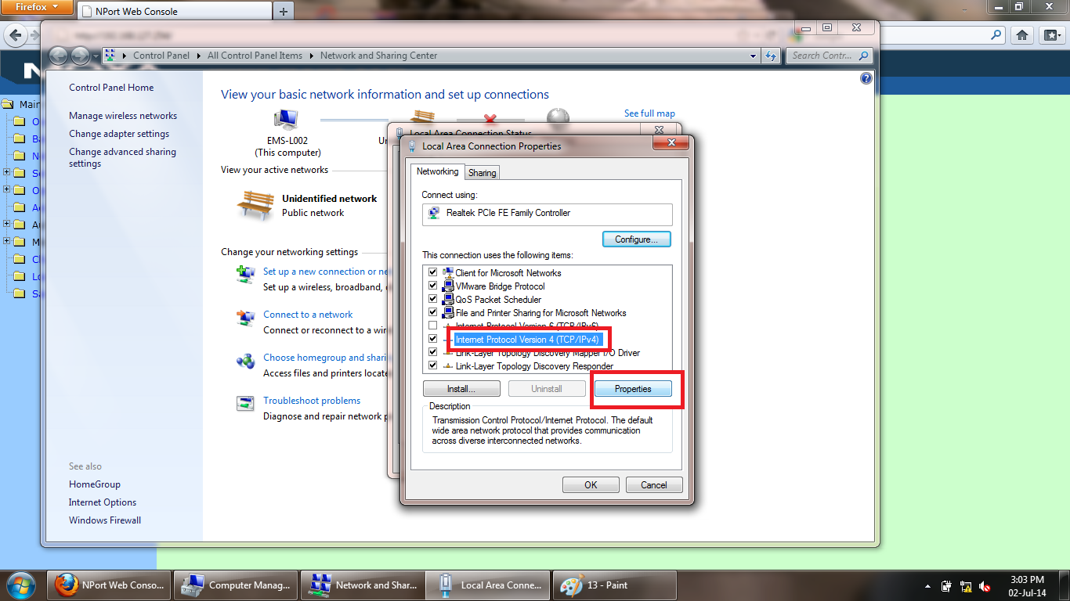

Set the IP of laptop as 192.168.127.250 as shown below.

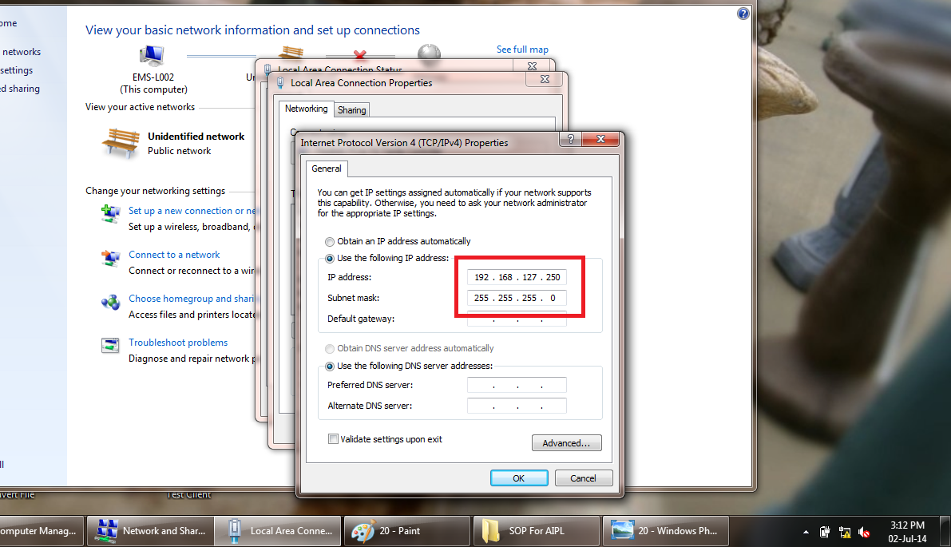

Now open web browser i.e. Firefox or Internet Explorer as shown below and in URL tab enter the IP 192.168.12.254 as below and hit the Enter Key.

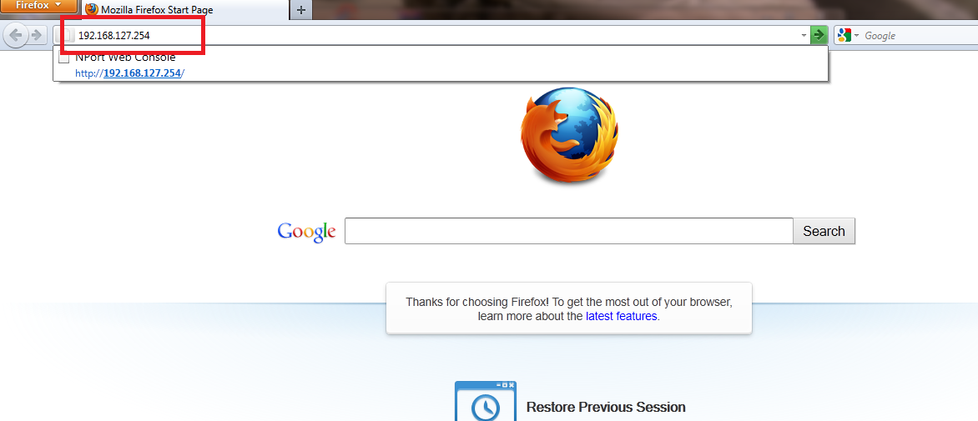

A window like below will open and click on Network Setting as shown below.

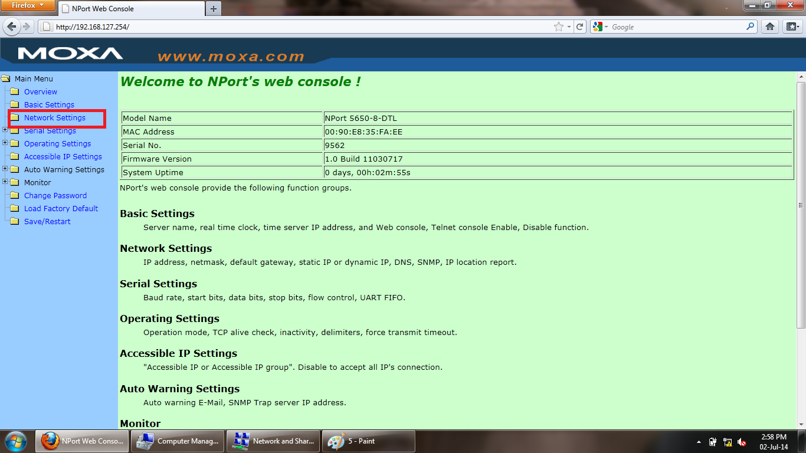

Now enter the IP 192.168.12.204 as shown below into IP address and enter Netmask as shown below and click on submit.

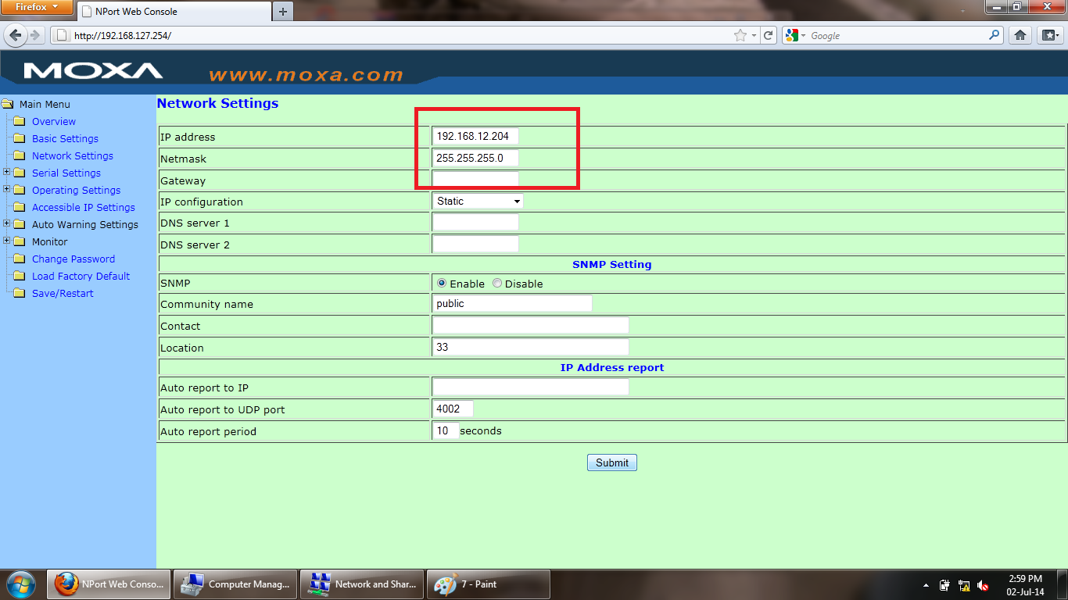

A window will appears like below, now click on Save/Restart button and wait for a Beep Sound from the device.

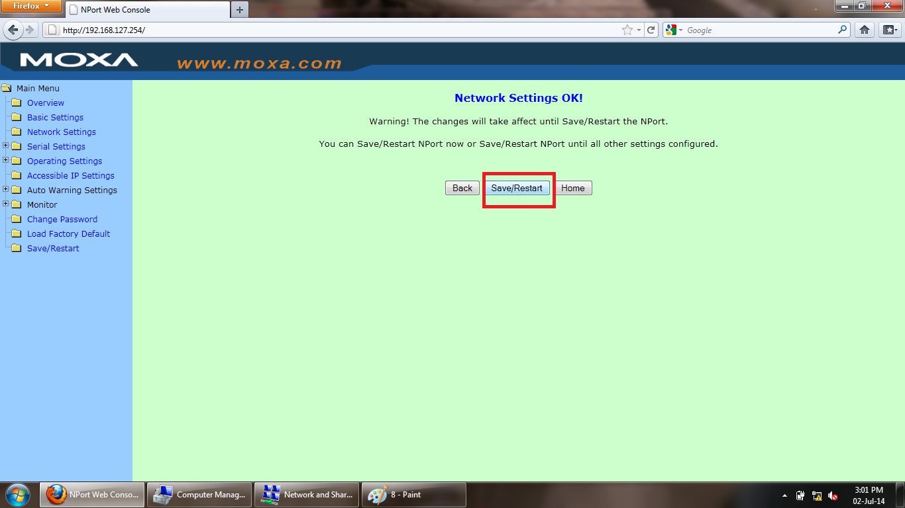

Now again go to Network and Sharing Center as shown below.

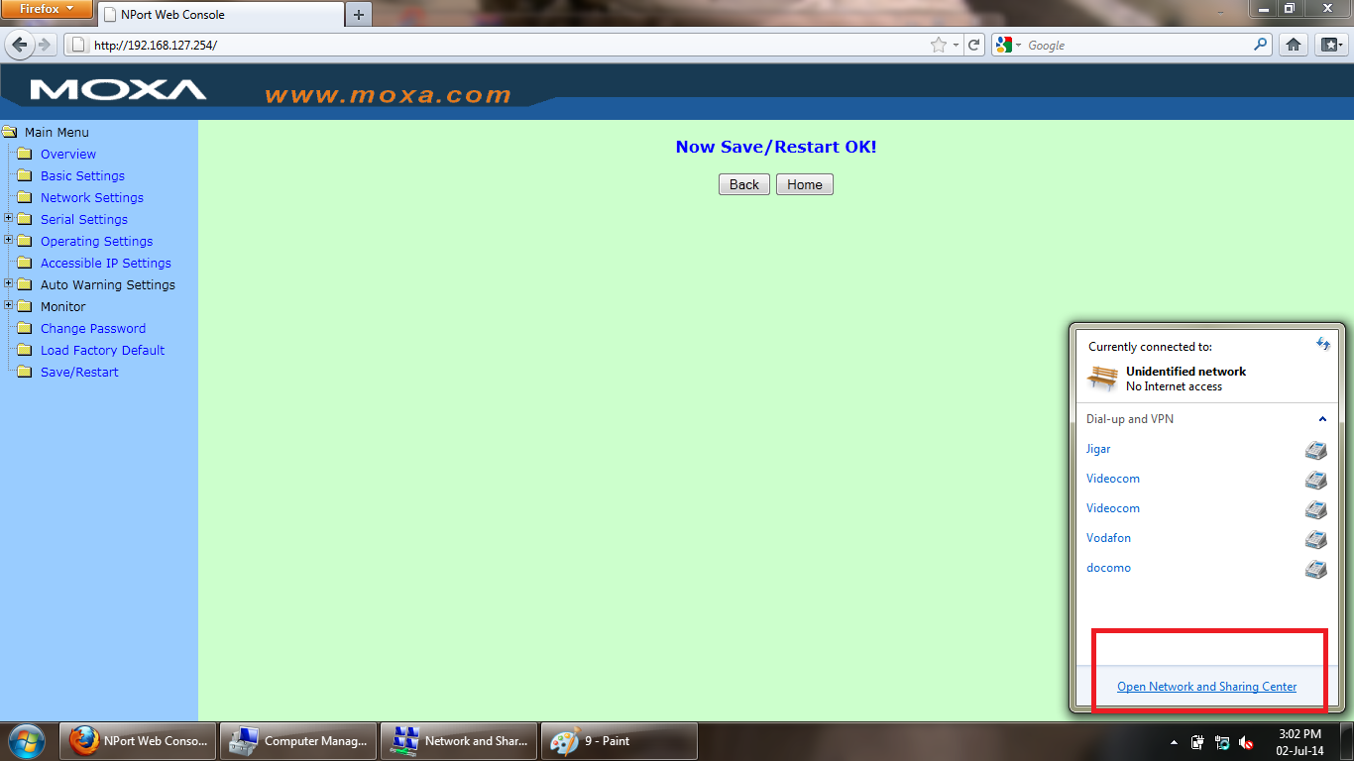

Now click on Local Area Connection as shown below.

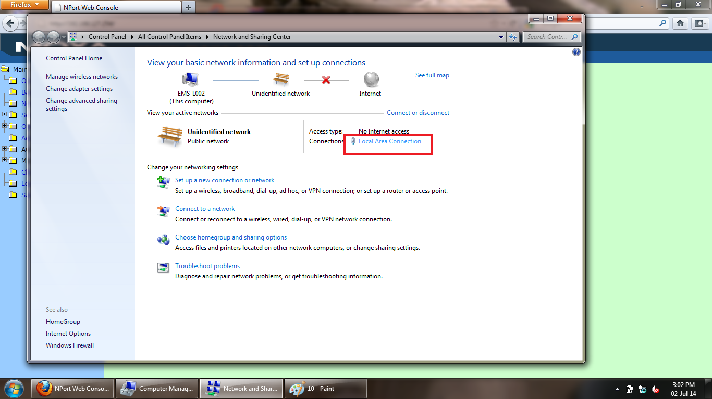

Click on Properties.

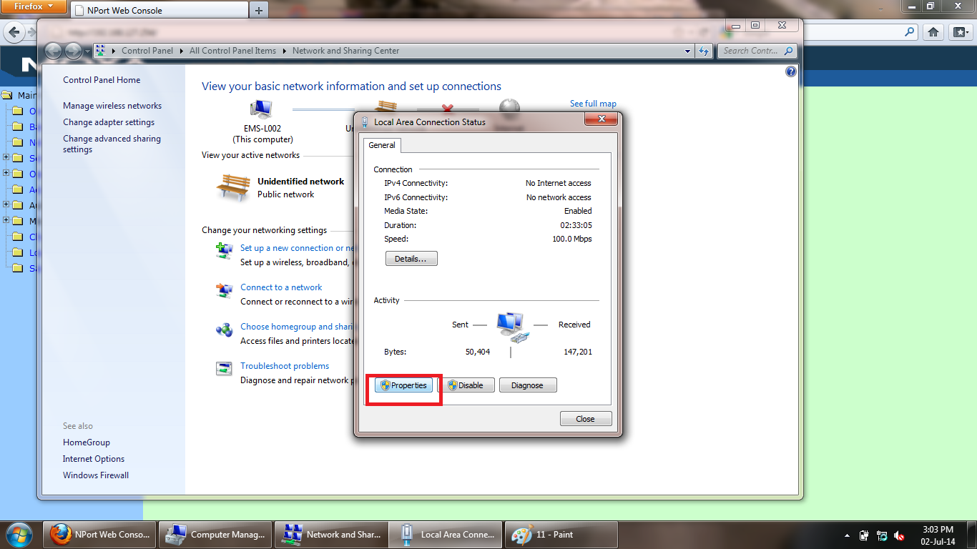

Click on IPV4 as shown and open properties.

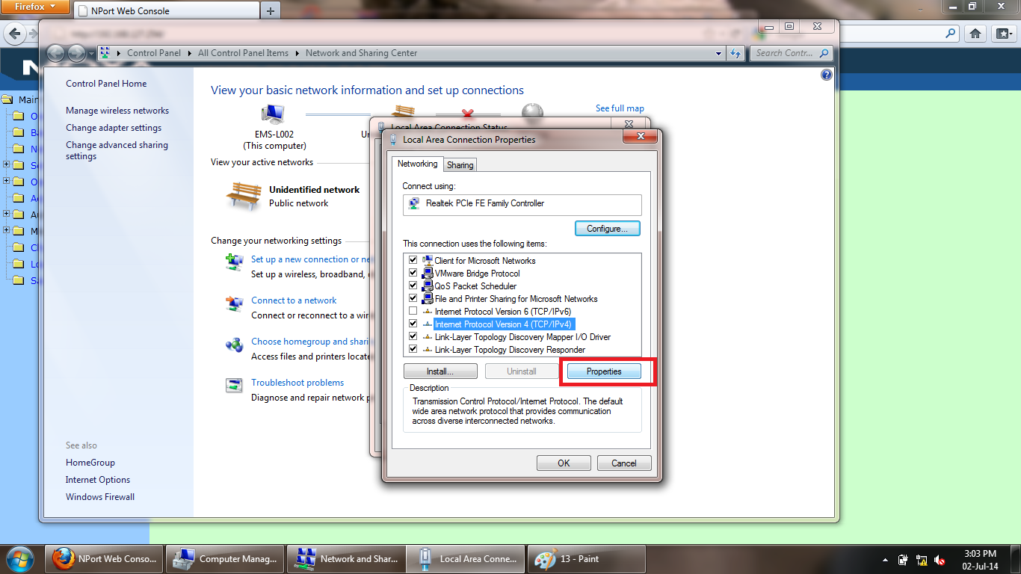

Enter the IP Address 192.168.12.250 and subnet mask as shown below and click on OK > OK > Close.

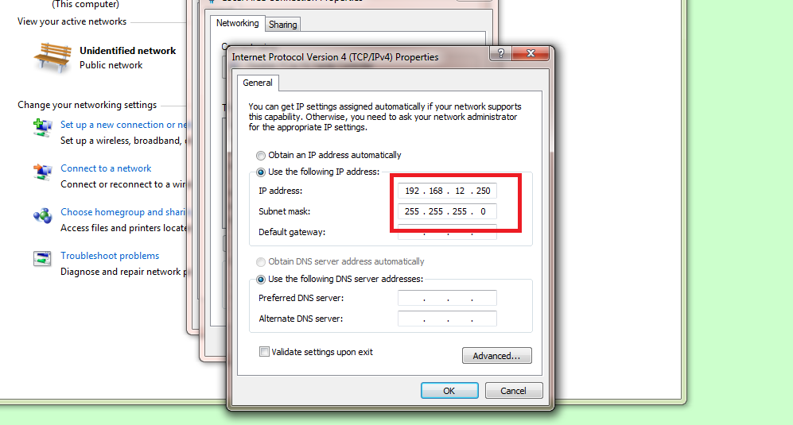

Now again open web browser as shown below and in URL tab enter the IP 192.168.12.204 and hit the enter key.

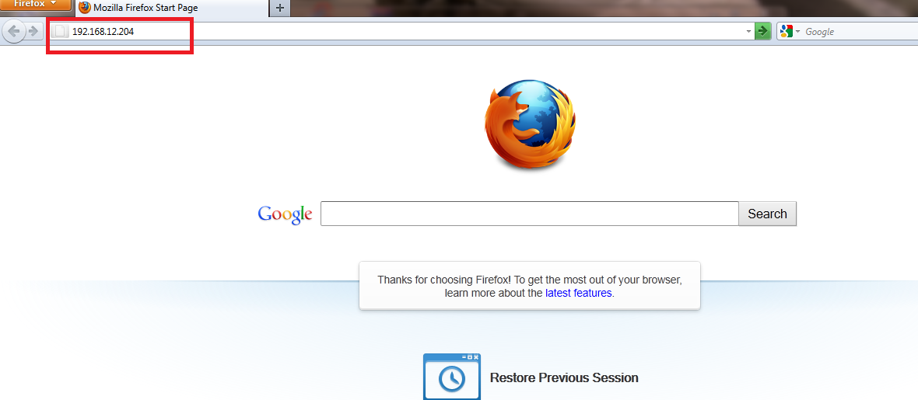

A window like below will open, now click on Serial Setting and a window like below will open.

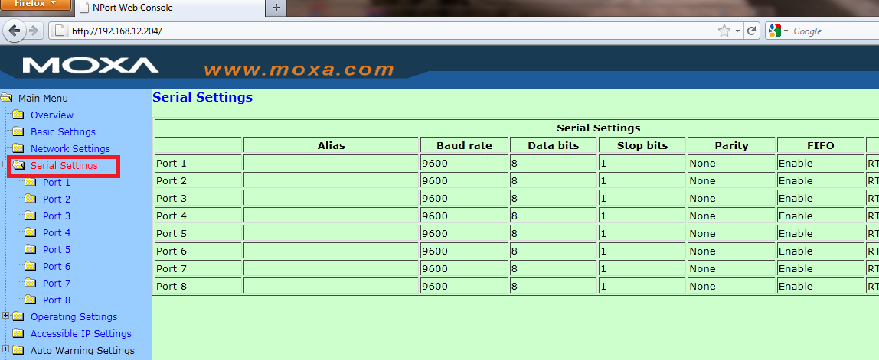

Now Double click on Port 1 and a window like below will open.

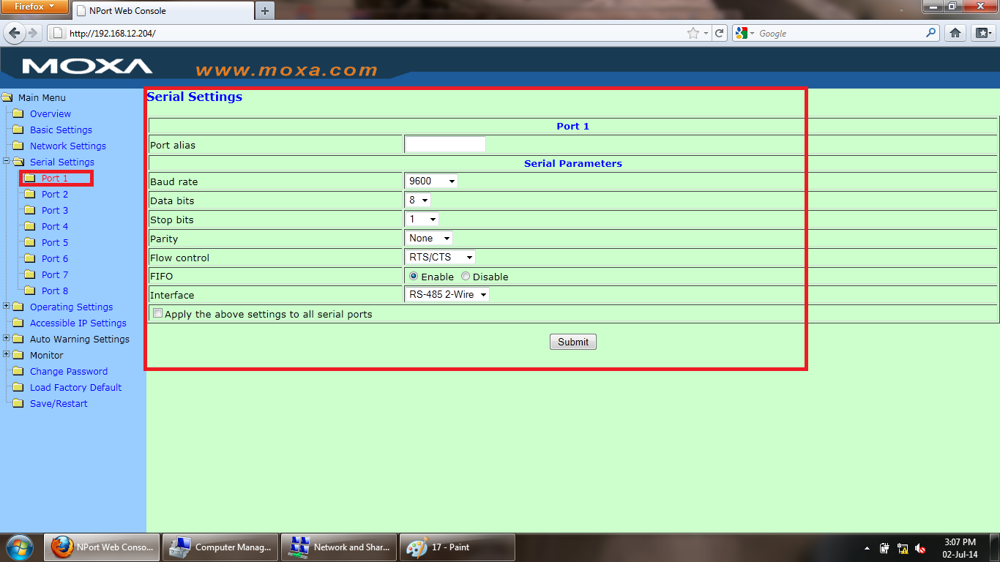

Now select a check box and RS-485 2-Wire from drop down box and set all the parameter as shown below and click on submit button.

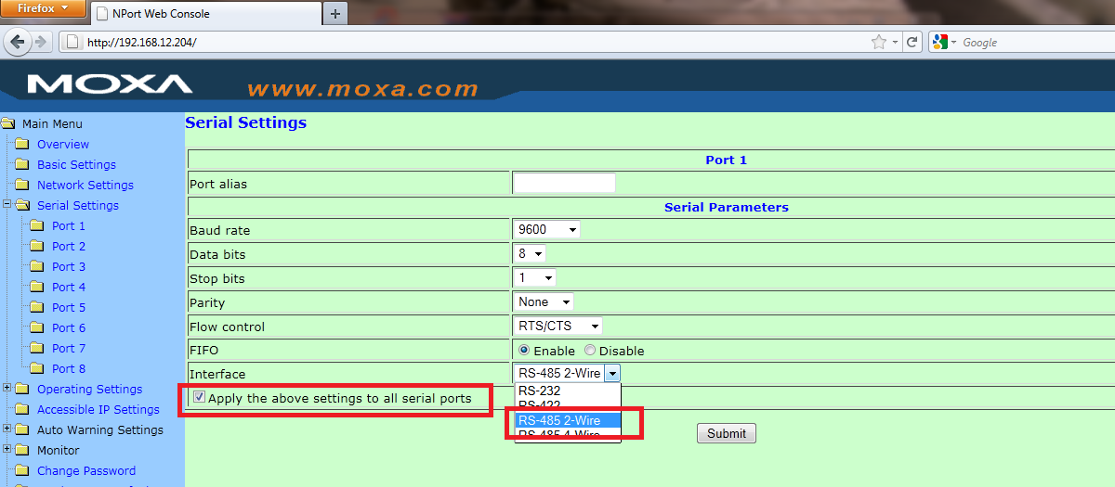

A window will open like below and click on Save/Restart button and wait for a Beep Sound from device.

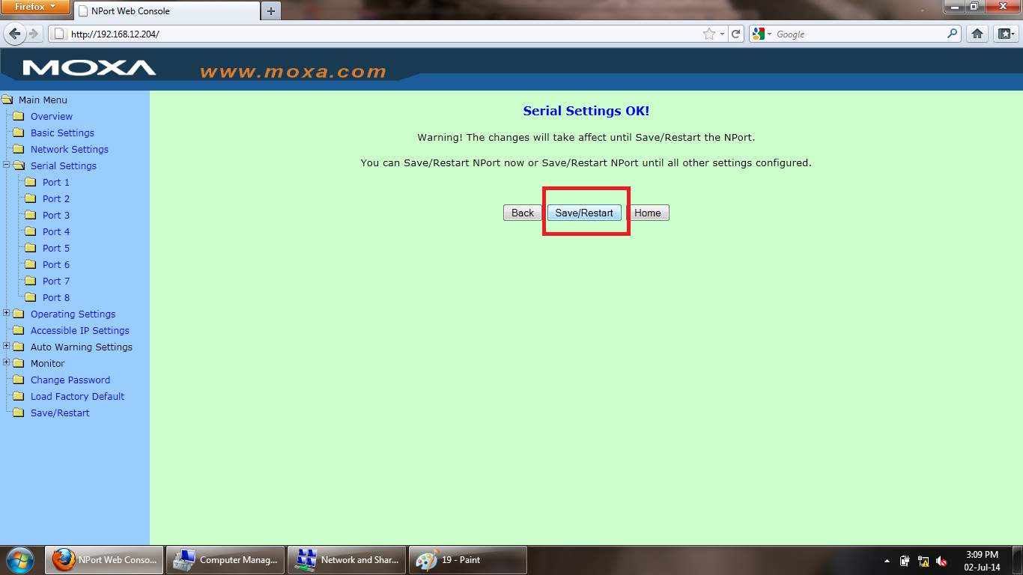

Now remove the Ethernet cable from device.

You Are Done With Configuration.

Thank You.