**Backup and Restoring Modern application**

1. **Backup of the Modern application**

To take Backup of the Modern application click on export and select location where you want to save .aapkg file

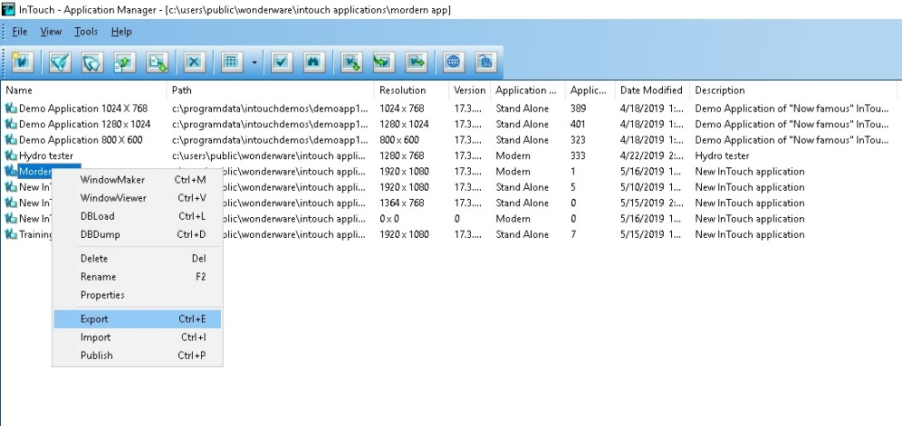 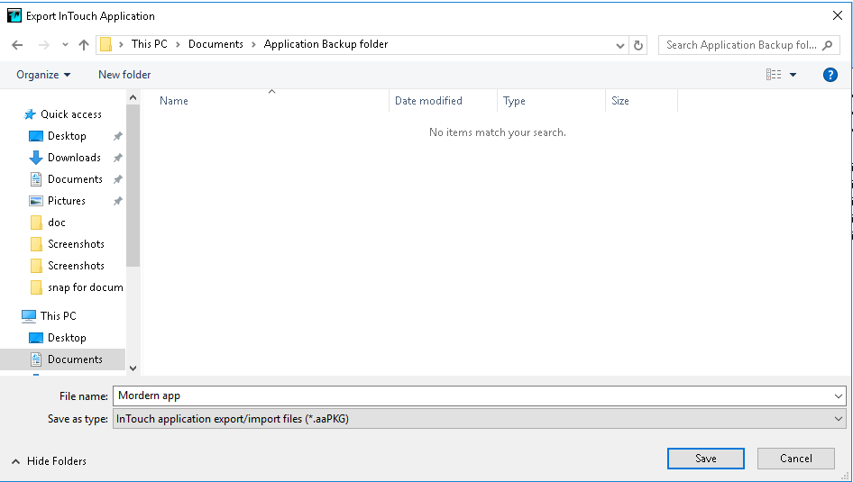

By clicking on save it will start exporting.

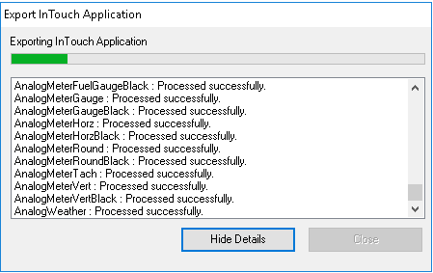

Note: .aapkg stands for Archetra application package

1. **Restoring Modern application**
2. Open to application manager go to file > import option

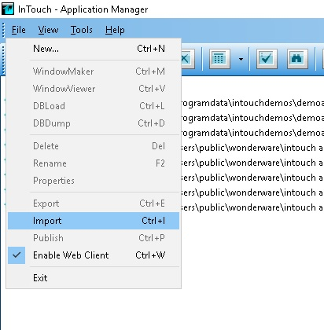

1. Select .aapkg file

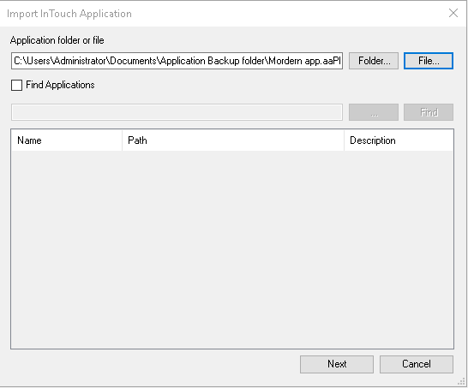

1. Click on next

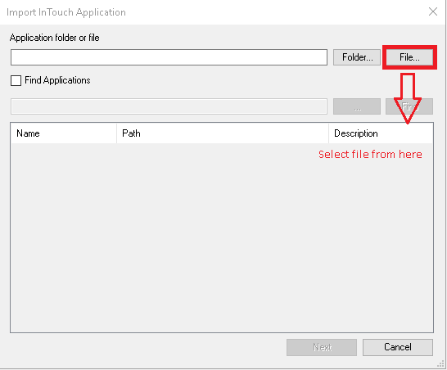

1. It will create new application enter directory application name

