**Alarm DB Purge & Archive Utility**

InTouch Alarm database is getting to large and needs to be archived and purged. This can be accomplished by using the Alarm DB Purge-Archive Utility as below

1. 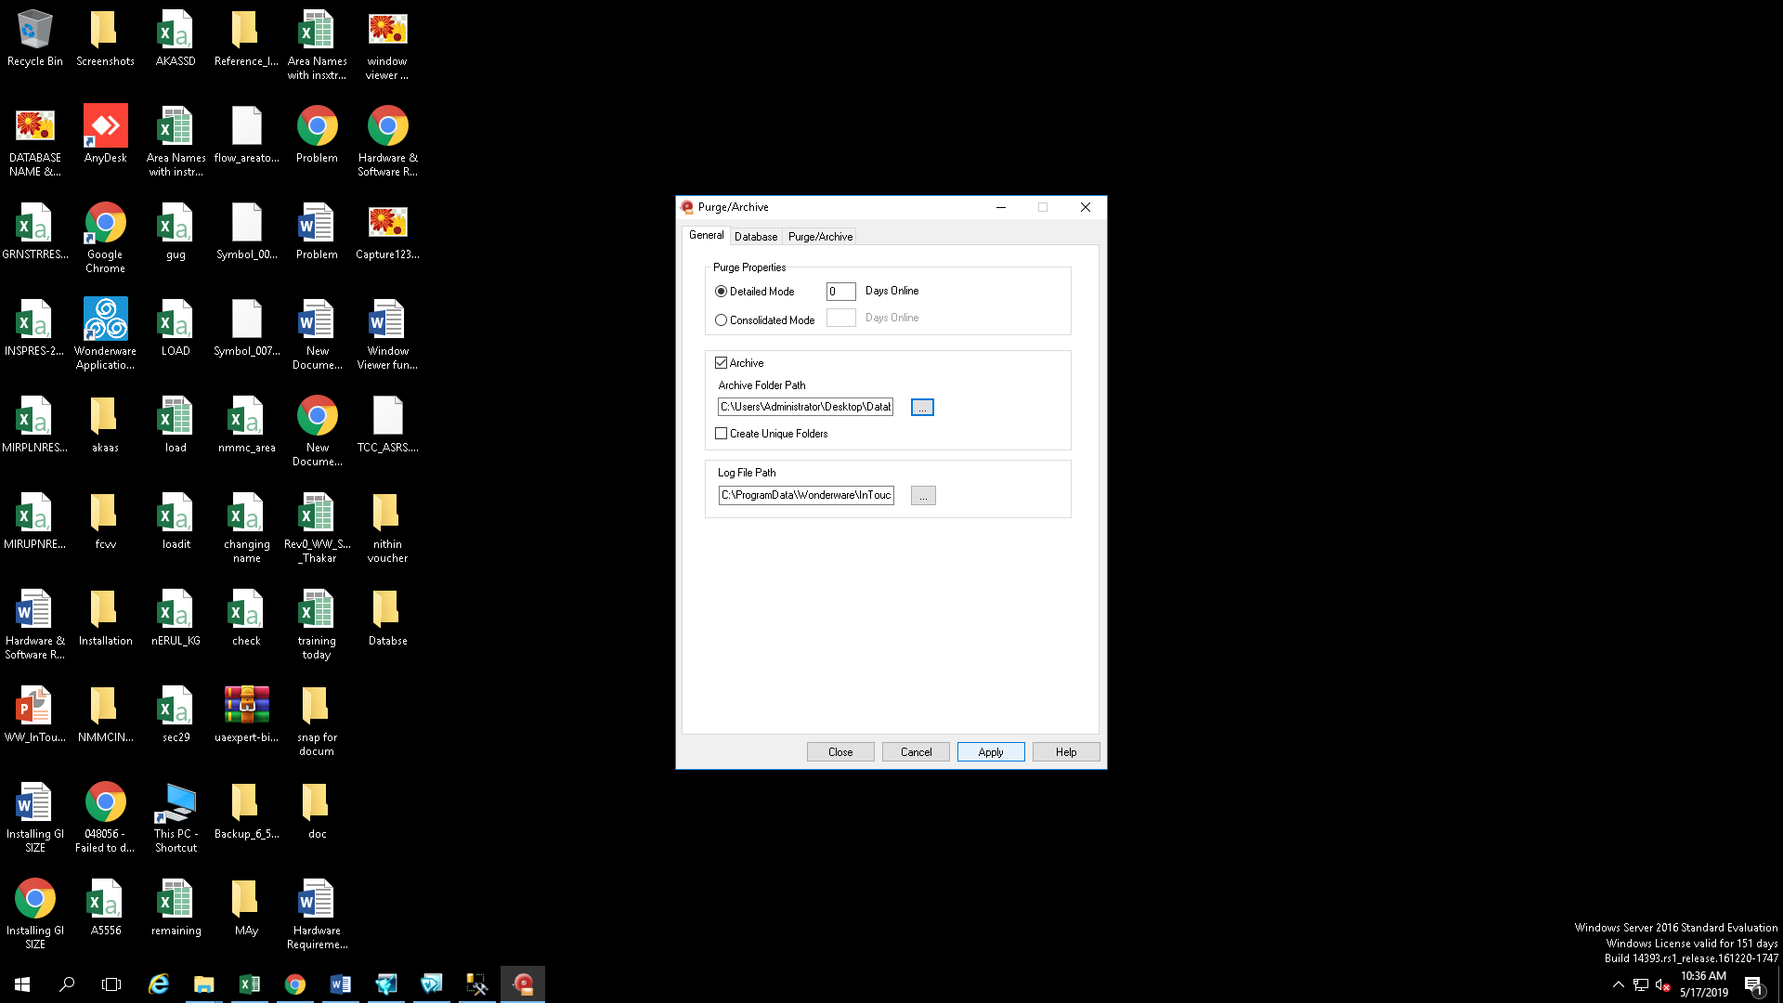Launch the Utility go to genral tab and click on archive
2. 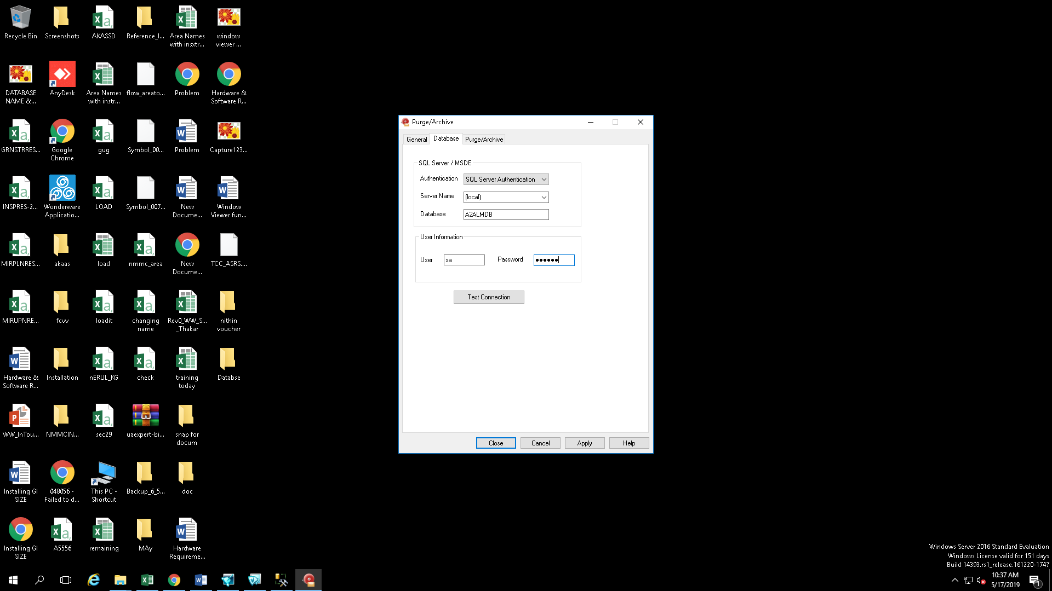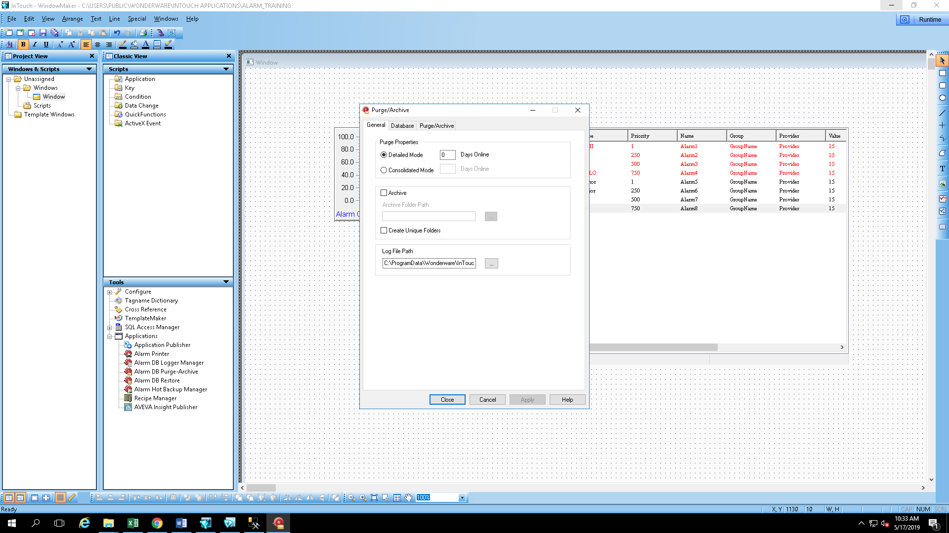Go to Database and enter SQL credentials and test connnections

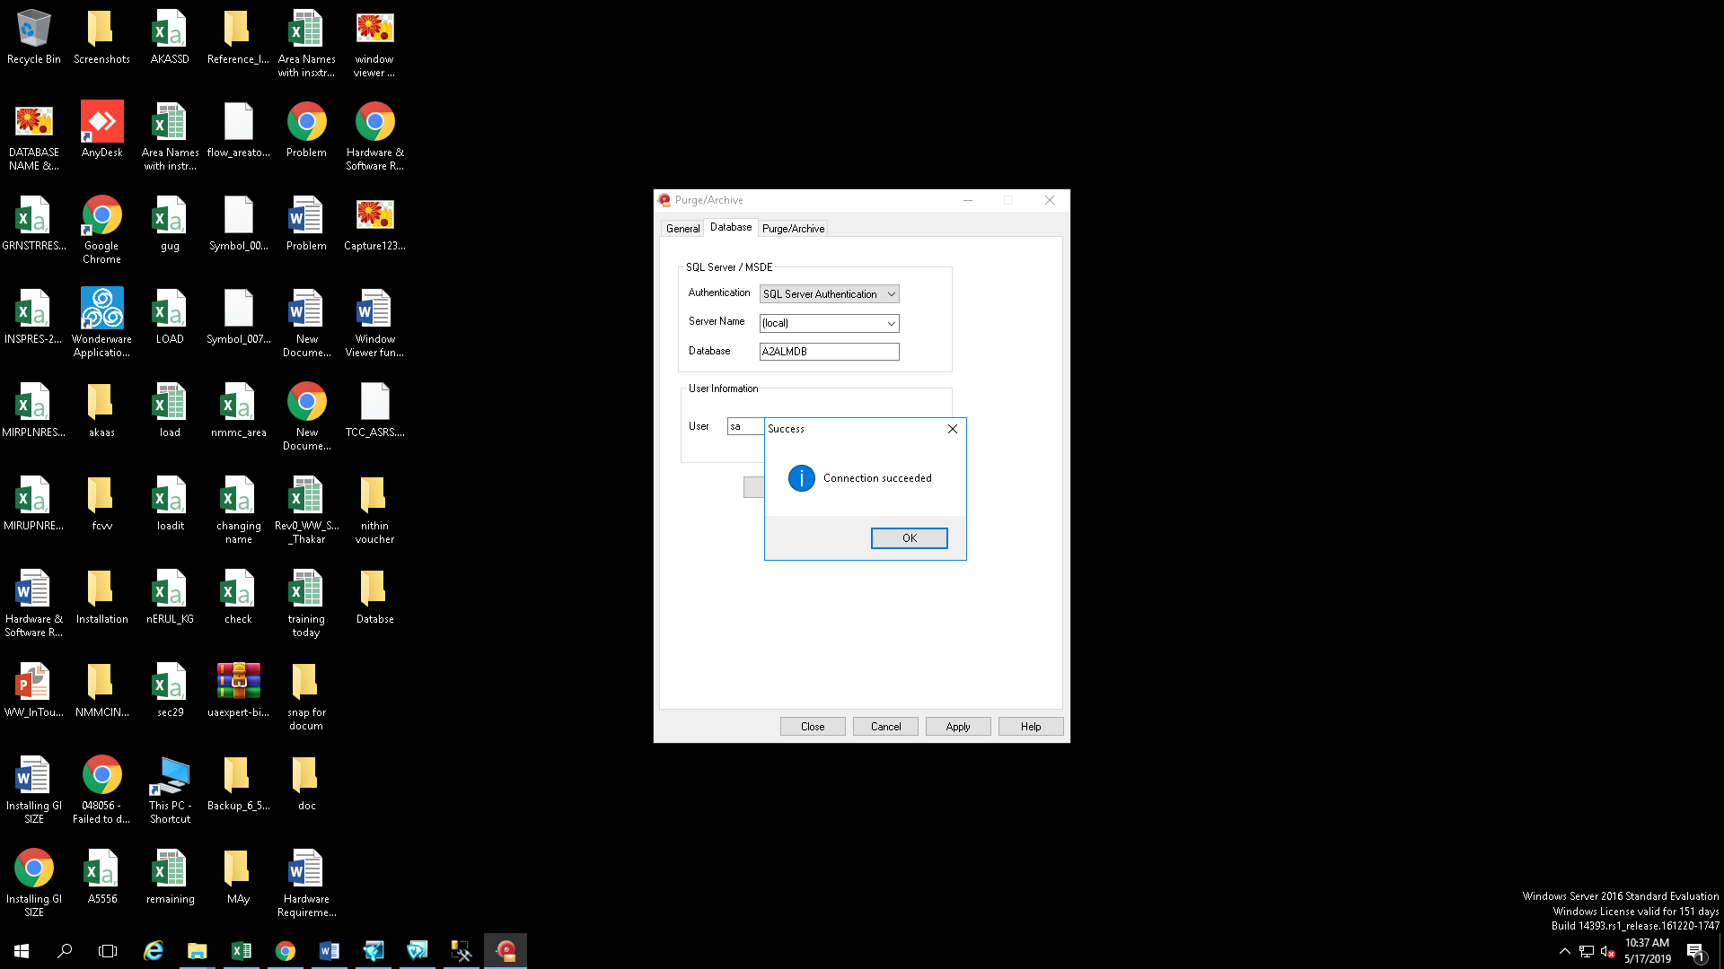

1. Click on the Purge/Archive tab and setup the desired schedule for the purge and archive to happen. Or click on the Purge Now

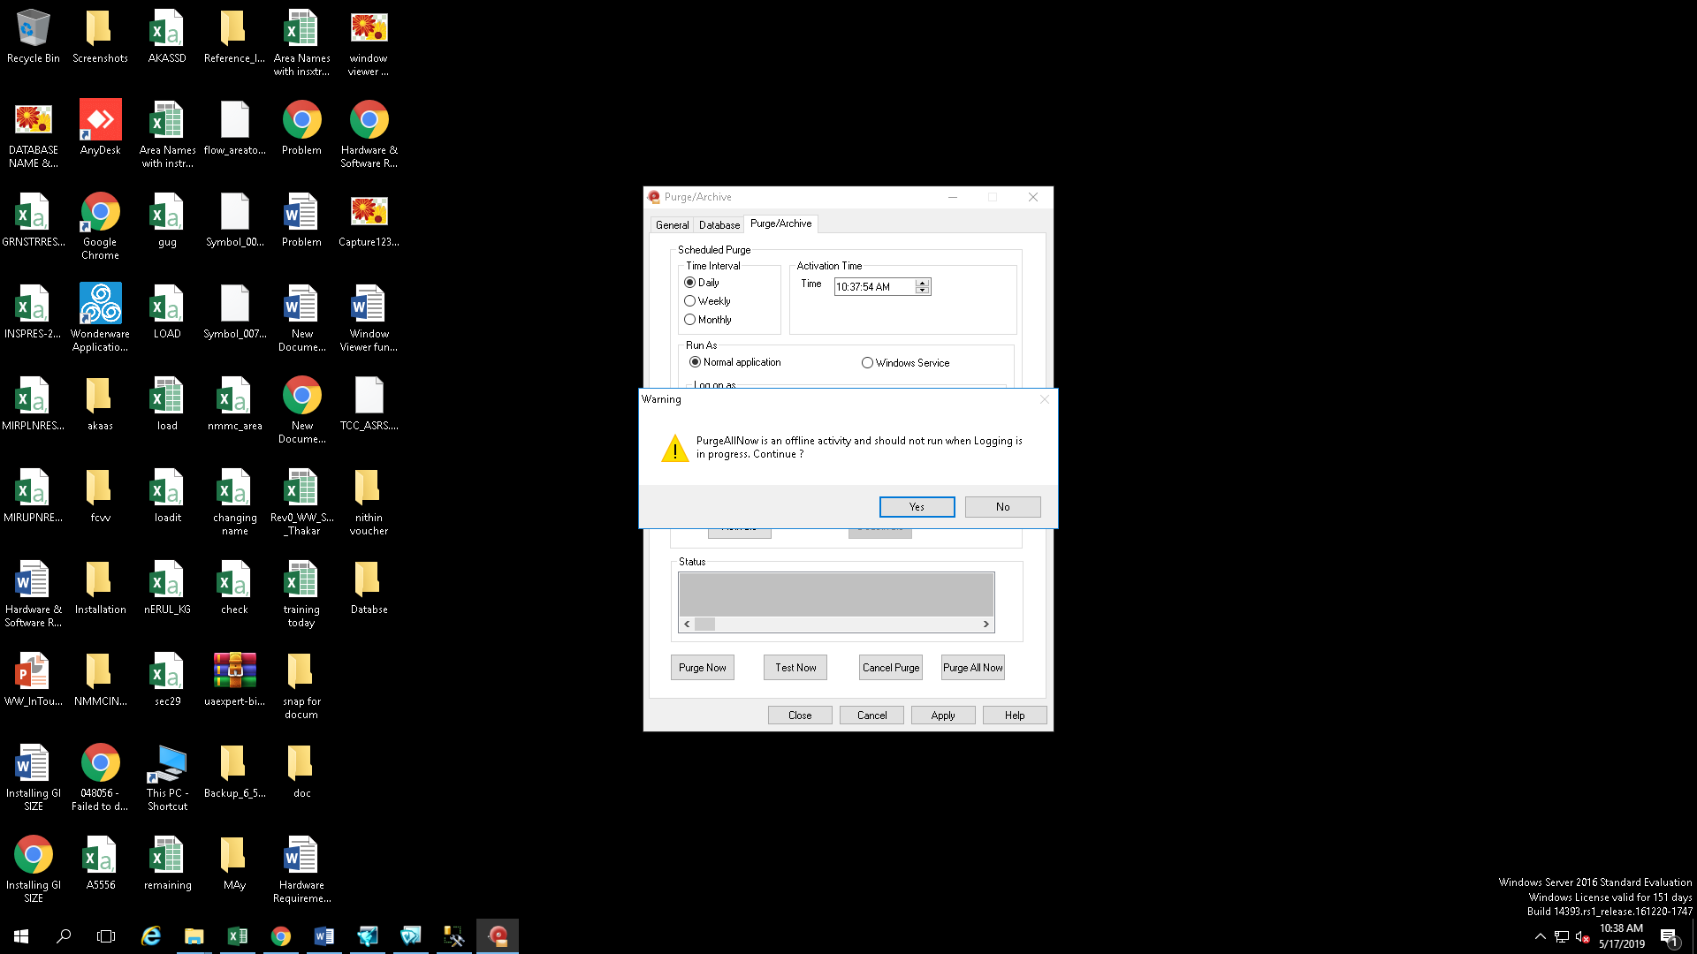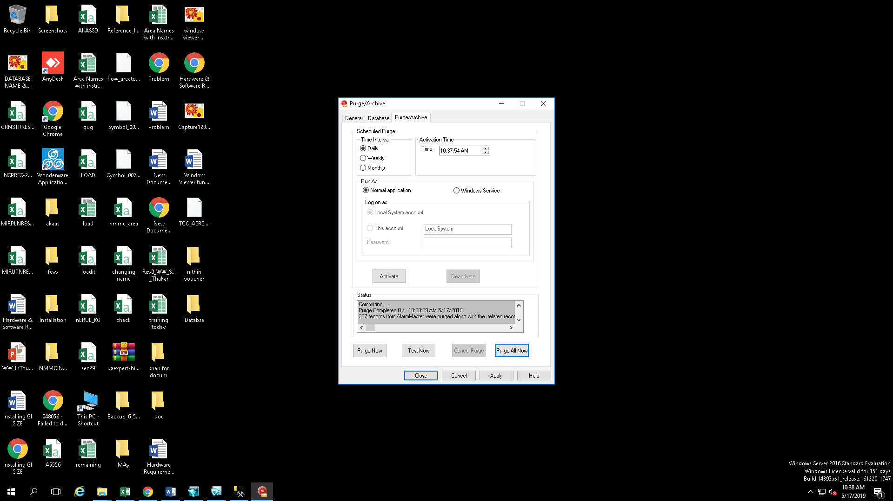

1. Now all SQL database will be stored in the desired folder

