

1

# SOP for Adam 4017+

* Materials require for testing:-

1. ADAM 4017+

* 1. SMPS(For Power Supply)
  2. U-PORT
  3. ADAM Apex Software(In PC)
* Now Connect All hardware as per below:

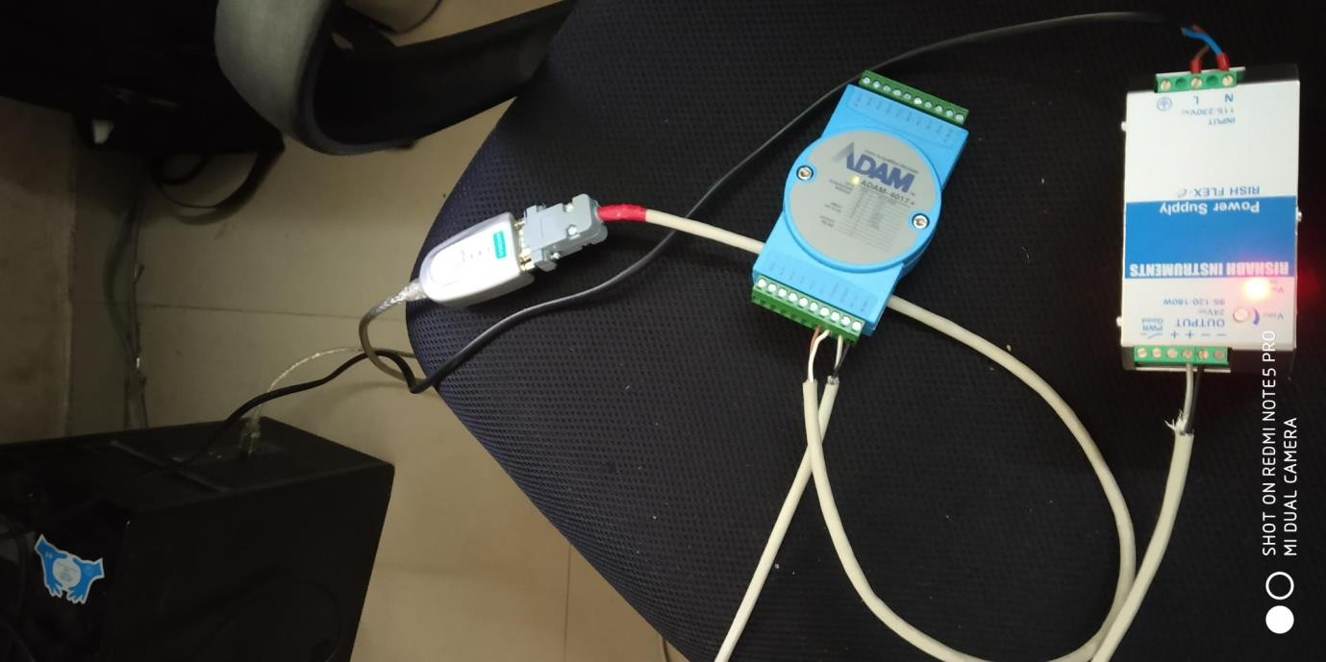



2

# SOP for Adam 4017+

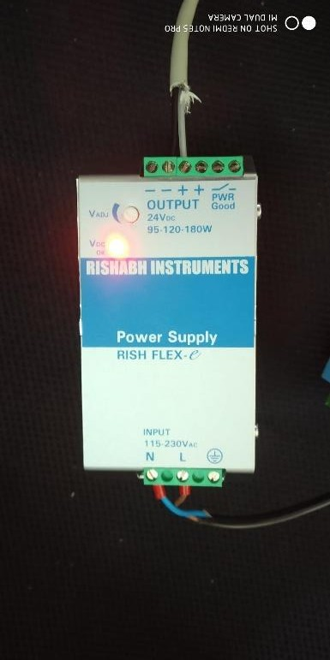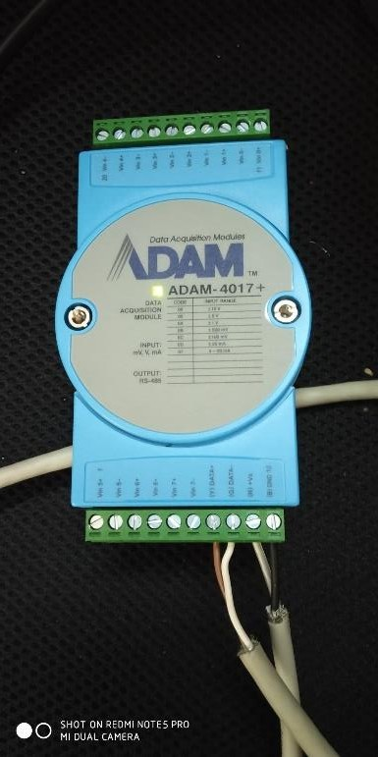



3

SOP for Adam 4017+

* Now open ADAM Apex Software on PC.

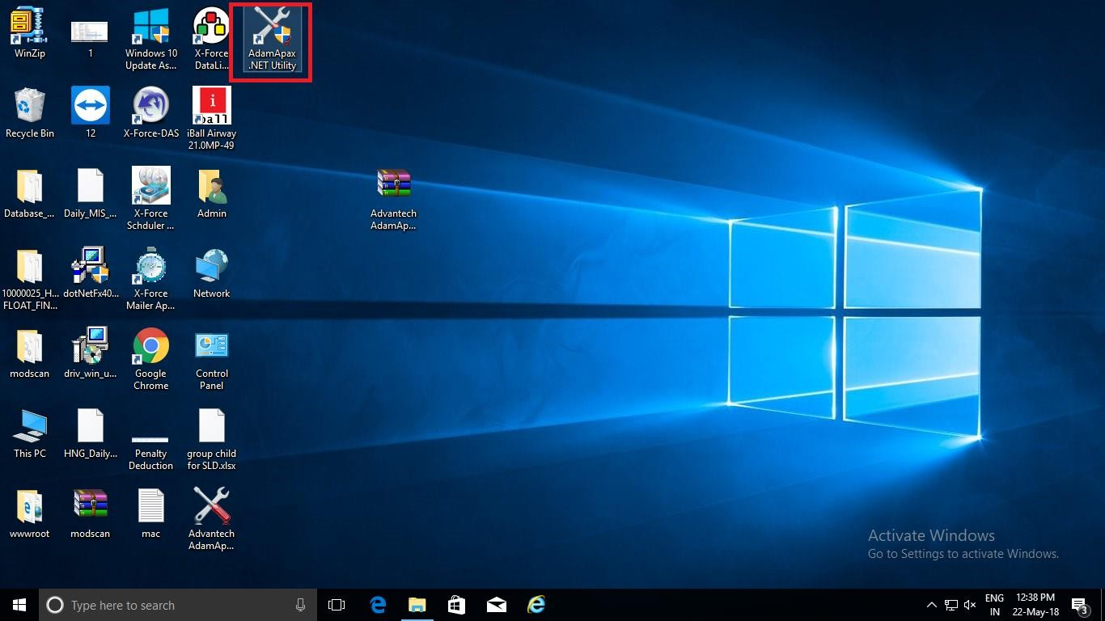



4

# SOP for Adam 4017+

* Now this screen will appear.

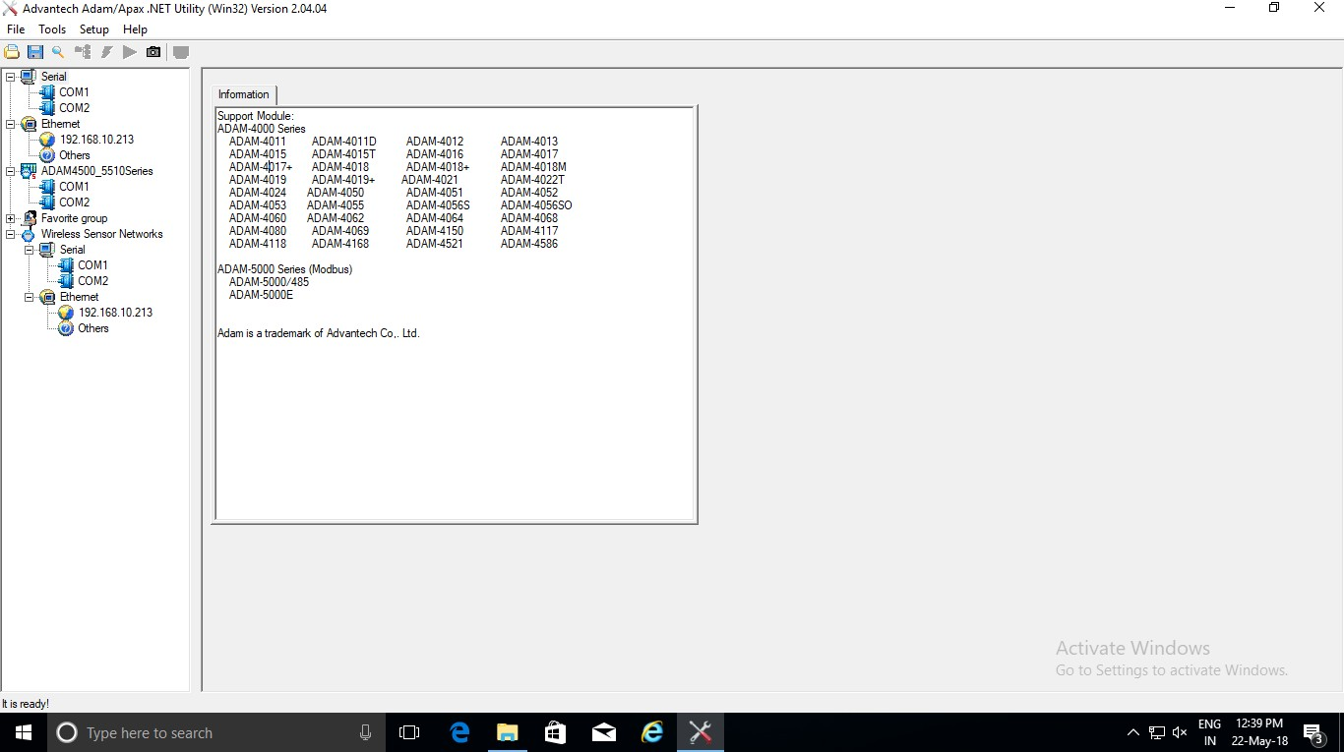

* Now in Serial Tab click on COM that is assigned to U- PORT. (Like COM2 in this case).

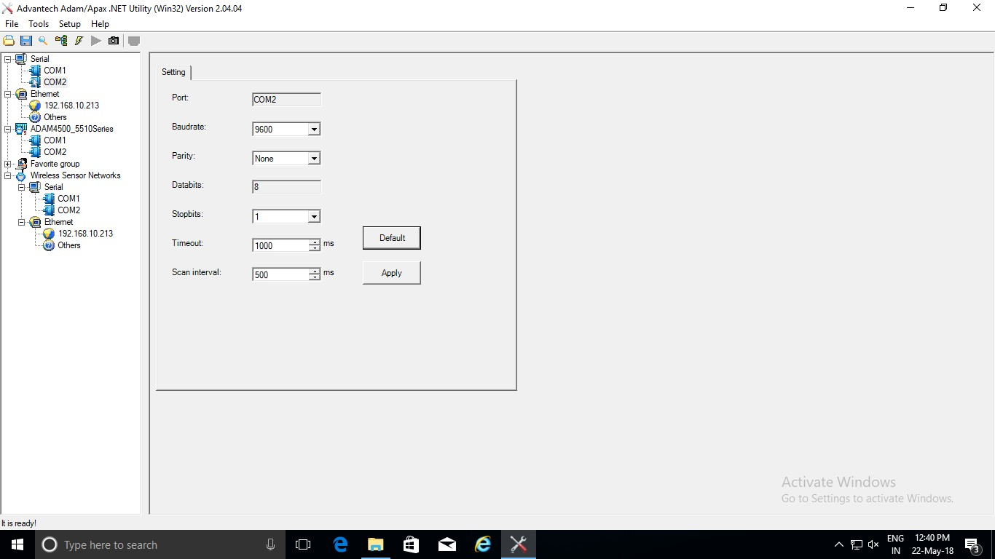

5

SOP for Adam 4017+

* Now click on restore default & apply.

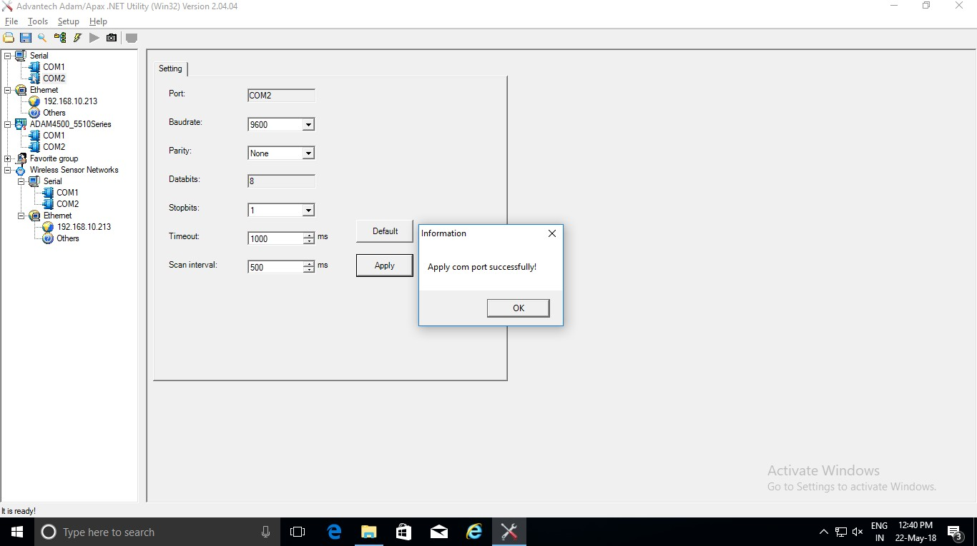



6

# SOP for Adam 4017+

* Right click on COM2 & select Search. After that start the search.

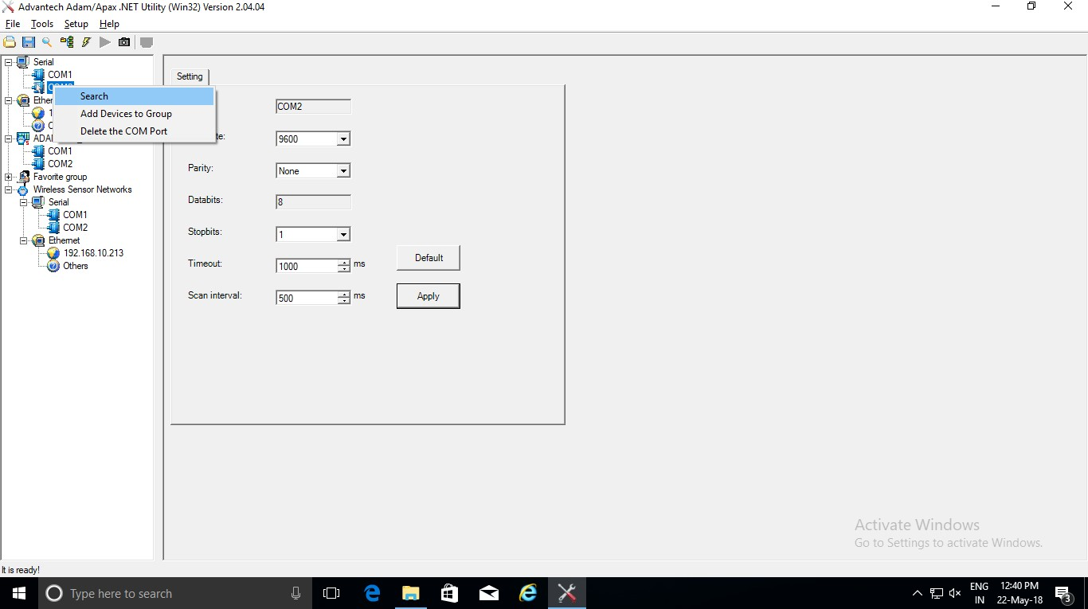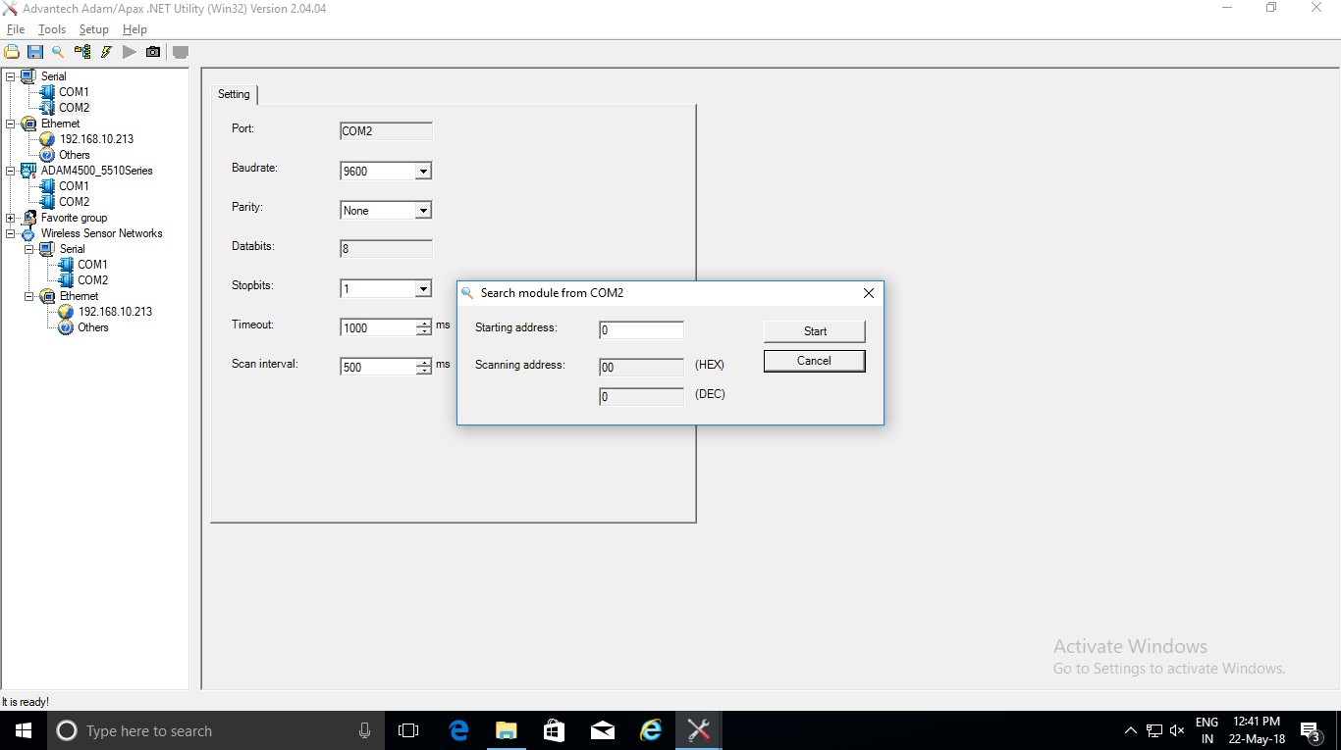



7

# SOP for Adam 4017+

* When ADAM will detect, Cancel the search & click on that, after click Data area.

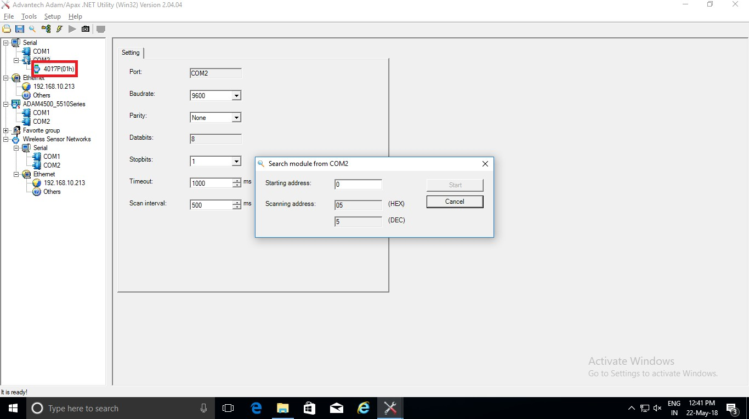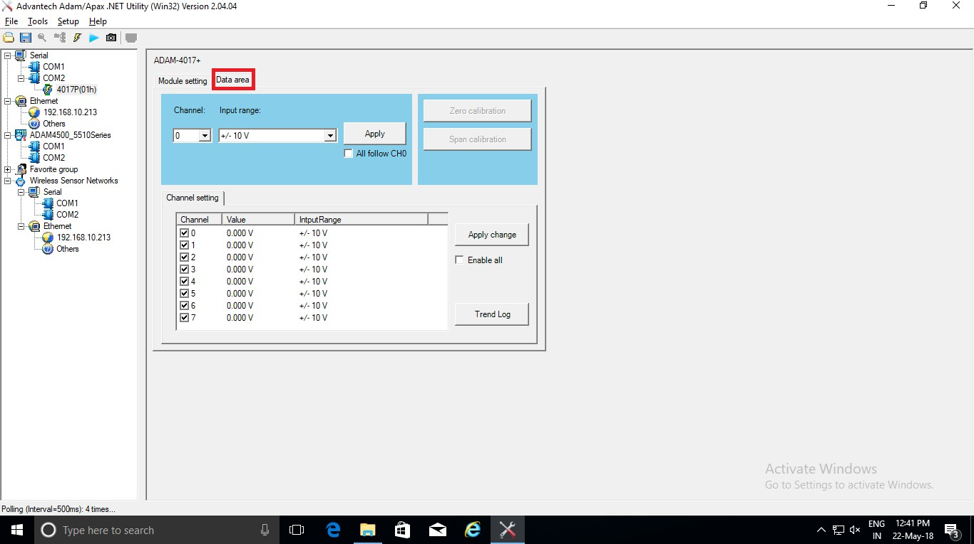



8

# SOP for Adam 4017+

* Now short the ADAM as per below & it will reflect changes on Voltage.

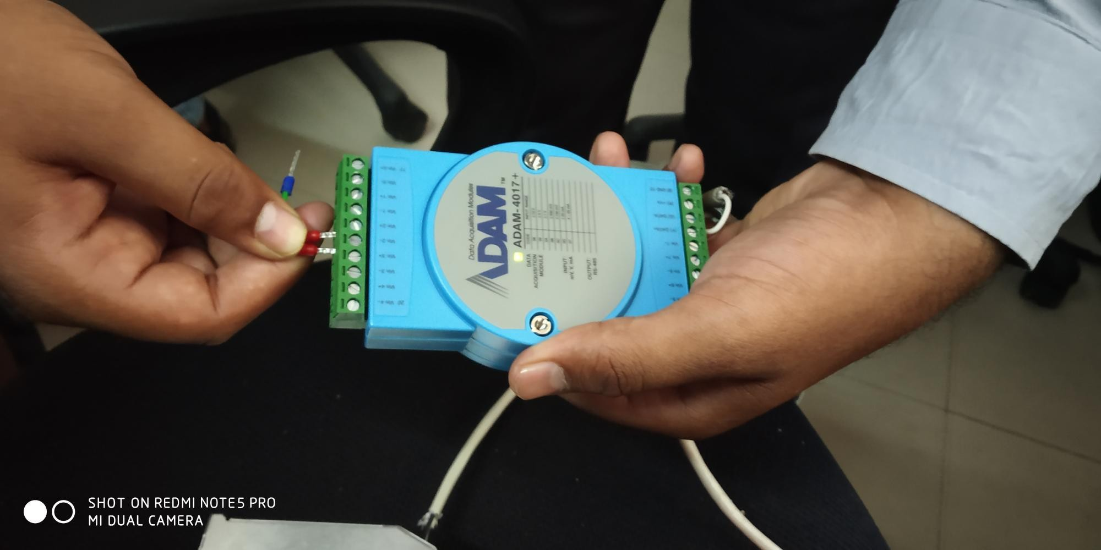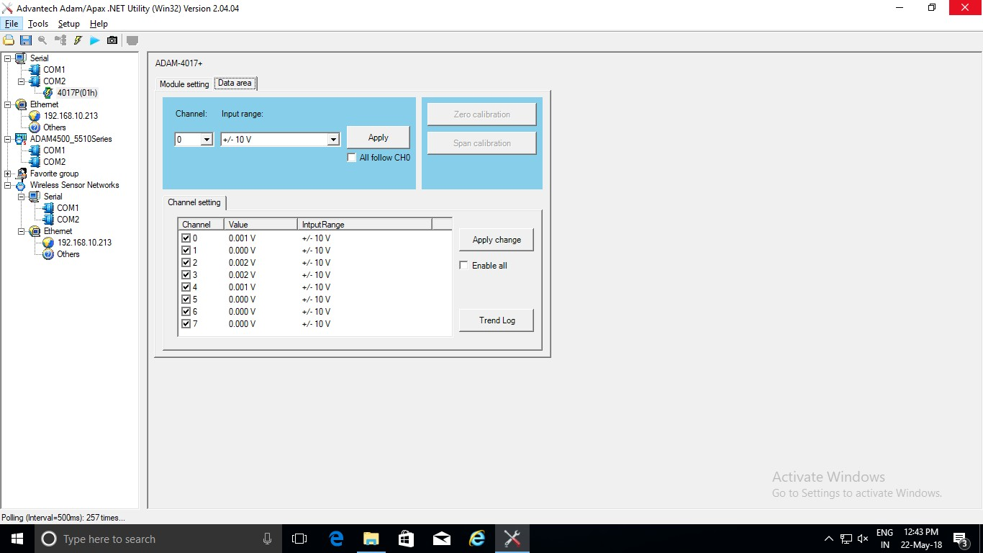



9