SOP For HTML Web Trend

**By**

**Mehul Mawapuri**

**Follow below screenshot and instruction for How to Configure and Access HTML Web Trend**

* Open dbo.tbl_int_menu table of EMS_Config database and changed NewTrend URL as per the location show in below screenshot.

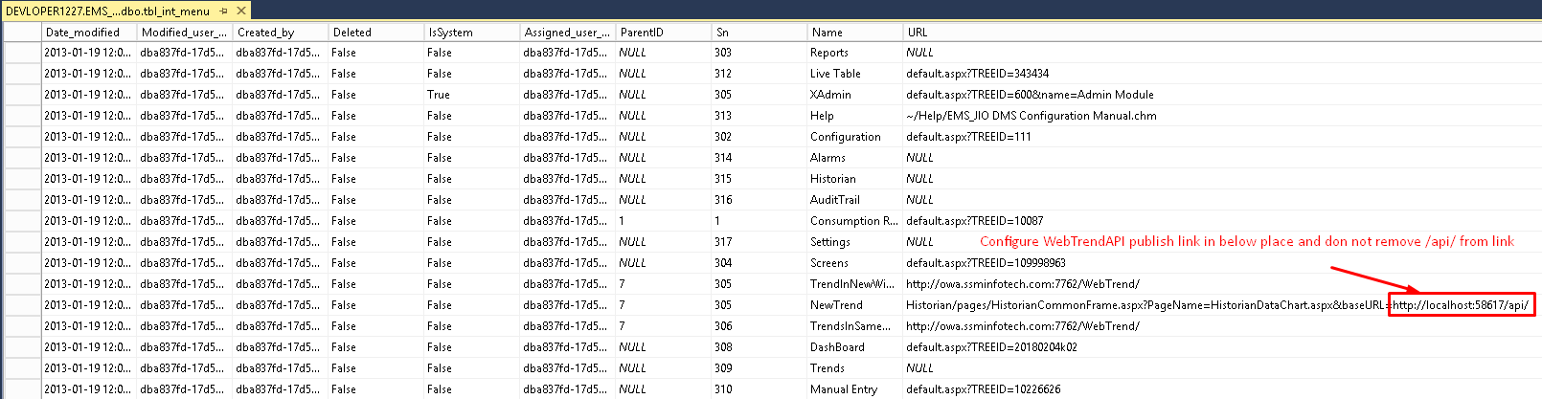

* Open EMS Portal in Web Browser follow the steps shown in below screenshot.

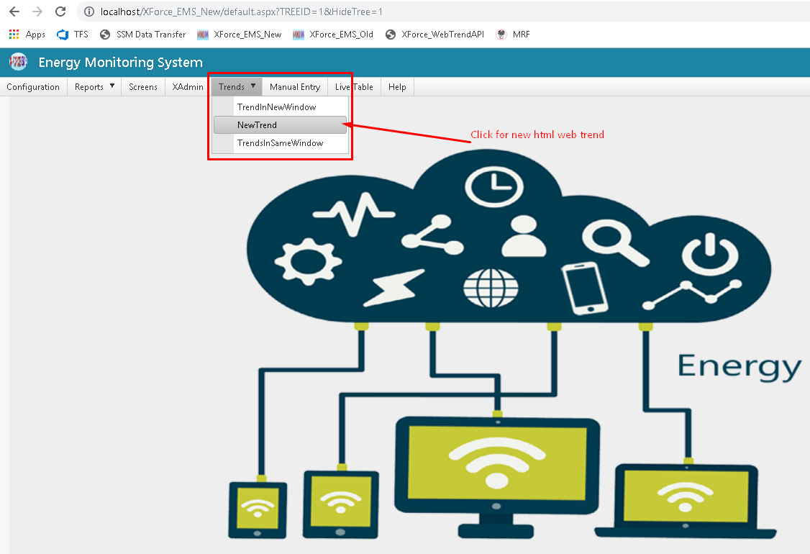

* Make sure configured link in database should appear as it is.
* See in below screenshot where to check the HTML Web Trend Link.

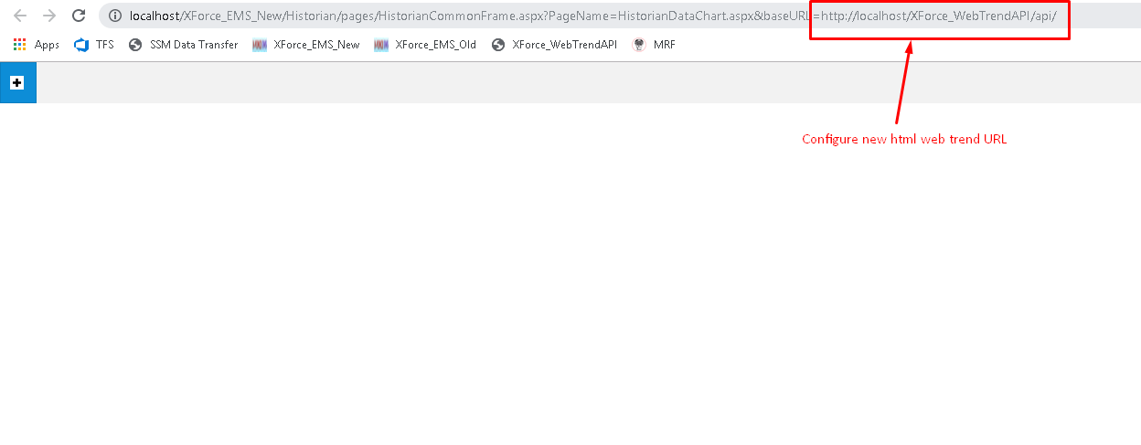

* Click on plus button to open HTML Web Trend Window.

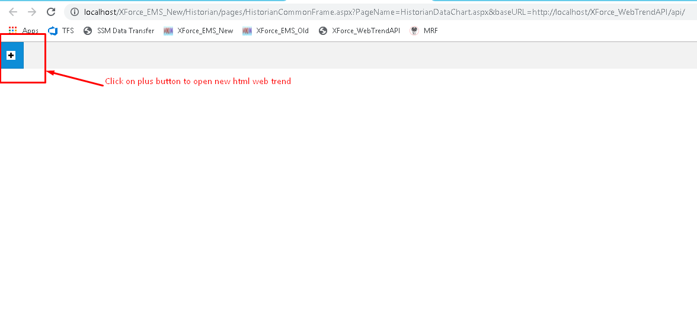

* Check on location and then click on ADD button.
* Selected location devices will display in device list.

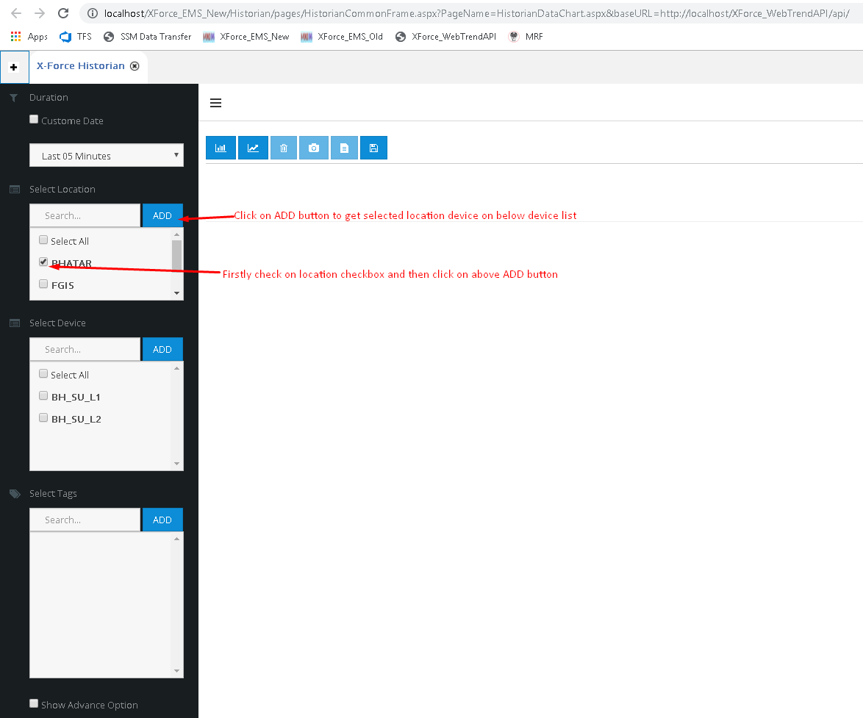

* Check on device and then click on ADD button.
* Selected device tags will display in tag list.

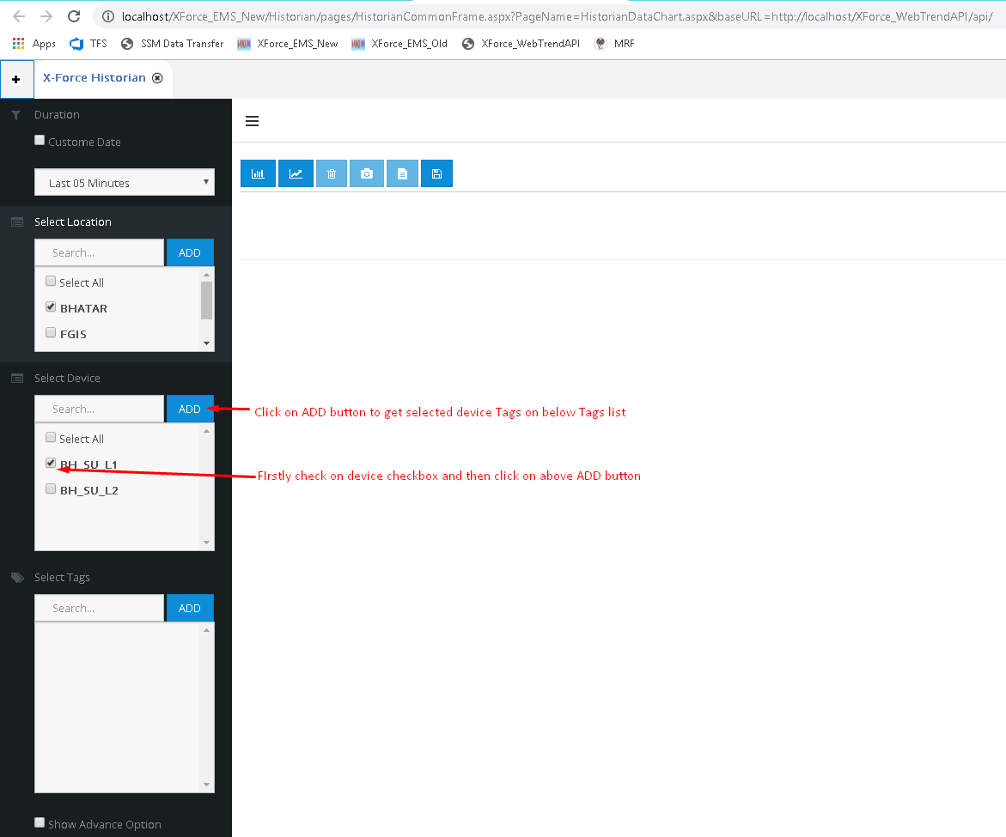

* Check on tag and then click on ADD button.
* Selected tags will display in grid panel as displayed in below screenshot.

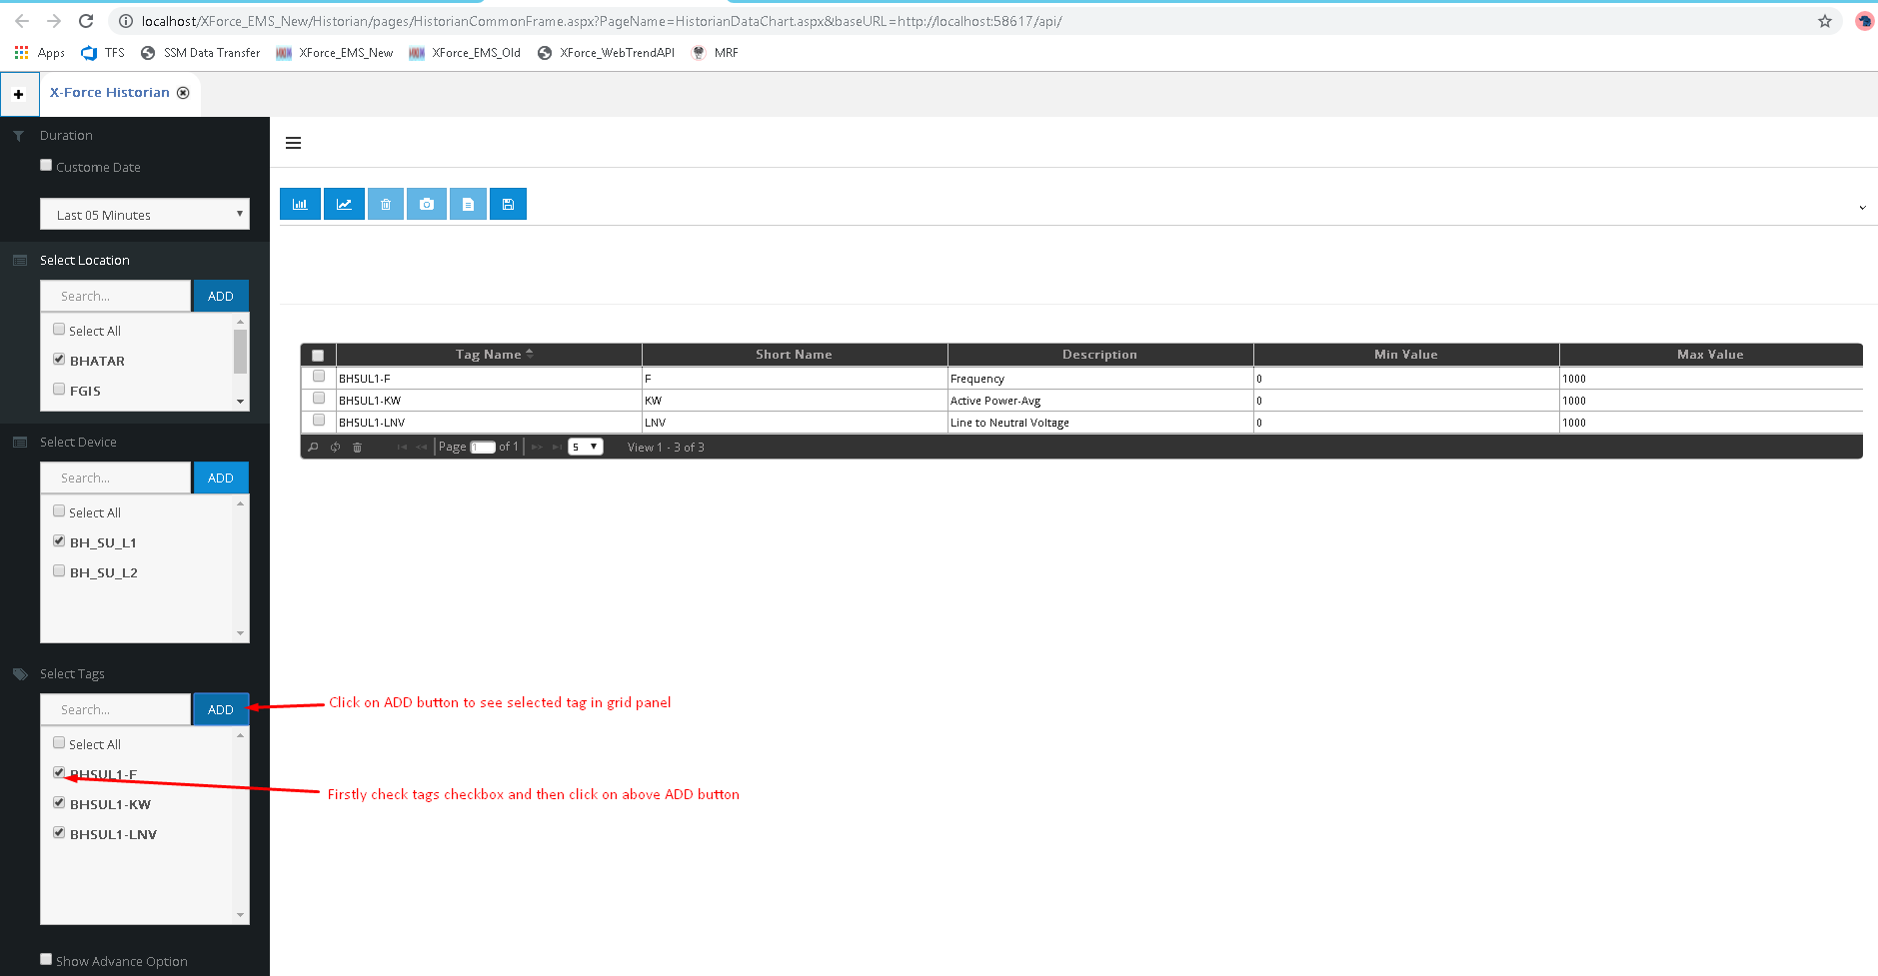

* Below screenshot will show DateAndTime (duration) filter option for which date or time data should display on HTML Web Trend.
* As mentioned on below screenshot click on last button which Draw Chart button will draw chart above grid panel which you can see in next screenshot.

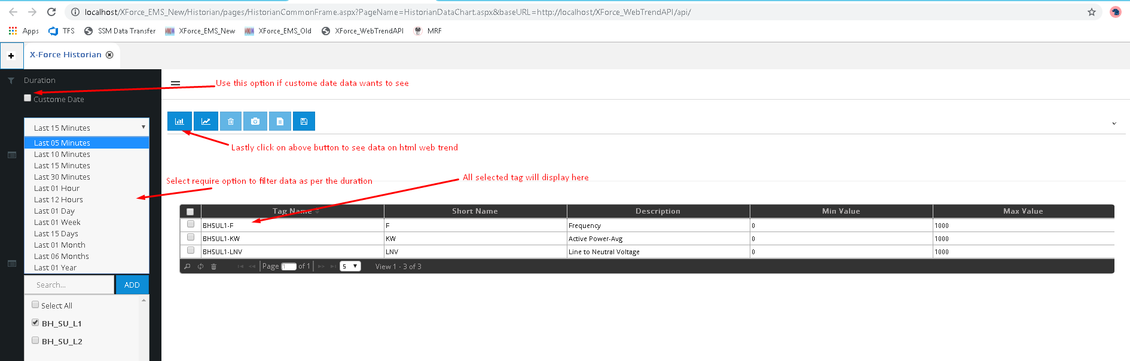

* Below screenshot will show other option of Web Trend link Destroy Draw Trend button, Screenshot button, Export to Excel button, SaveTagGroup button.
  + Destroy Draw button will clear html web trend chart.
  + Screenshot button will take snap of draw chart.
  + Export to excel button will give all tag data in excel which are shown on trend.
  + SaveTagGroup button will save all tag in one group which is appearing in grid panel so user need no to go through whole selection process every time.

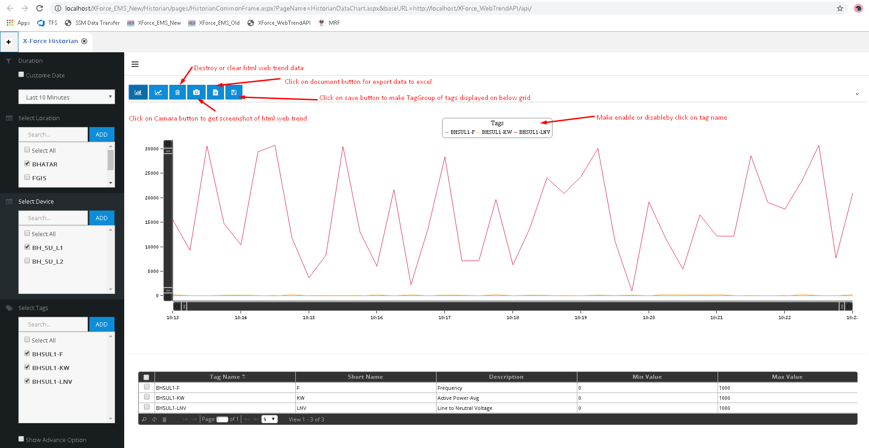

Export data from HTML Web Trend

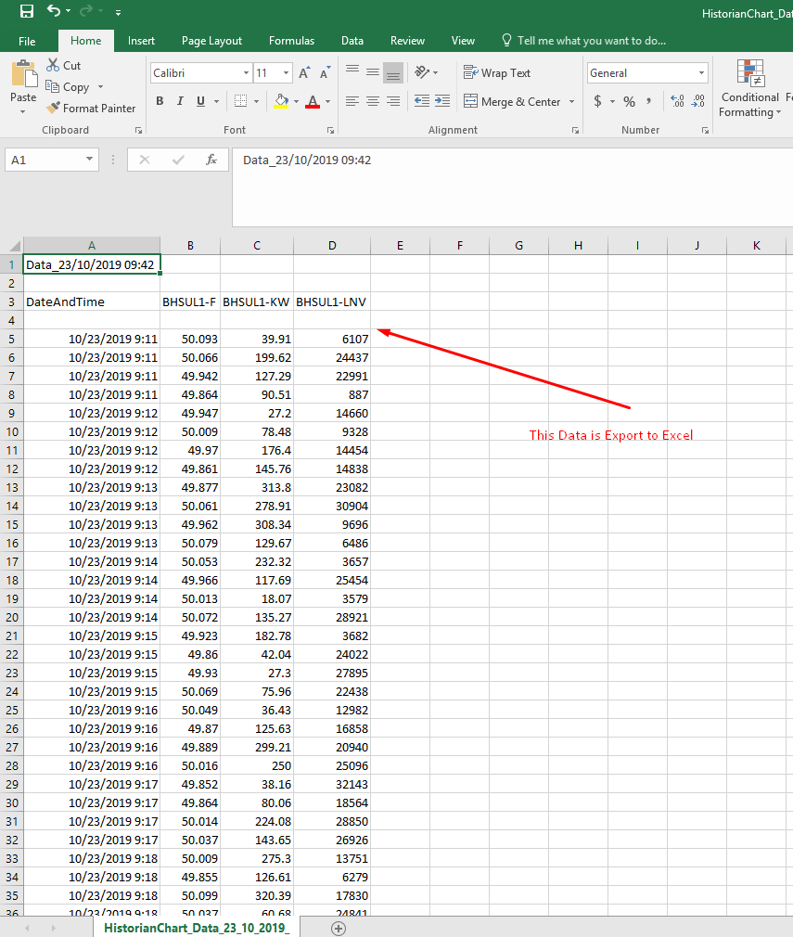

* Below screenshot will display when click is made on save button.
* Select Group Name from Select Group list item and then click on Open button.

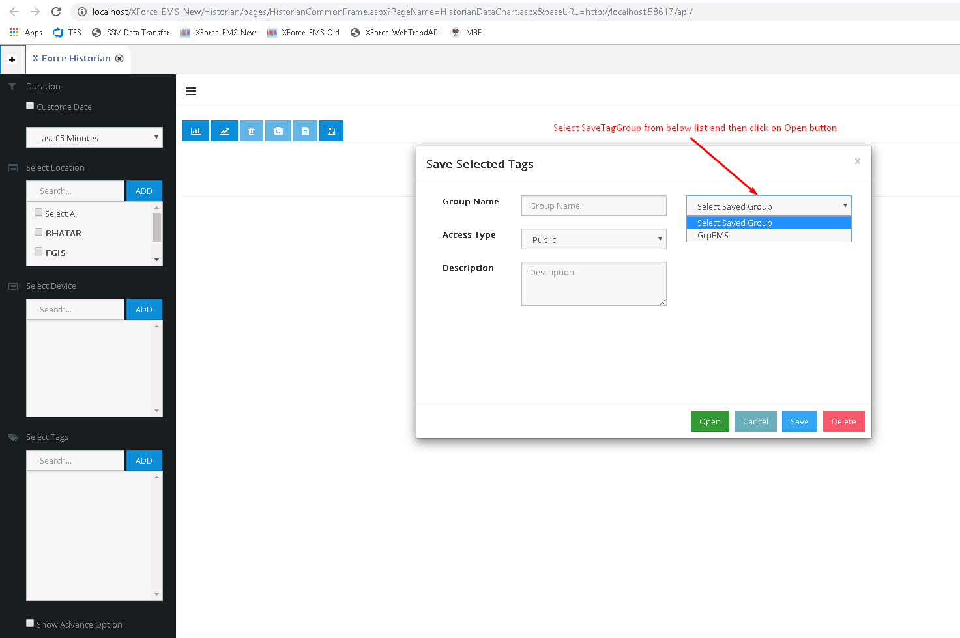

* After click is made on Open button grid panel will display filled with all tag names which you have saved while made a group.

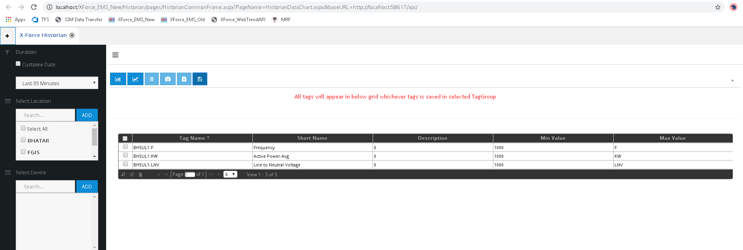

* Click on Draw Chart button as shown in below screenshot to draw button. Make sure you select DateAndTime (duration) as option is shown on above scrrenshot.

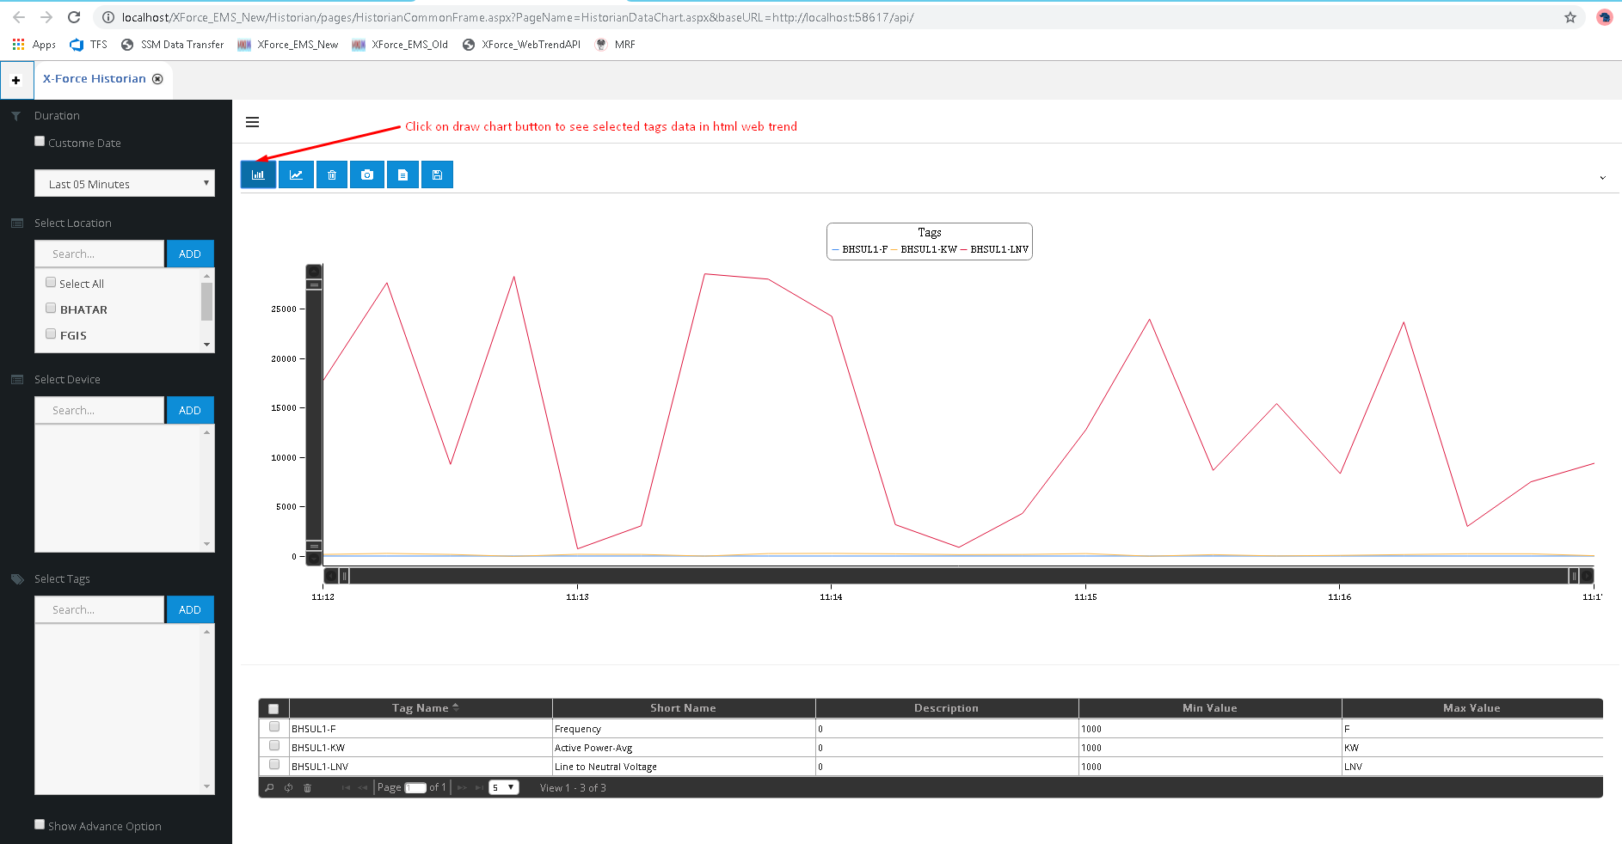

* Below screenshot will guide you to access SaveTagGroup features.

