**Configuring WindowViewer Properties**

1. Open WindowMaker. Go to the Special menu, point to Configure, and then click WindowViewer. The WindowViewer Properties dialog box appears.

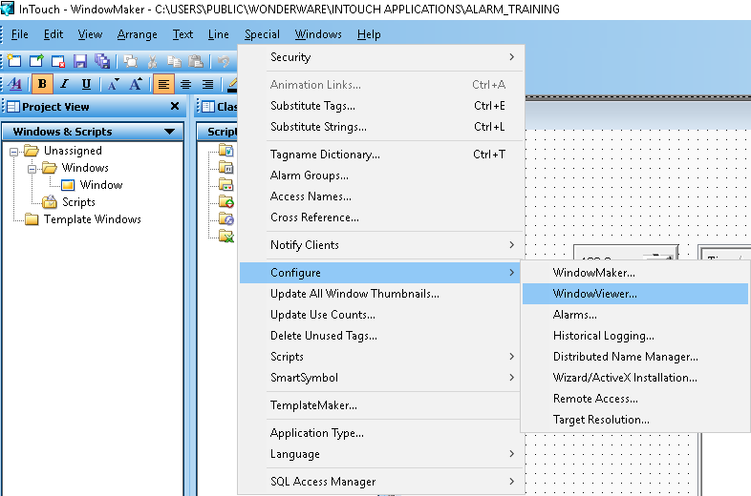

1. Click the General tab

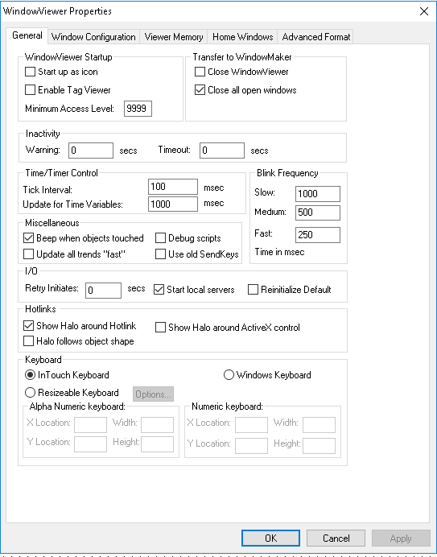

* Select the Start up as Icon check box if you want WindowViewer to start up minimized.
* Select the Enable Tag Viewer check box to allow the Tag Viewer application to be started at run time. The Tag Viewer allows you to watch and monitor tags and modify tag values at run time.
* In the Minimum Access Level box, type the minimum security access level required to run the Tag Viewer application. The value must be between 0 and 9999.
* Select the Close WindowViewer check box if you want WindowViewer to automatically close when you start WindowMaker.
* Select the Close all open windows check box if you want all open windows to close automatically when you transfer from WindowViewer to WindowMaker.
* In the Inactivity area, set warning and time-out periods for operator inactivity.
* In the Tick Interval box, type the interval that the InTouch HMI uses to check its internal timers.
* This interval determines when Application While Running, Window While Showing, Condition While on True/On False, Key and Touch Pushbutton Action While Down QuickScripts can be started.
* In the Update for Time Variables box, type the interval in milliseconds that time is updated for system tags like $Msec, $Second, or $Minute.
* Select Beep when objects touched if you want the InTouch application to emit a beep sound when operators select touch-sensitive objects on a window.
* Select Update all trends "Fast" if you want your trend objects to be updated more quickly.
* Select this option only if no objects overlap run-time trends on the application window. If you select this option and any object overlaps a trend, the object can be drawn incorrectly.
* Select Debug Scripts if you want a message to be written to the Logger each time a QuickScript runs.
* If you select Debug from the Window Configuration property sheet, you can switch QuickScript logging on and off from WindowViewer's Special menu.
* Select the Use old SendKeys check box if you are using an international application developed with InTouch version 3.26 or earlier.
* In the Blink Frequency area, type the interval length in milliseconds for your Slow, Medium, and Fast blink animation links.
* In the Retry Initiates box, type the number of seconds to wait before the InTouch application retries connecting to an I/O Server after a failed connection attempt. The I/O Retry Initiates box has no effect when InTouch can successfully connect to the I/O server the first time.
* Select the Start local servers check box if you want a dialog box to appear when you start WindowViewer and the I/O Server you are trying to communicate with is not running.
* Select the Reinitialize Default check box if you want to reinitialize Access Names with their default settings. Current values assigned to Access Names are ignored and they are reinitialized with their original settings.
* Select the Show Halo around Hotlink check box if you want an object on the run time screen to be highlighted when the user moves the cursor over it.
* Select the Halo follows object shape check box if you want a highlight halo around the contours of an object when the user moves the cursor over it.
* If you want a halo around Active X controls, select the Show halo around Active X control check box.

Click OK.

NOTE: You need to restart window viewer to apply these settings

1. Click on the Window Configuration You can configure properties that determine the visual characteristics of WindowViewer as it runs an InTouch application. These properties determine the menus, commands, and standard controls that appear on a WindowViewer window. Select the check boxes for the visual characteristics

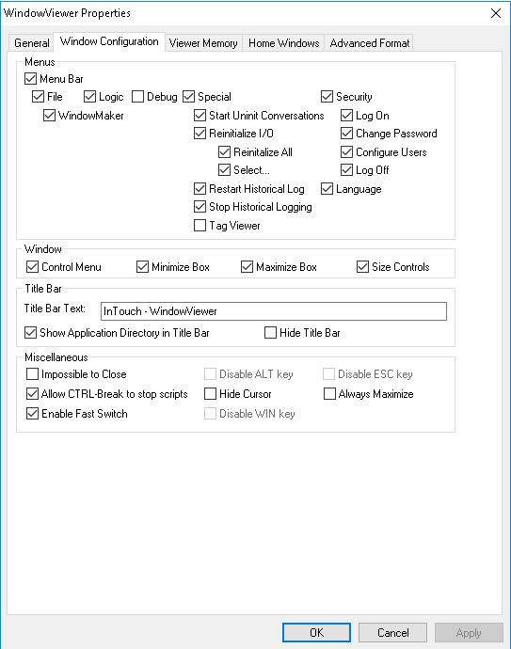

1. Click on OK