**Wizard ActiveX Installation**

1. Go to special>Configure>Wizard/ActiveX Installation

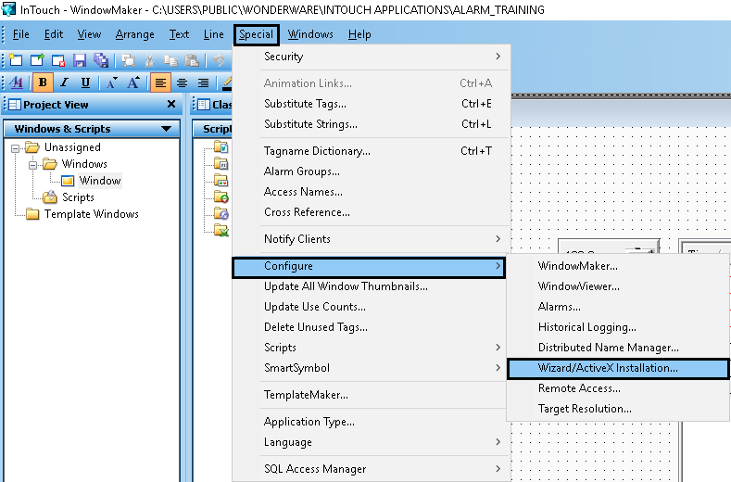

It will show installed ActiveX Control and Available ActiveX Control

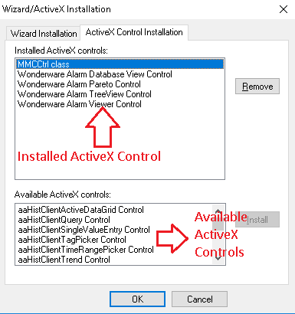

1. Select ActiveX Control from available ActiveX control and install it.

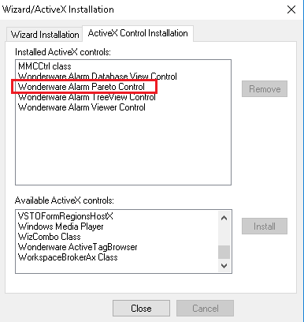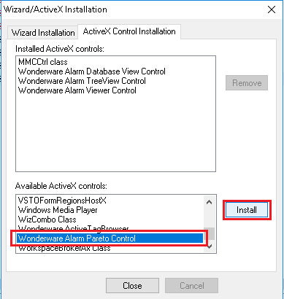

1. After installation it will show in the wizard.

