Wizard ActiveX Installation
- Go to special>Configure>Wizard/ActiveX Installation

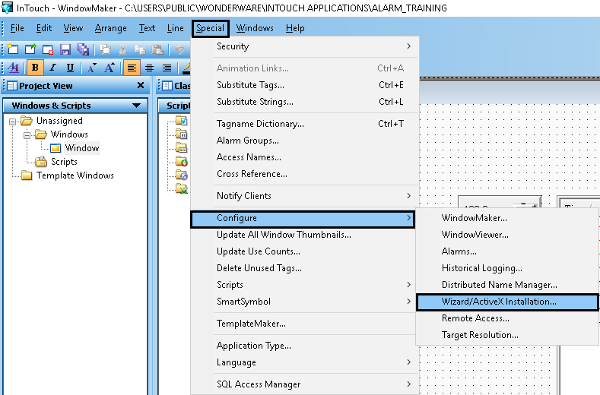

It will show installed ActiveX Control and Available ActiveX Control
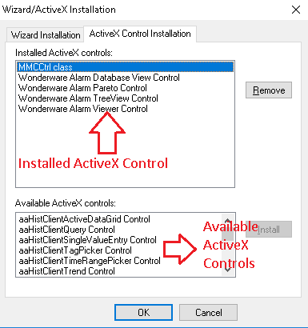
- Select ActiveX Control from available ActiveX control and install it.

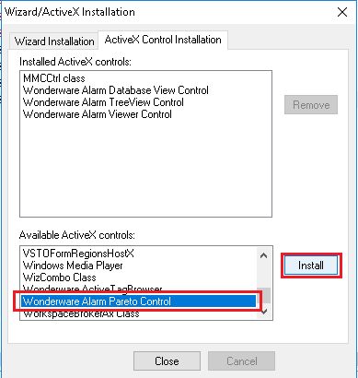
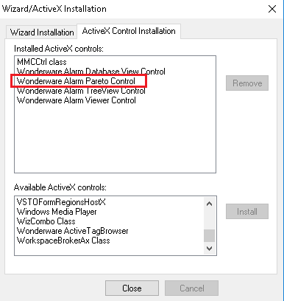

- After installation it will show in the wizard.

