OI ABCIP CompactLogix Configuration
Allen-Bradley Compact logix Hardware Setup
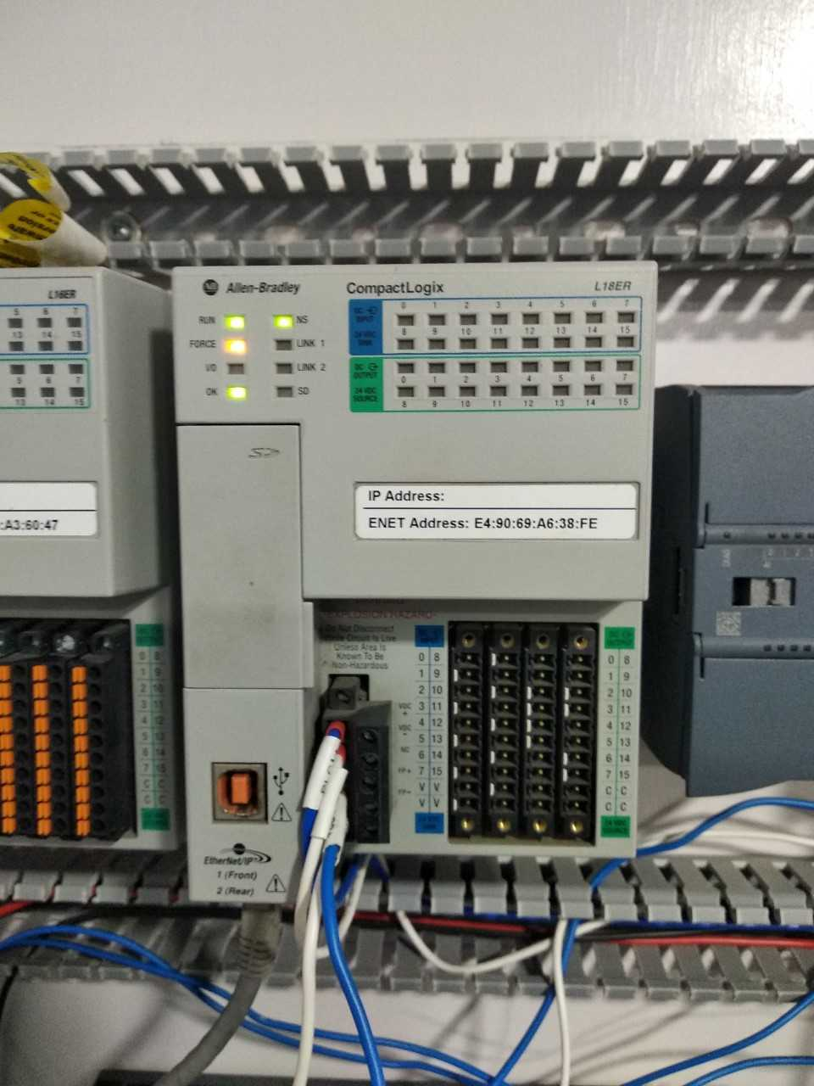
Power supply
LAN

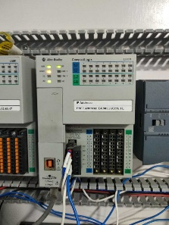
Process
Power Supply
SMC
LAN
ABCIP
WWClient
Suitelink

The Wonderware ABCIP OI (Operations Integration) Server is a Microsoft Windows application that allows client applications direct and indirect access to Allen-Bradley families of ControlLogix, GuardLogix, FlexLogix, CompactLogix, SoftLogix 5800, MicroLogix, PLC-5, and SLC500 controllers.
The OI Server does not require any Rockwell Software RSLinx™ package
The ABCIP OI Server communicates with supported devices either directly or indirectly across the following device networks:
- ControlNet
- Data Highway 485 (DH485)
- Data Highway Plus (DH+)
- DeviceNet
- Ethernet
The ABCIP OI Server will provide direct and indirect connectivity to the following Allen-Bradley controllers:
- ControlLogix Controllers
- GuardLogix Controllers
- SoftLogix 5800 Controllers
- CompactLogix Controllers
- FlexLogix Controllers
- MicroLogix Controllers
- PLC-5 Controllers
- SLC500 Controllers

- Install ABCIP OI After installation it will show in the SMC.
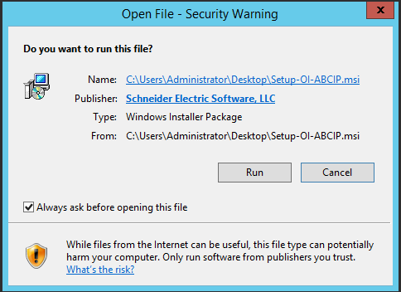
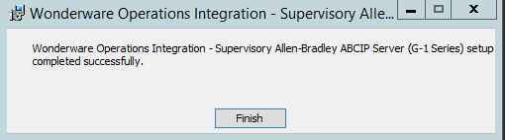
- Navigate to the Operations Integration Supervisory Sensors – Allen- Bradley ABCIP and right click on the configuration and add PORT_CIP Connection
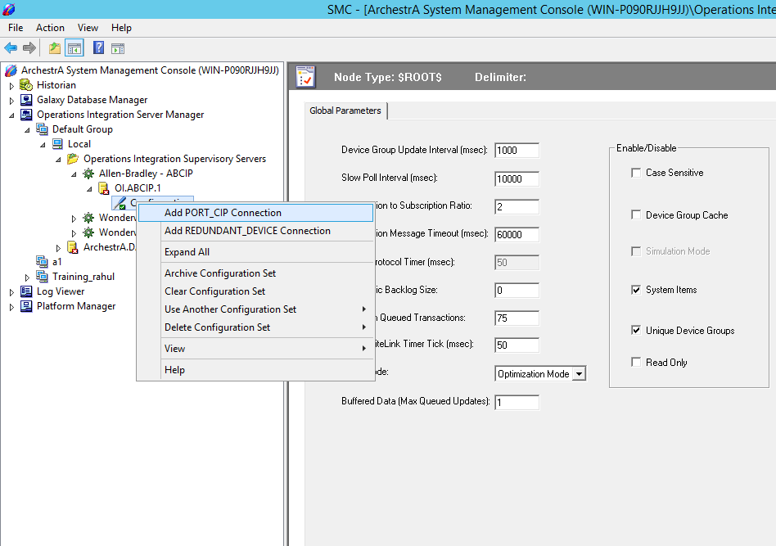

- Add ENB_CPLX Connection (For CompactLogix)

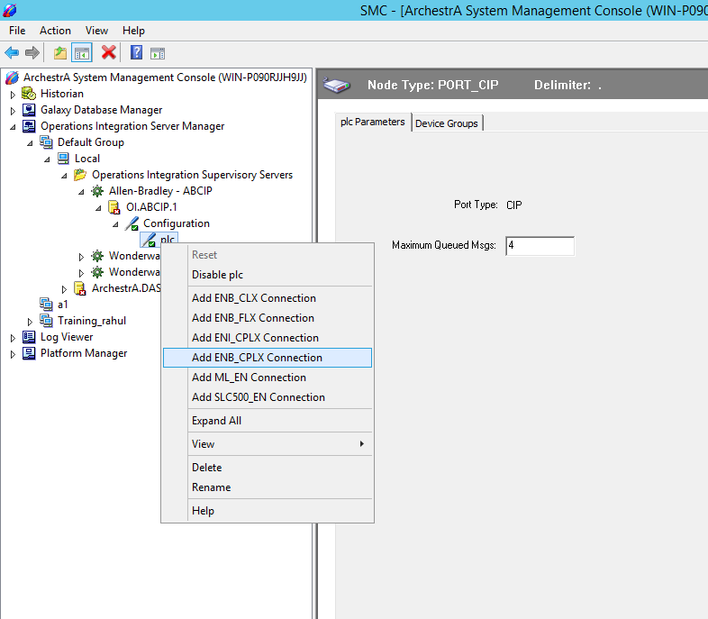
- Enter IP Address of PLC and Save it.

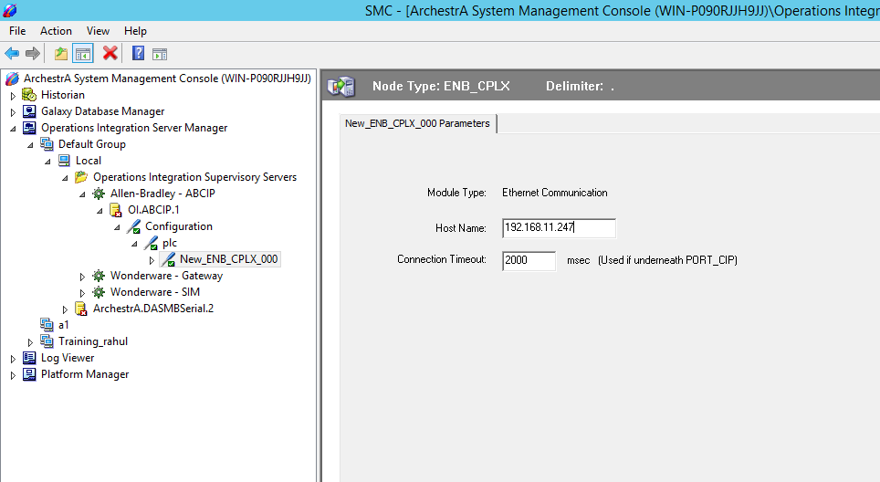

- Add BACKPLANE_CPLX connection

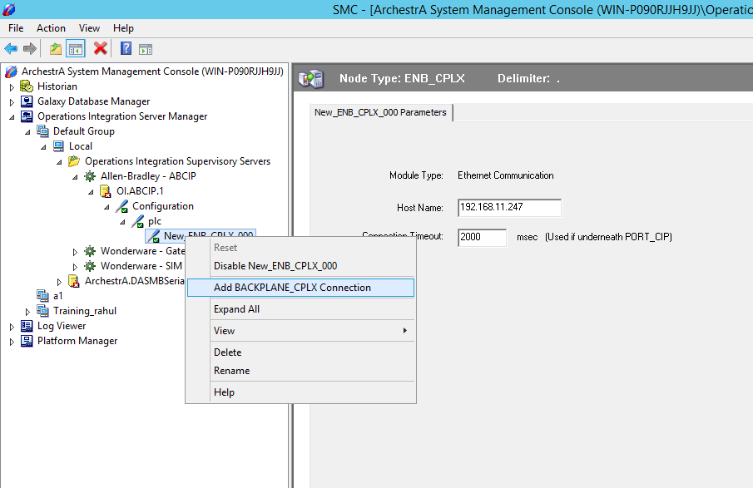

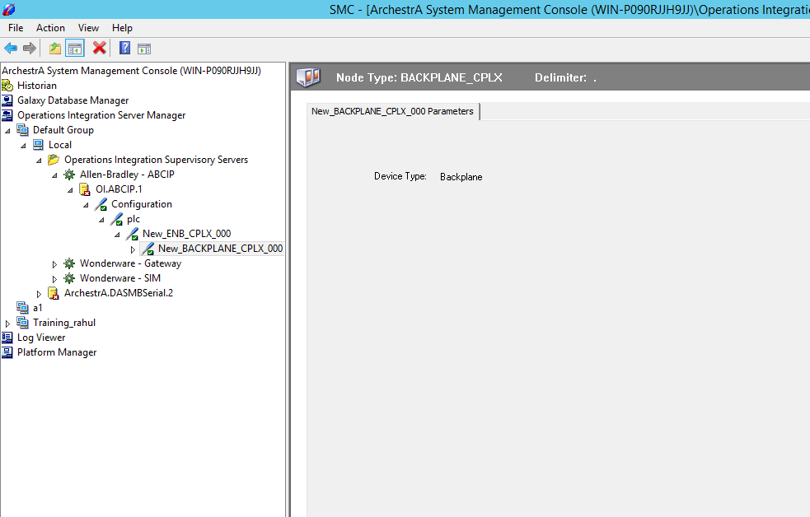

- Add Logix_CPLX Connection.

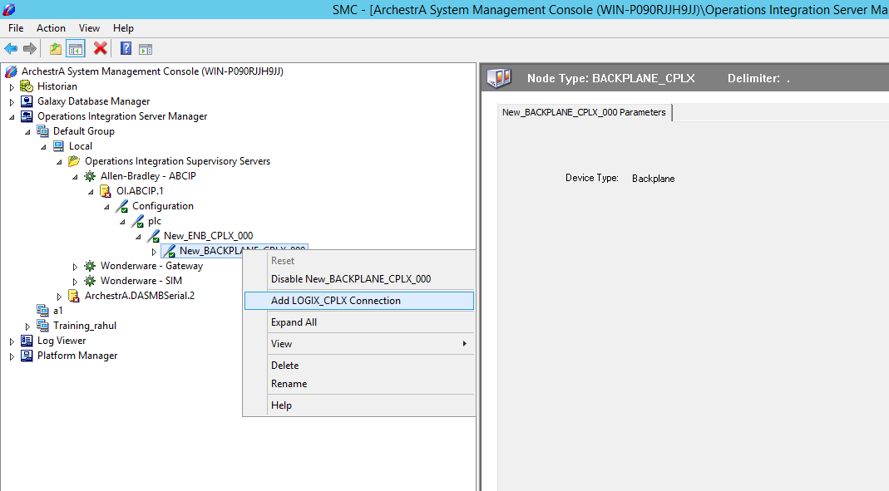

- Add Device Group and device items

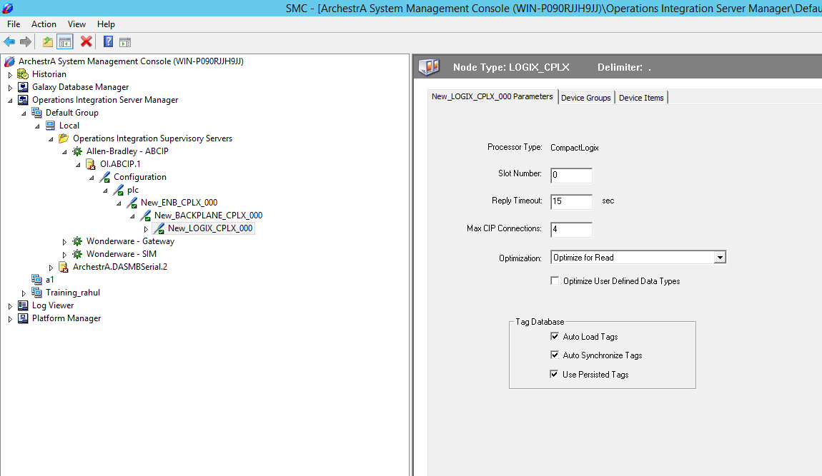
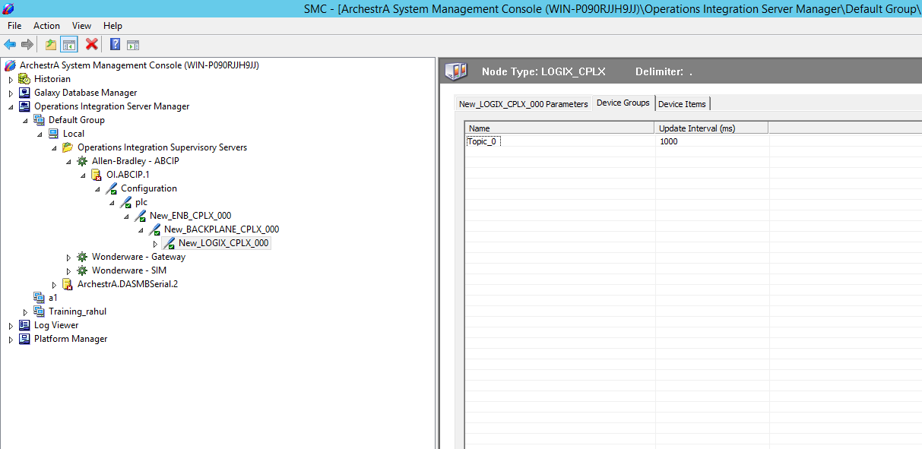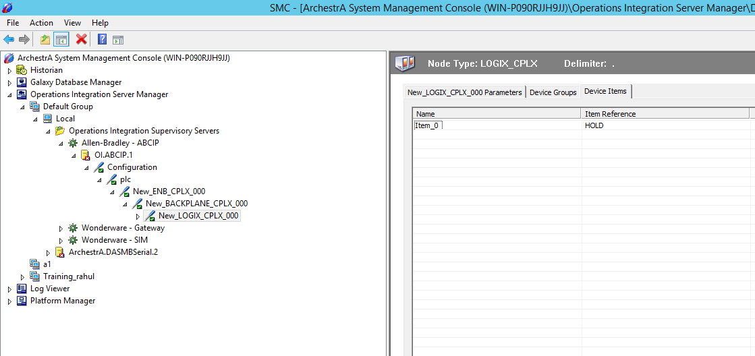

- Activate OI ABCIP Server

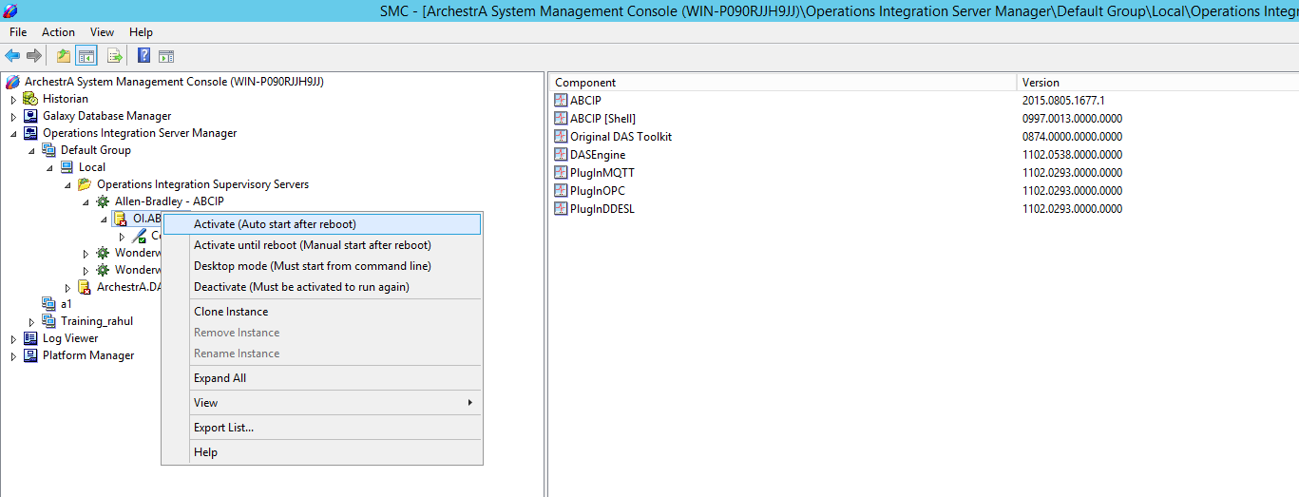

- Open WW Client.



- Go to connection and create connection.

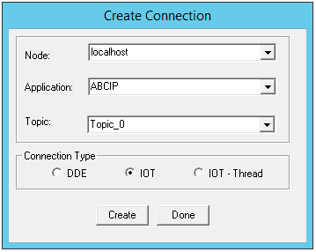
- Go to item and add item.
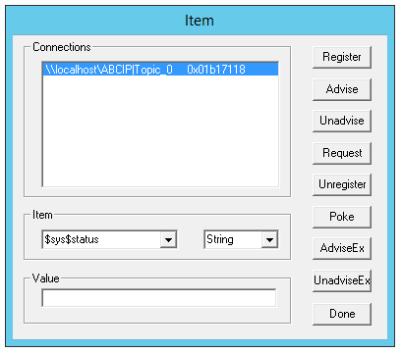

- Now tags will show in the wonderware client.



- You can also view that data in SMC in Diagnostics.

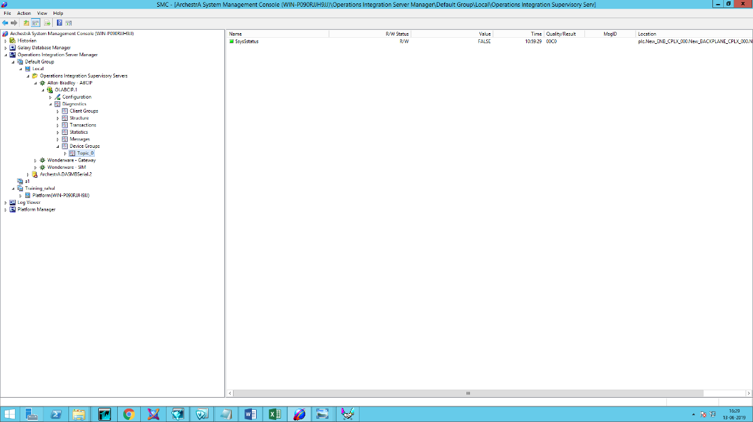
OI ABCIP ControlLogix Configuration
Allen-Bradley Control logix Hardware Setup
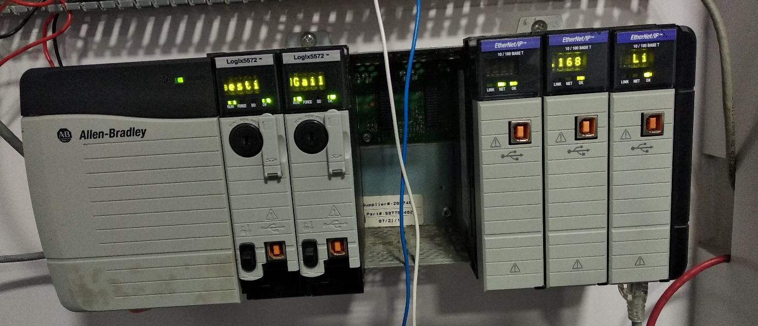
LAN

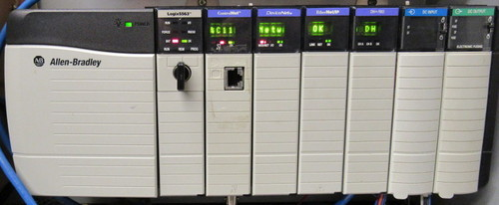
Process
Power Supply
SMC
LAN
ABCIP
WWClient
Suitelink

- Install ABCIP OI After installation it will show in the SMC.
- Navigate to the Operations Integration Supervisory Sensors – Allen- Bradley ABCIP and right click on the configuration and add PORT_CIP Connection

- Click on PLC and add ENB_CLX Connection
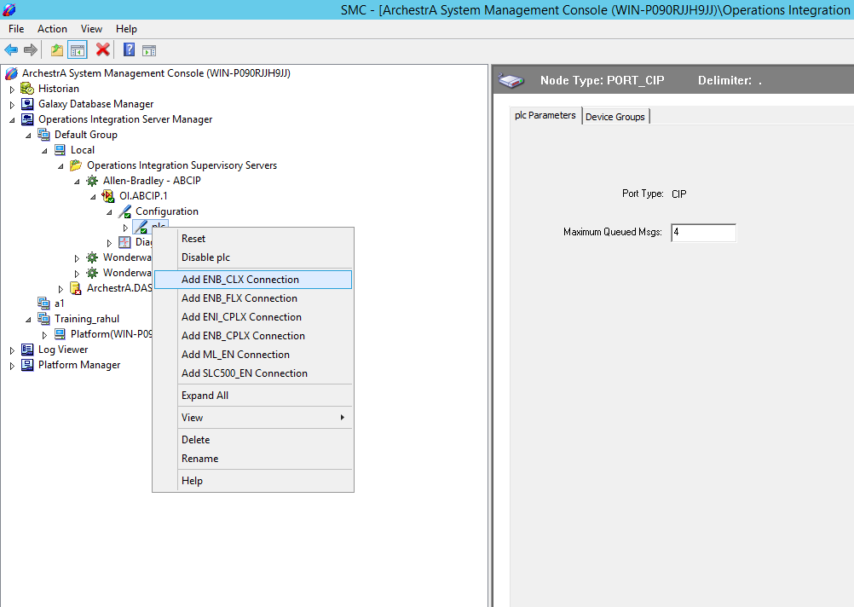

- Enter IP Address of PLC
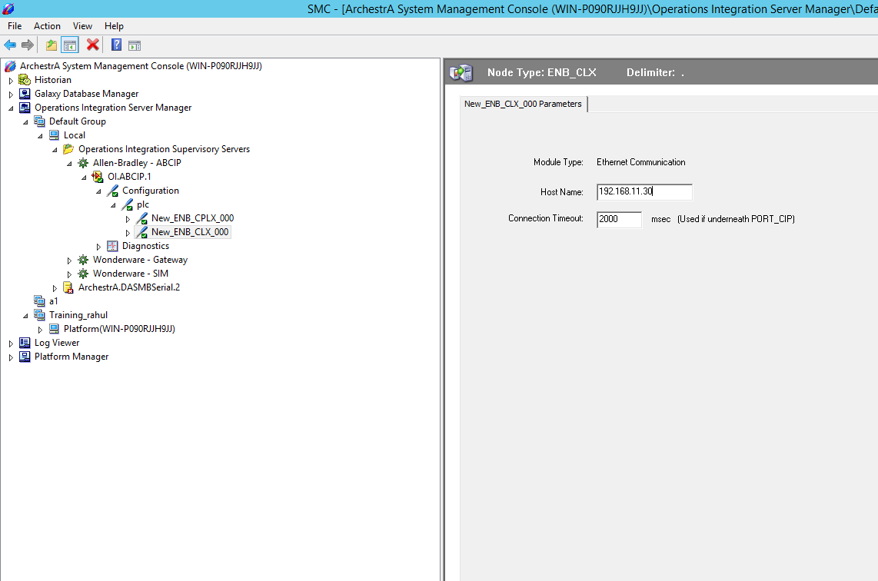
- Right click on ENB_CLX_000 and Add Backplane_CLX Connection

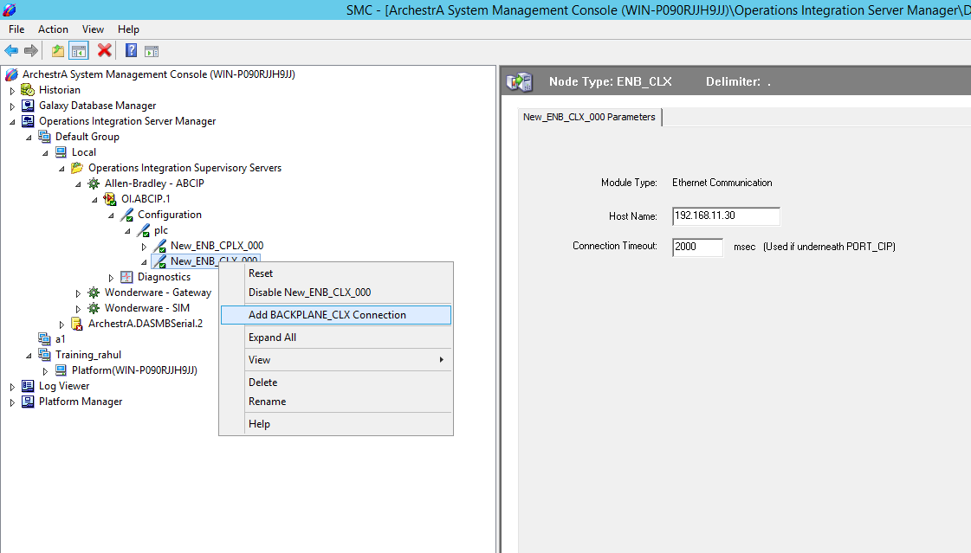

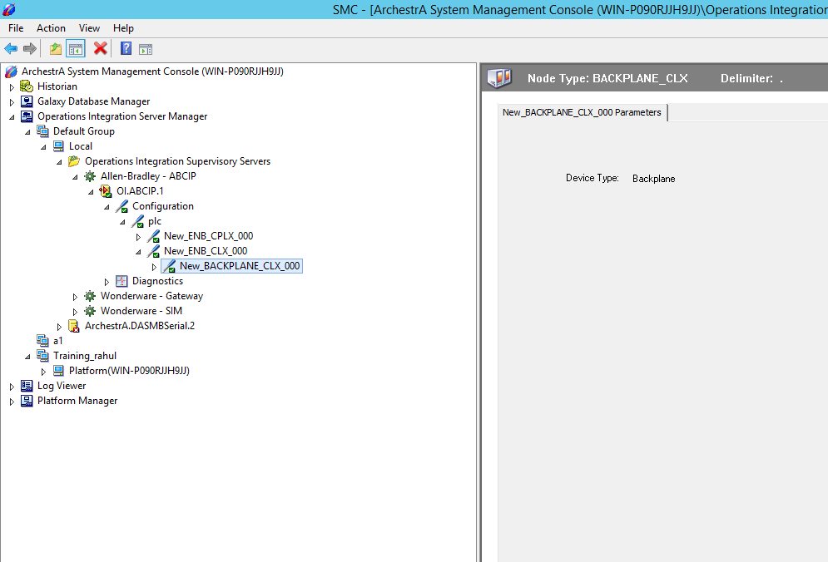

- Right Click on Backplane and add Logix 5000 Connection and add device Group and device items.
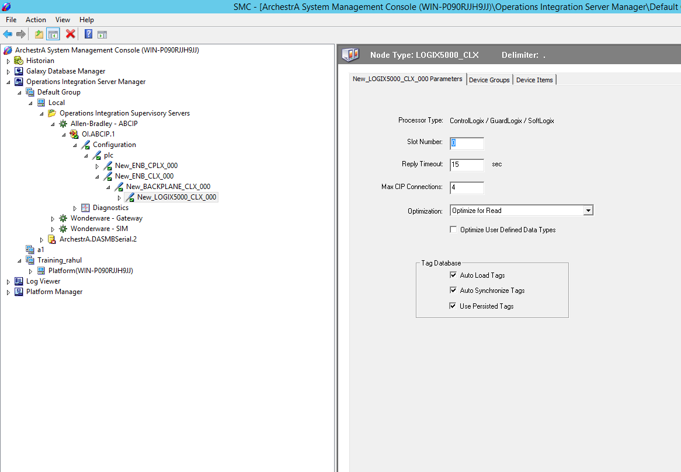

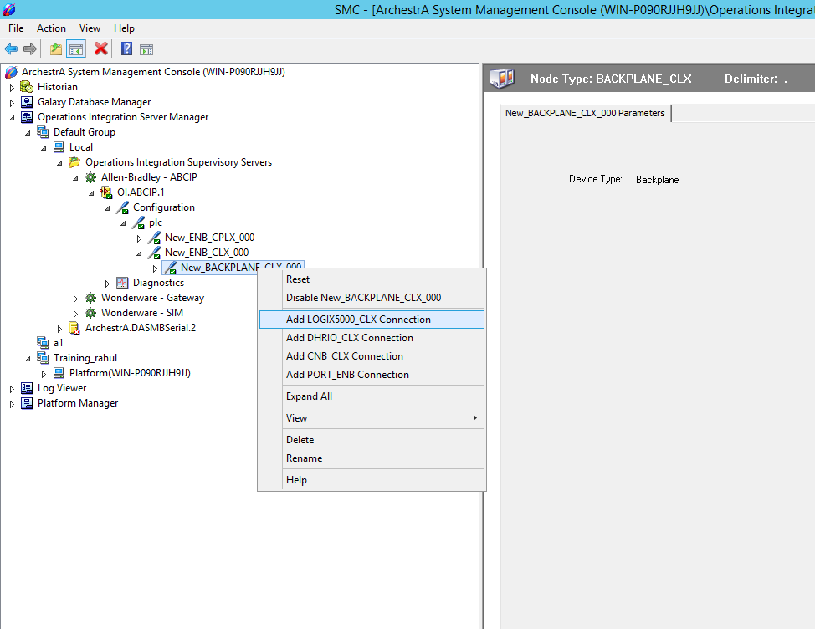
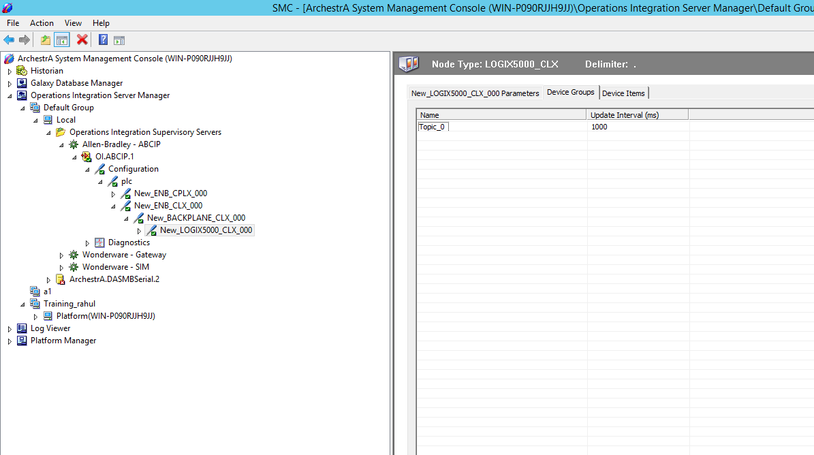

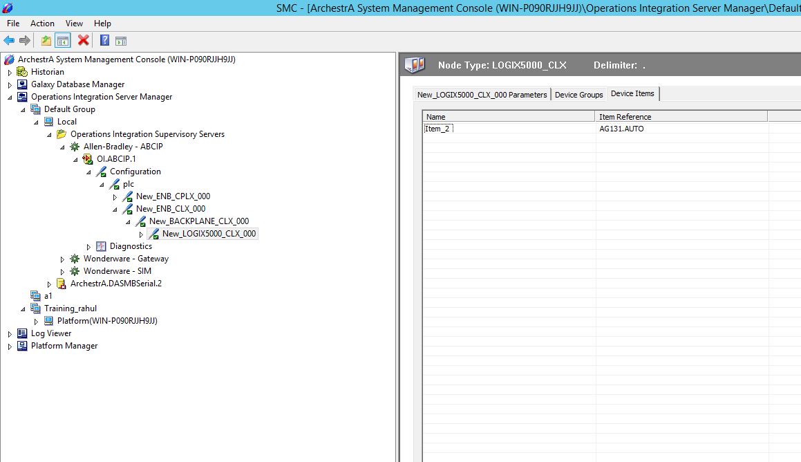

7. Now open WW Client and check connectivity of tags as described above.

