Energy meter Looping Connection:-

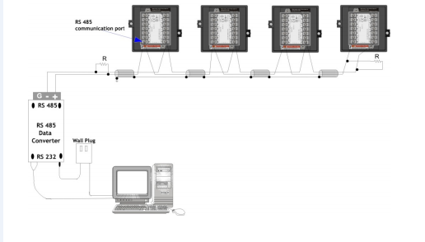
Fig.1
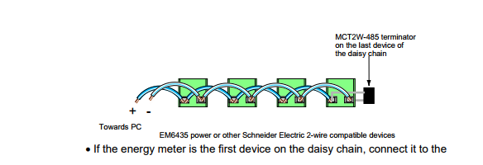
Fig. 2

Loop structure of energy management system is seen in above fig 1.All the energy meter’s RS 485/232 port is in loop is connected parallel with each other (maximum 32 energy meter take in loop as per the standard).

Possibility of Fault in Loop:-
No | Fault | Step to correct
1 | Cross connection in Loop | Manually check connection between +ve to +ve and –ve to –ve.
2 | Continuity Problem in loop | Step by step test loop by using the multi meter  If continuity breaks between two meter, then check the connection of RS 485.
3 | Terminal box(TB) short | Step by step check by using multi meter if continuity obtains between TB’s +ve and –ve terminal then replace it.
4 | DB9 connector | Check DB9 connector 3, 4, 5 number pin (+, - , GR).
5 | Due to External Factor | Provide proper protection to loop cable.
6 | Fault in MOXA port | Check loop by using U-port, if all meter are given response then change N-port MOXA port and also change in database new assign port and Restart X-force DAS.
7 | If more than one loop commutation fail in same N-port MOXA | Ping the same N-port MOXA on assign IP,if destination host unreachable than check LAN connectivity.

RS232 Communication | RS485 Communication
2,3,5 (+,-,GR) | 3,4,5 (+,-,GR)

