- Requirement :-

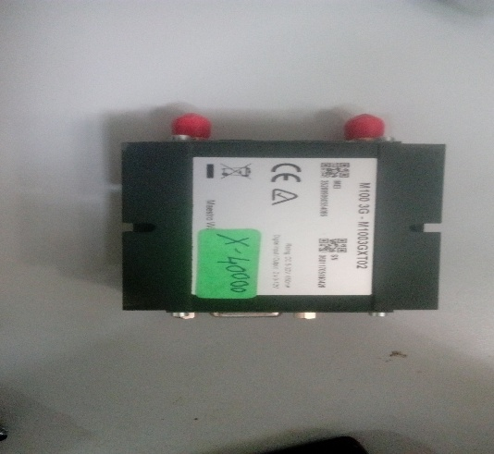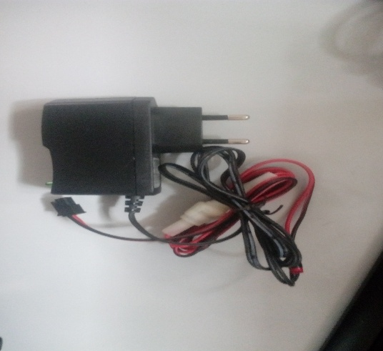

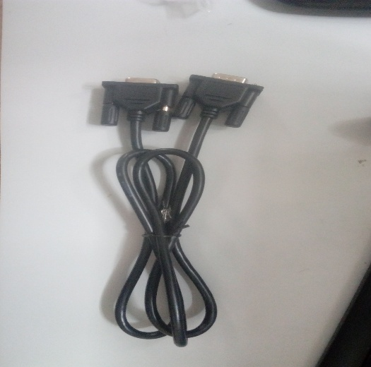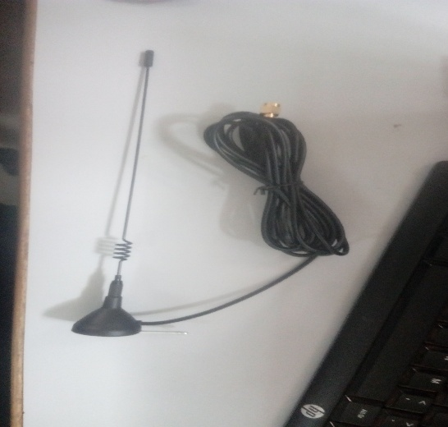

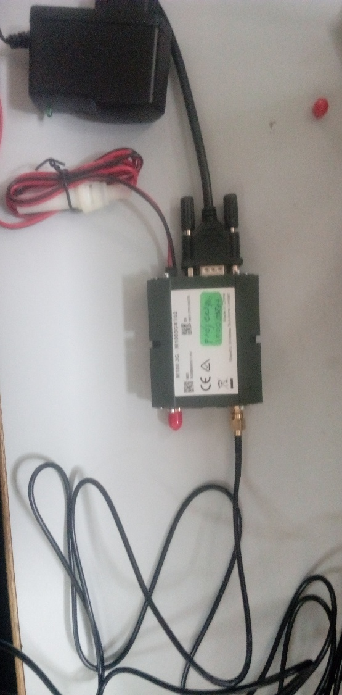

1. Open the a Hyper Terminal Private Edition(hyper terminal.exe) .

- 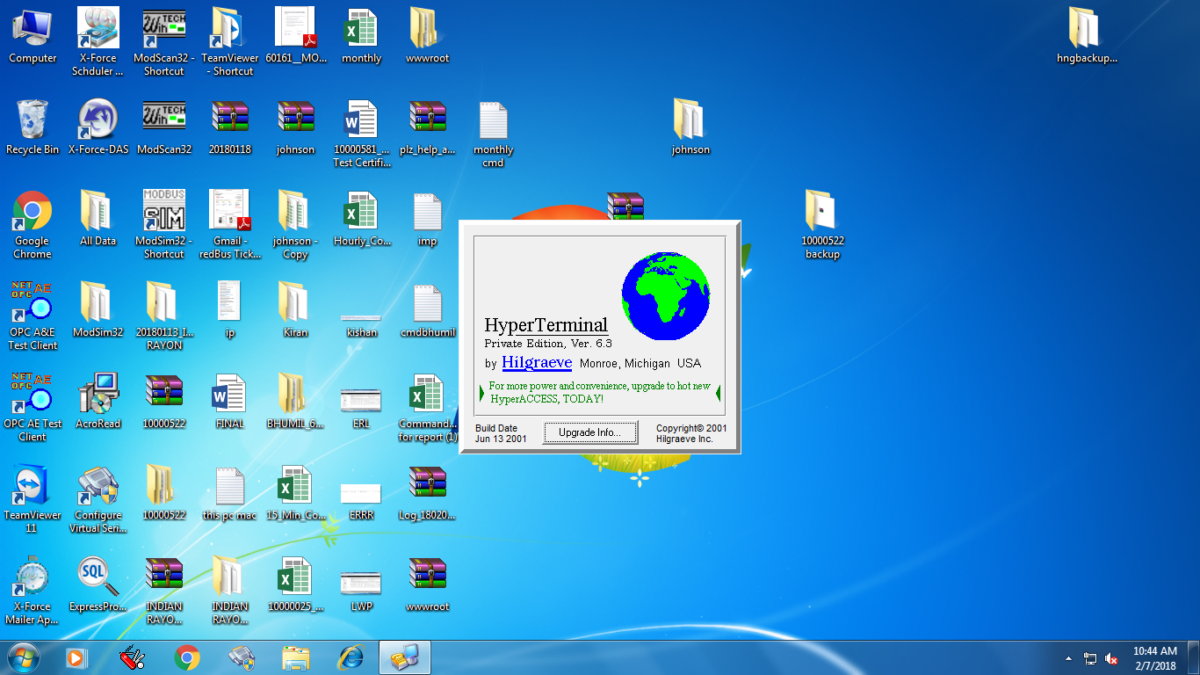
- Open new screen.
Name: Blank space Any Name type
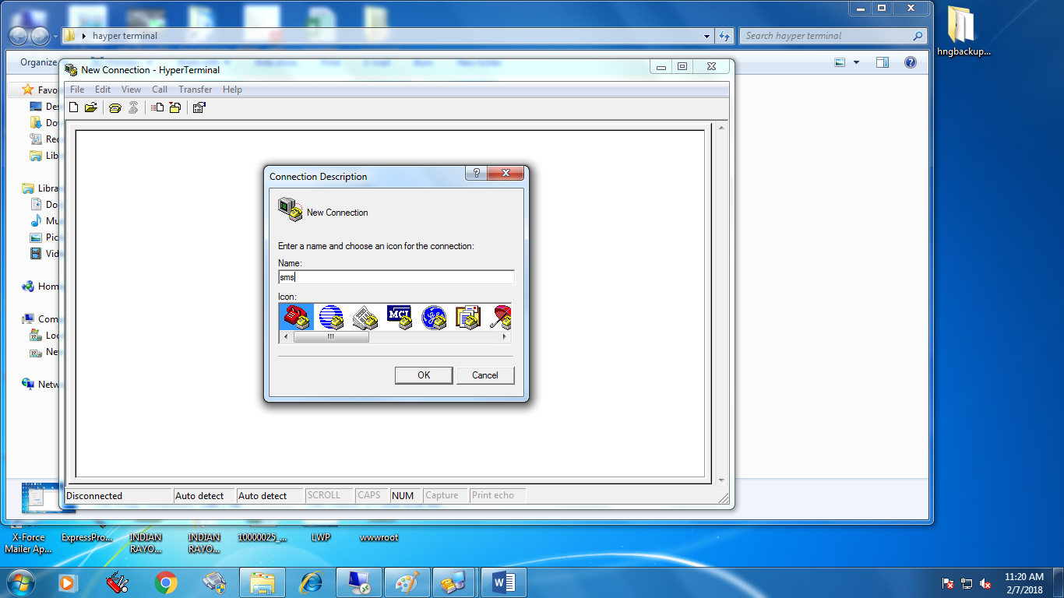
Click on the ok Button.
- Open the new screen.

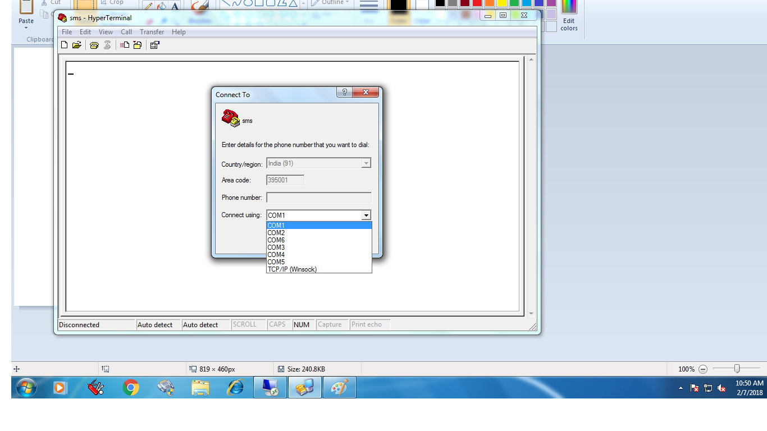
- Select the connect Using. Ex: com1, com2, com3 etc.
- Open new screen.
Select the information.
- Bits per second: 115200
- Data bits : 8
- Parity : None
- Stop bits : 1
- Flow control : None

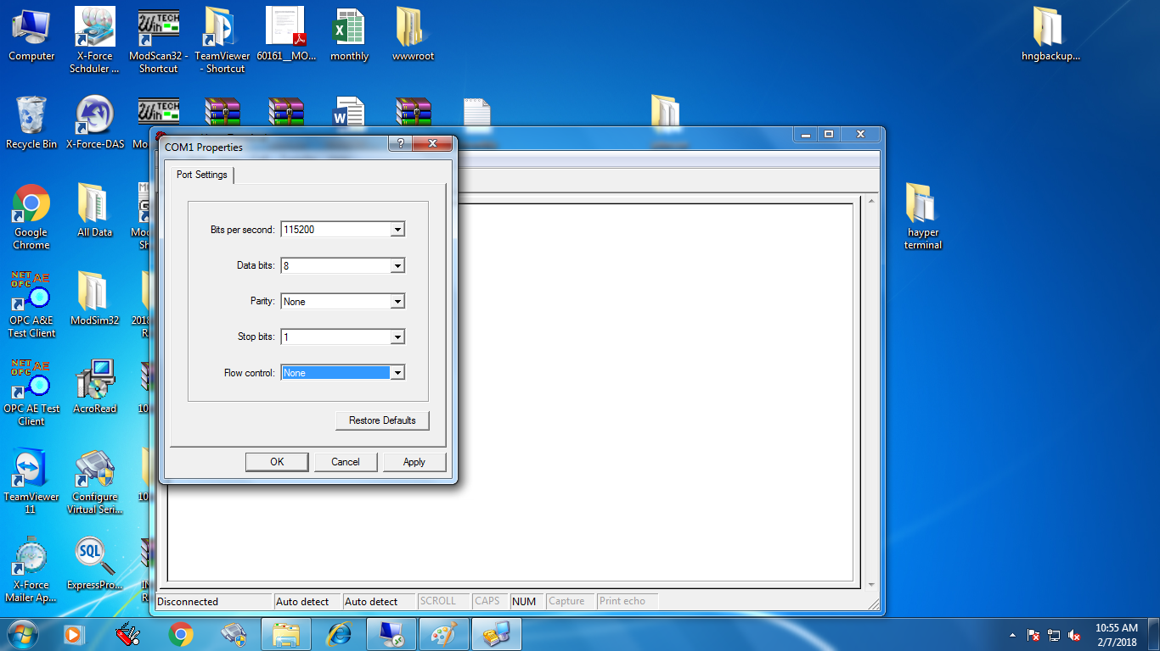

- Click on the Apply Button.
- Click on the ok Button.

- Open the blank screen.

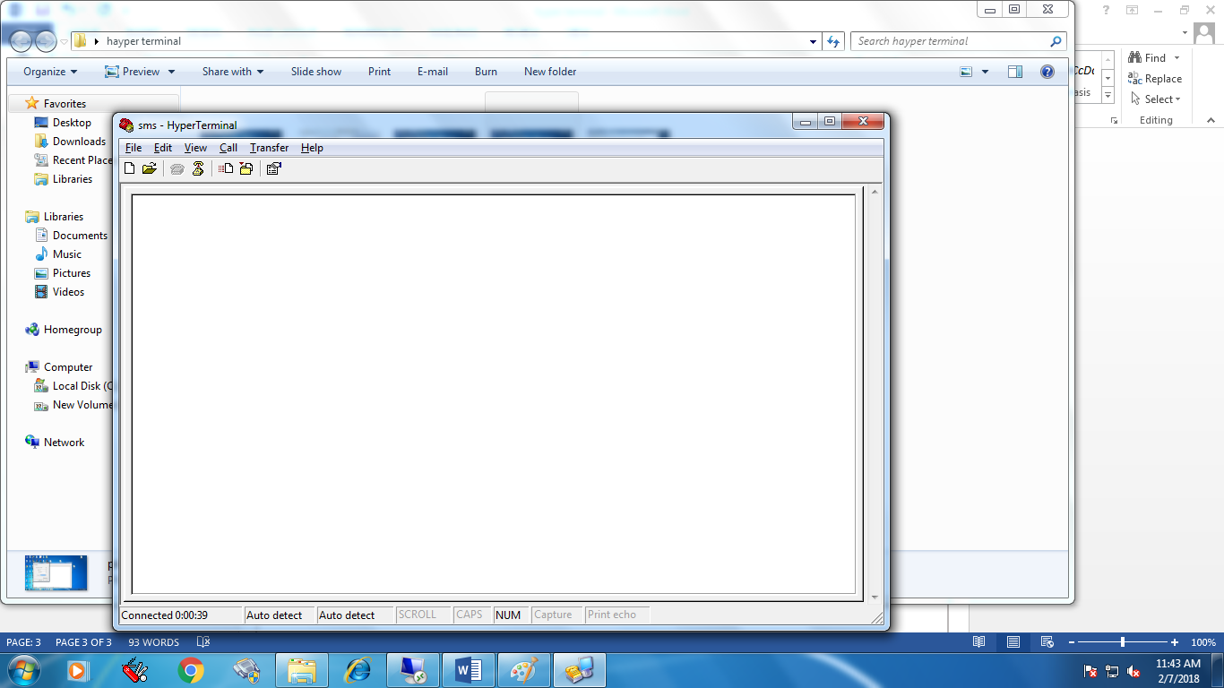

- Check the command.

(1)
At -> click Enter Button -> ok
Ctrl + cmgr=1 -> click Enter Button
Example: 9067899556

(2)
- click on the file.
- Select properties.
- Open screen.

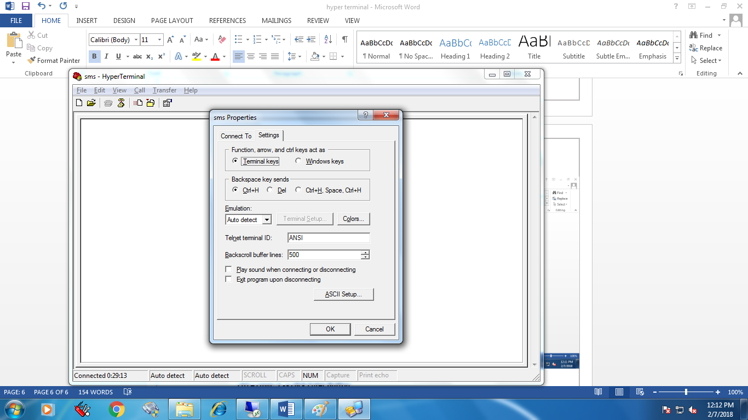

- Two option Connect To and Setting.
- Click on Settings.
- Click on ASCII SETUP button.

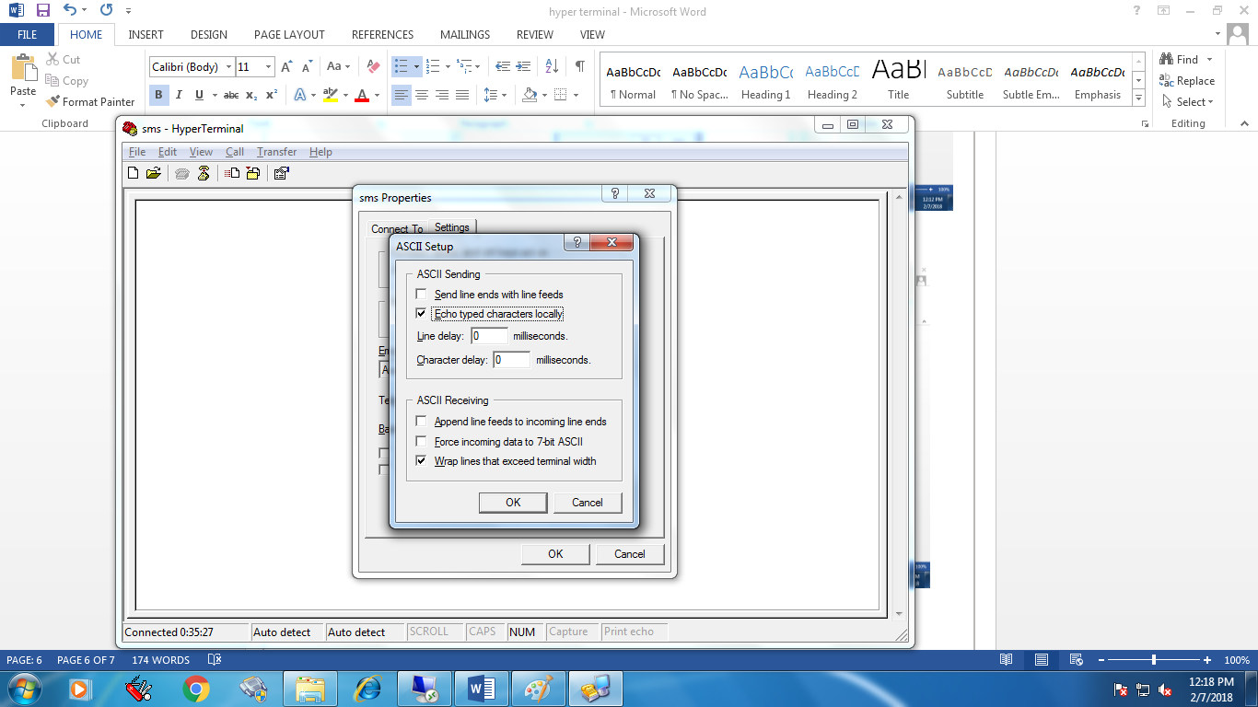

- Select Echo typed characters locally.
- Click ok button.
- Open blank screen.
- Type the command.

(2)
Aatt + click Enter Button -> ok
Ctrl + cmgr=1 -> click Enter Button
Example: 9067899556

Next process pending ……………

